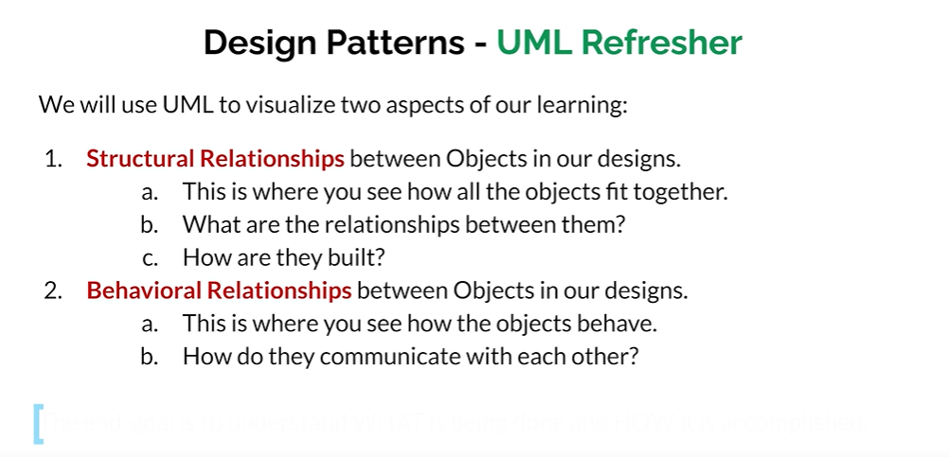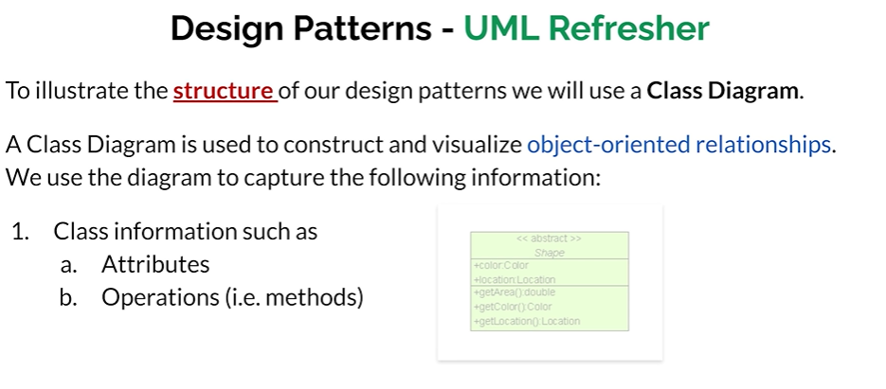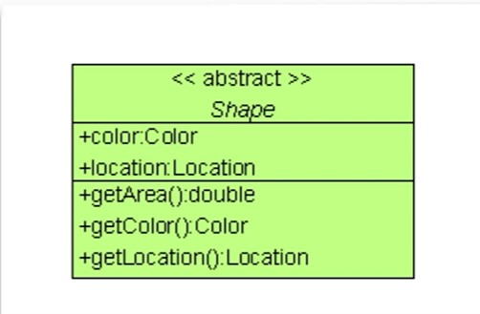

+ indicates it is public, - mean private

color,location are the attributes , getArea() getColor() and getLocation() are the operations or methods.

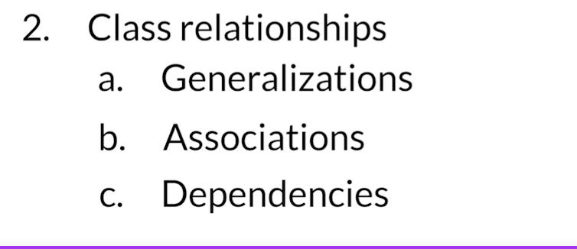

Generalization

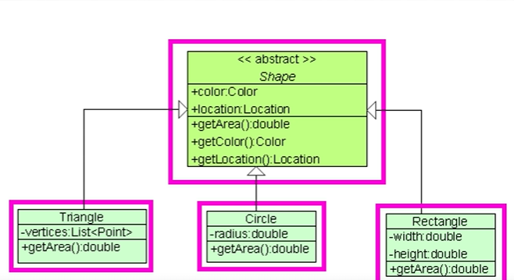

Here Shape is abstract class, we have 3 child classes that inherits from Shape.

Association

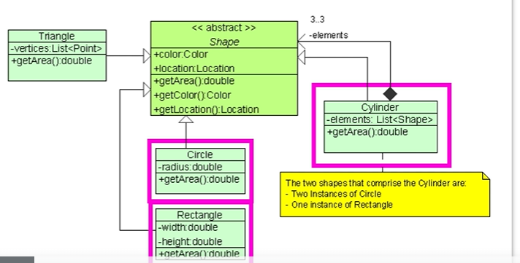

Here cylinder is also generalization of shape, (child of shape class)  
we elements as list of shapes. A cylinder is made of 3 separate shapes.

Dependency

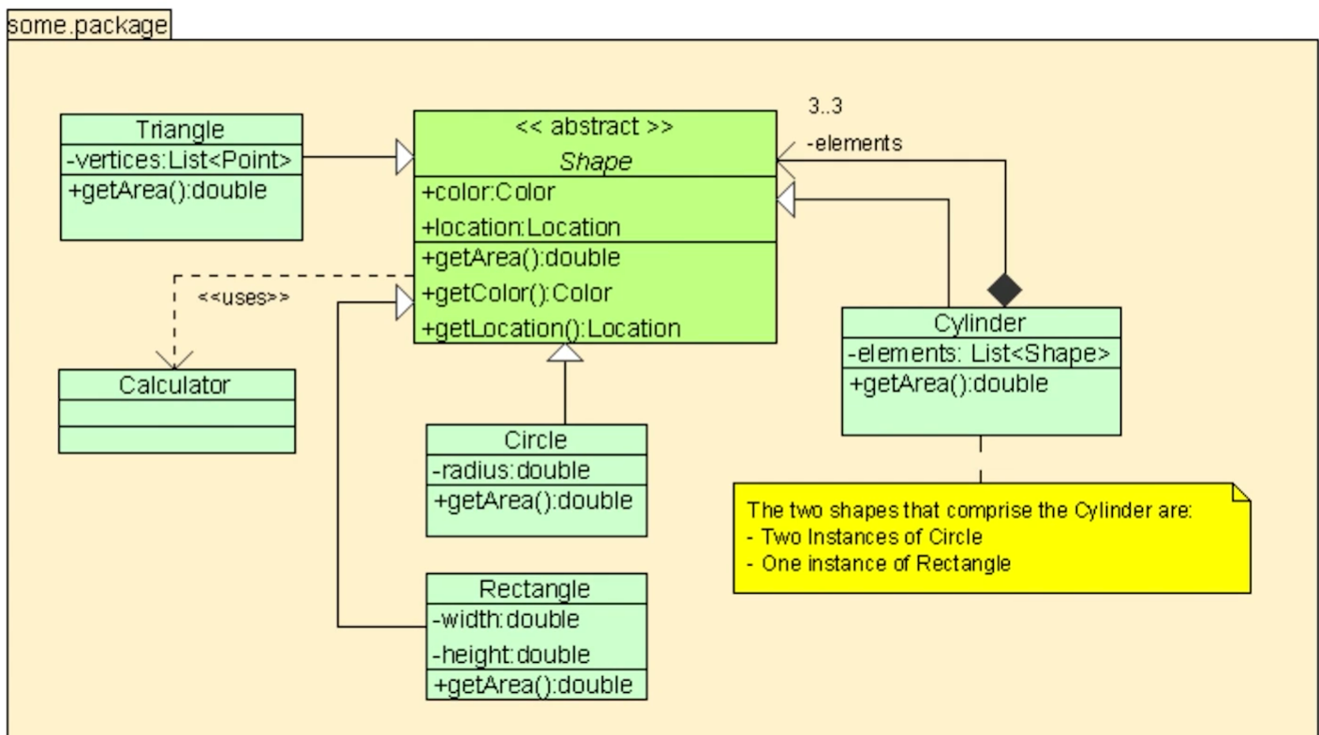

Everything is under package.

Calculator is not really associated with any class. But there is dependency between shape and calculator, Other words, Shape uses/needs Calculator , calculator is not the part of shape.

Example:

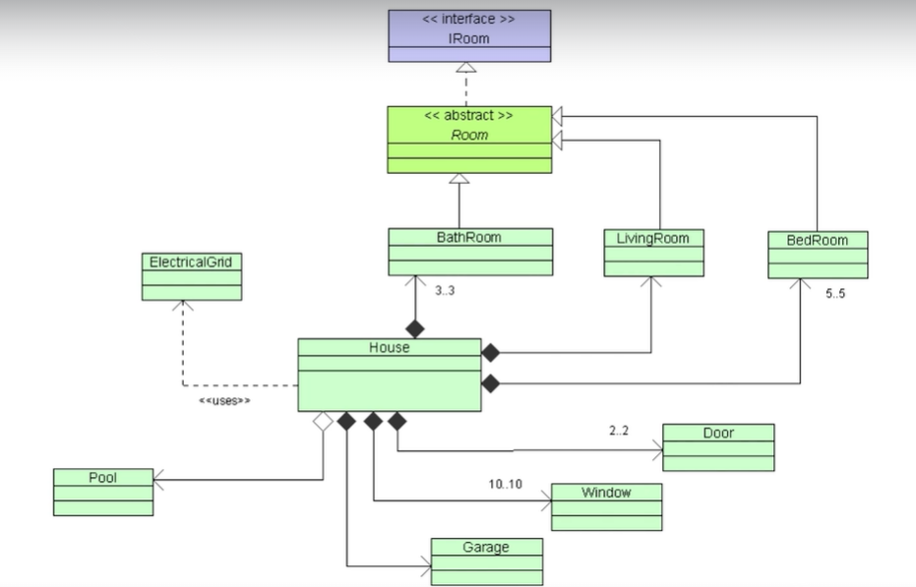

* IRoom is interface , Room implements the interface IRoom, we have 3 generalization of Room , Bathroom,LivingRoom BedRoom.
* House has lot of associations, it has 3 bathrooms, 1living room, 5 bedroom, 2 doors,10 windows, and 1 garage and has a pool.
* Black diamond-> House contains Bathroom, You cannot have an instance of Bathroom unless you have a House.. (If I remove destroy House, Bathroom is also get away)
* White Diamond- Pool is part of House, If house goes away, pool actually is able to stand on its own.
* ElectricGird-> is not part of House, the House depends on ElectricGrid. House uses the ElectricalGrid.

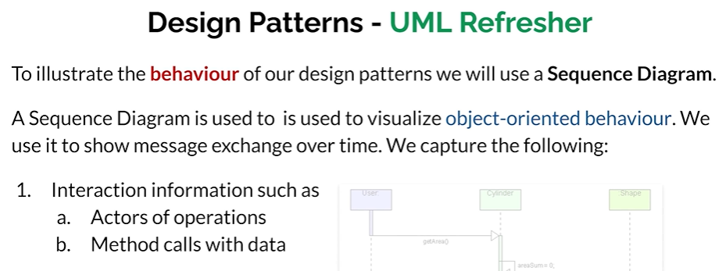

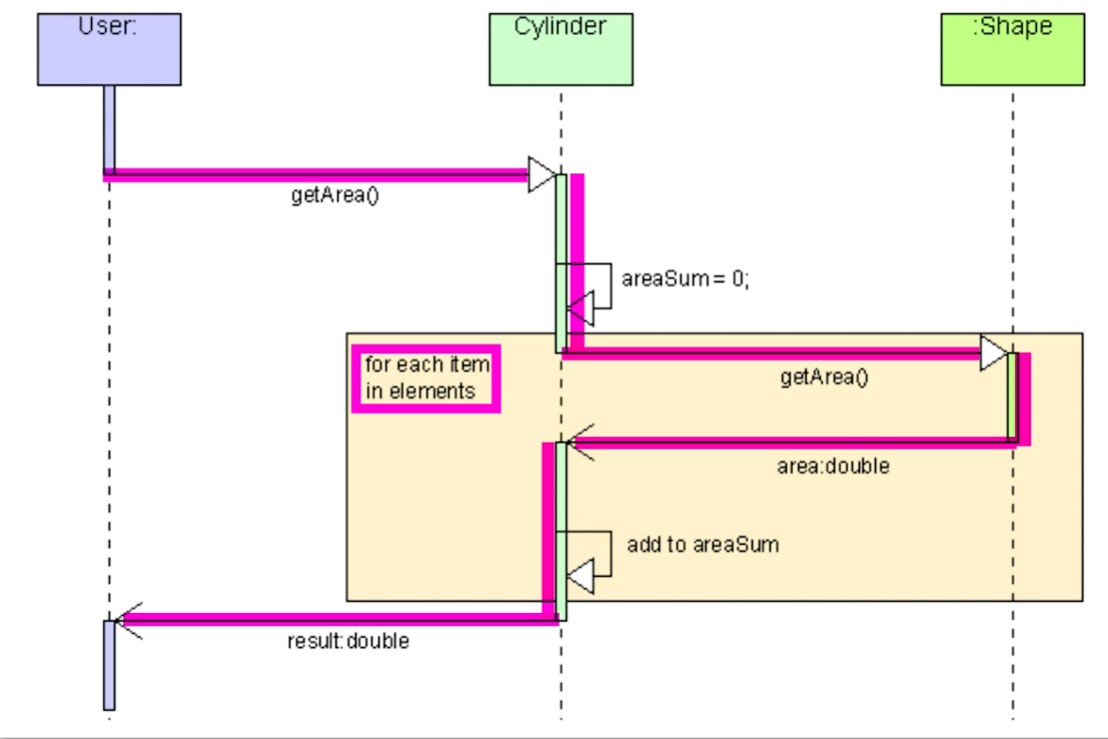

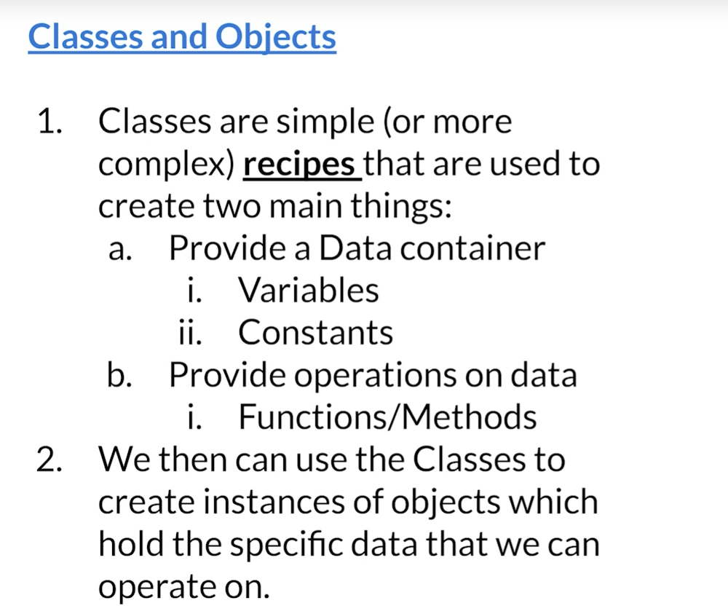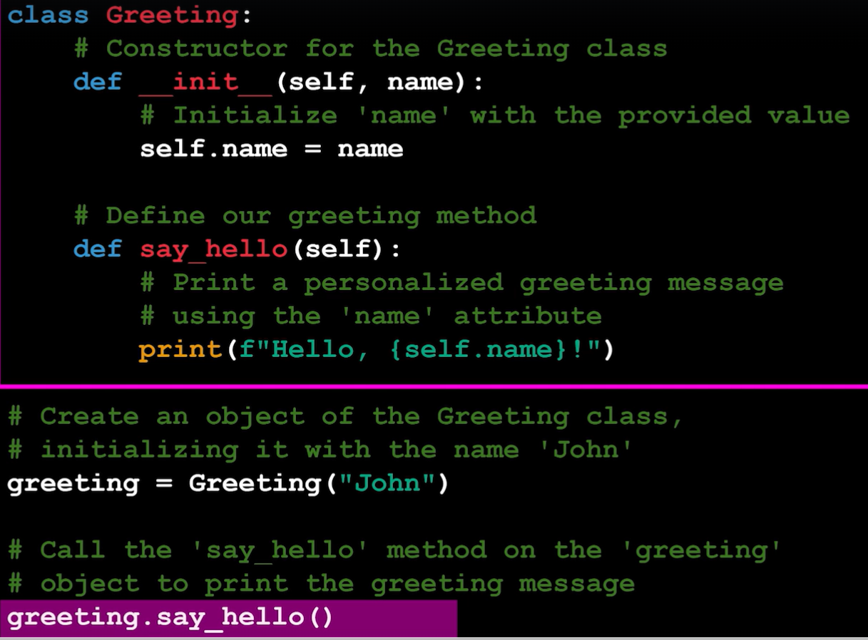

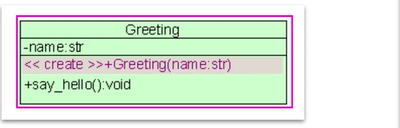

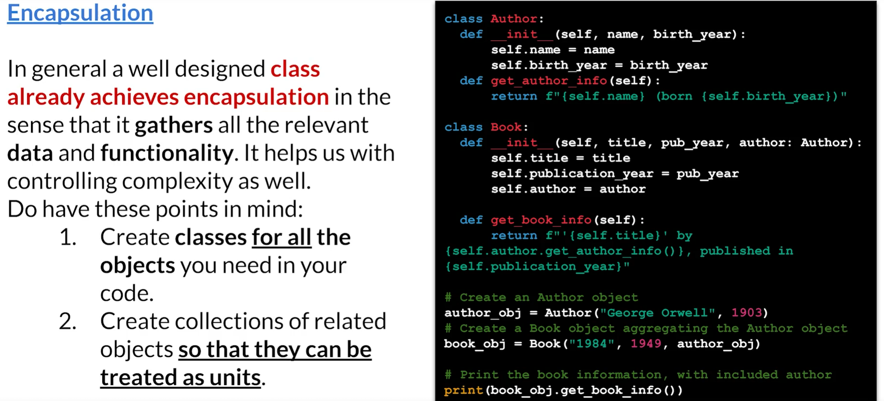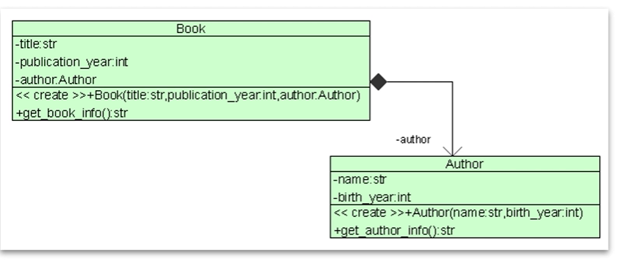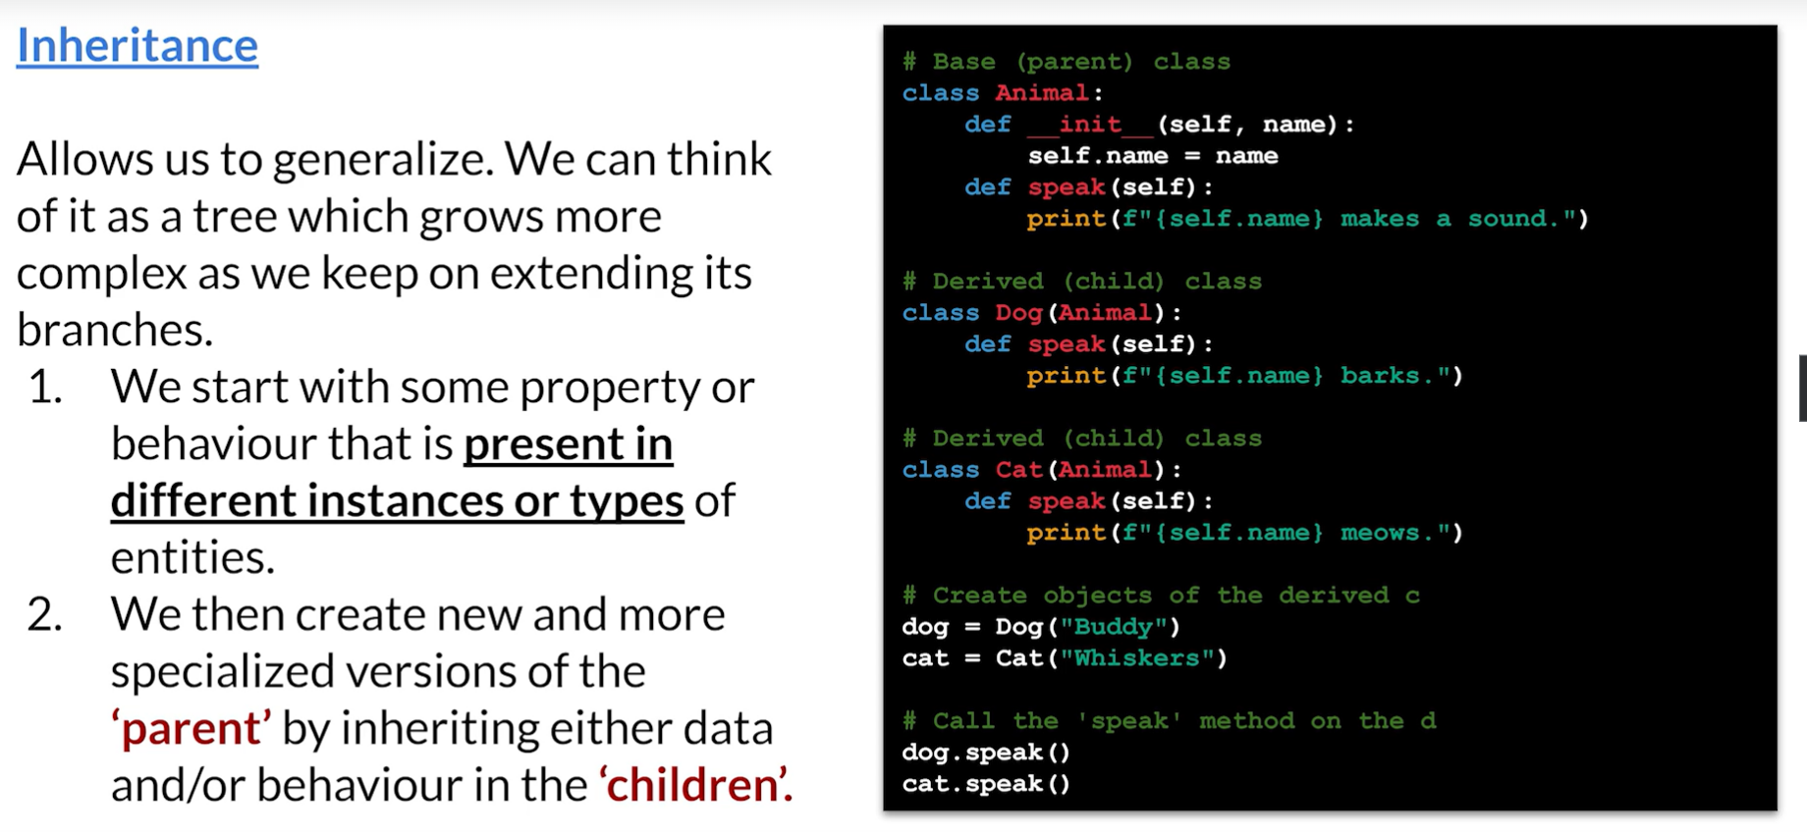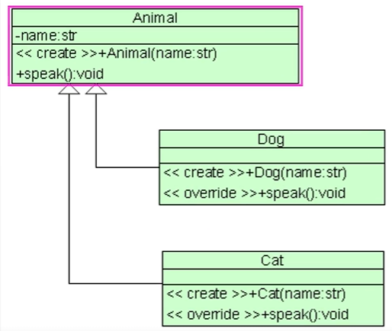

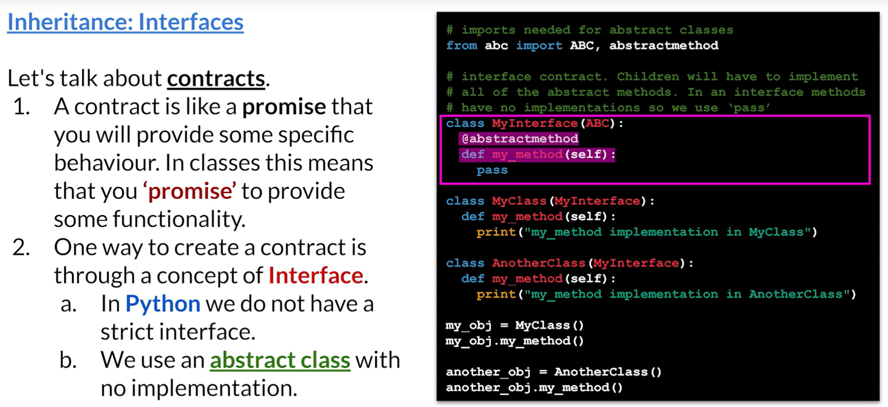

MyClass inherits MyInterface, which promises that there is going to my_method() in MyClass.

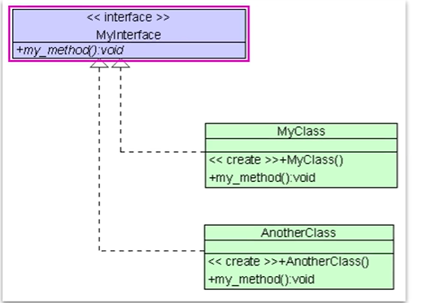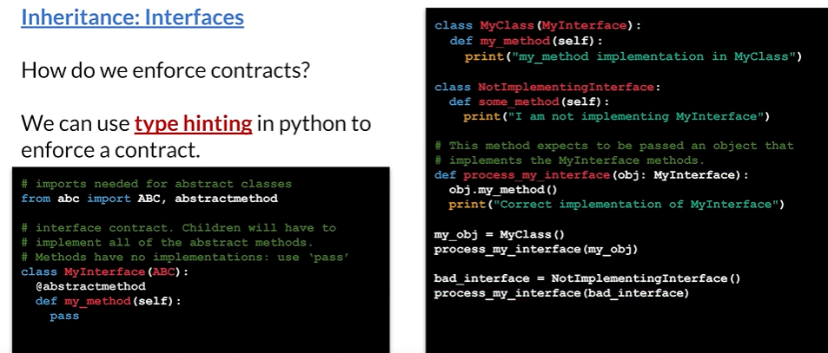  
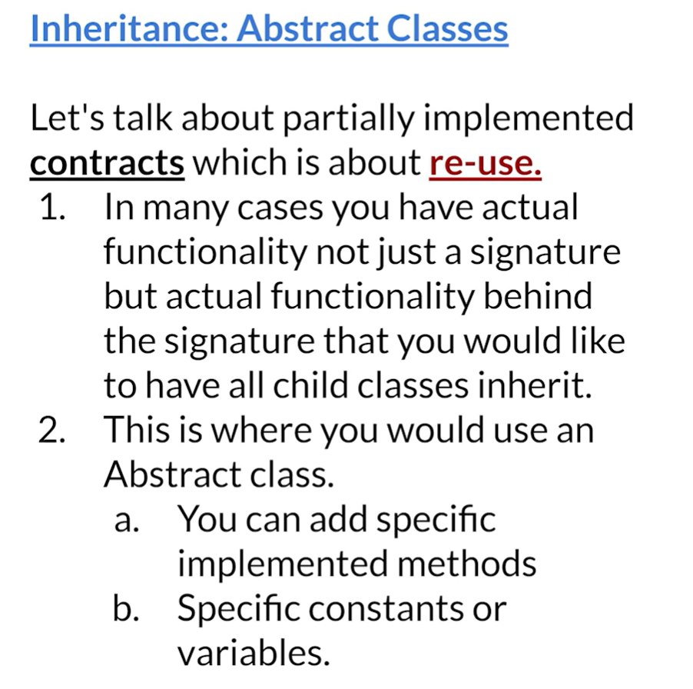

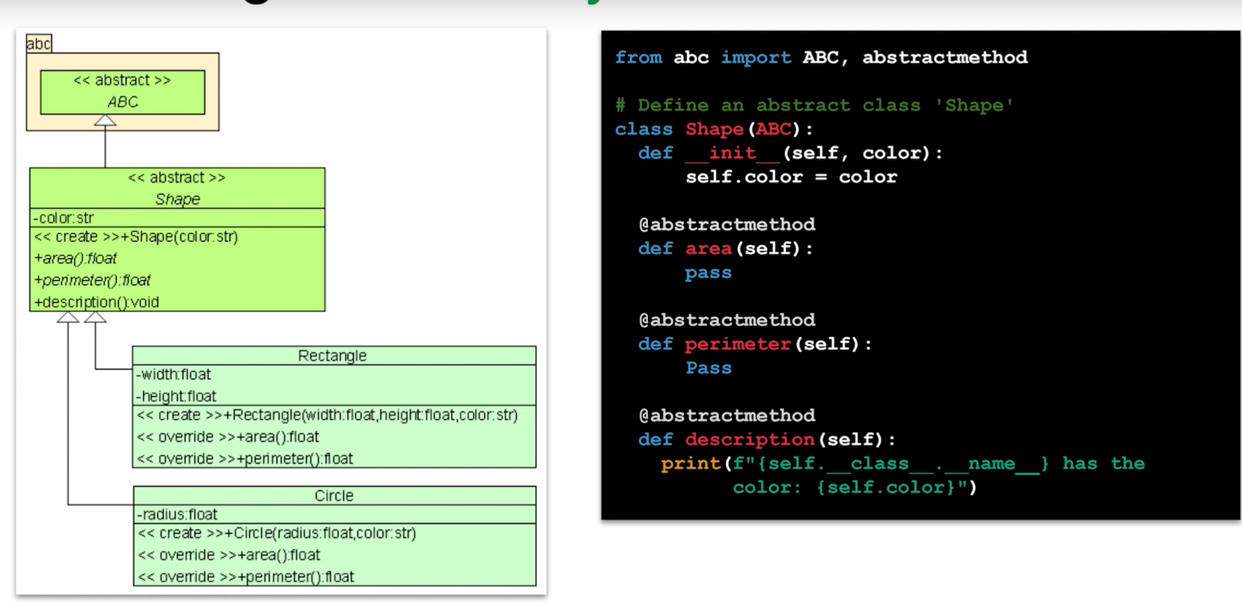

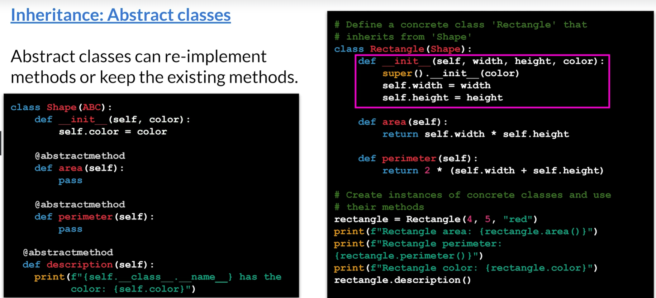

Abstract class is somewhere btw the Interface and Fully Implemented Class.

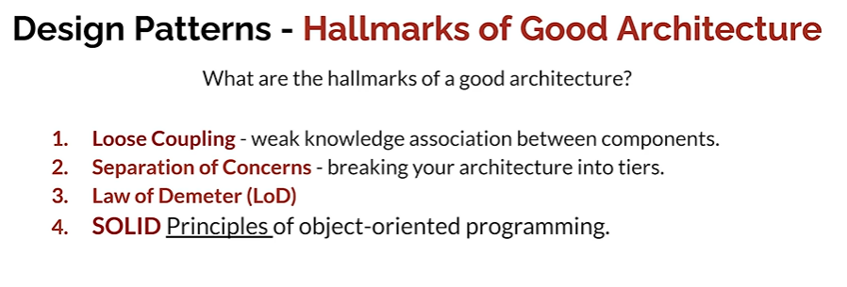

Loose Coupling

Here is an example of the different inter communication channels that these classes use. As you see, it's a lot. Here's a very similar diagram, but it shows the classes with a much cleaner route of communication.

The one on the left is an example of tight coupling.The one on the right is an example of loose coupling.

Changes to one component least affect the existence or performance of another component. So when you look at the diagram on the left and you look at the diagram on the right, you can definitely see that any changes to Class B when it's loosely coupled affect less classes than it does when it's tight coupling. And of course that means changes to testing, changes to documentation.

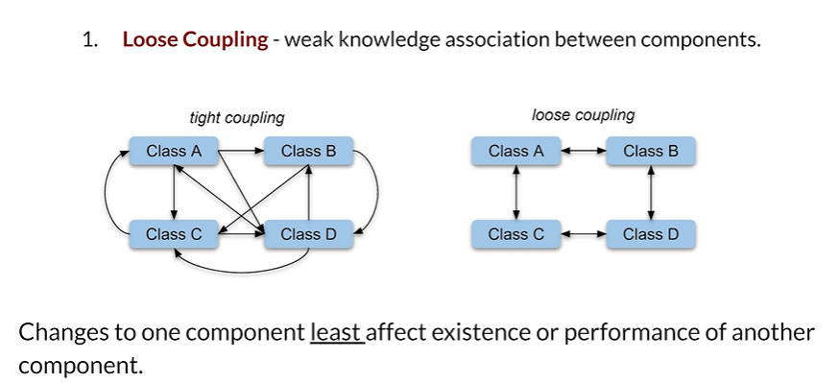

Seperation of concern

Breaking your architecture into tiers.

What does that mean?

Well, that basically means that you structure your architecture around main tiers of functionality.

You can have, for example, a presentation layer.

It could be your web UI, it could be your mobile UI.

You would also have a business layer.

That is where you have a lot of communication happening, deciding what is it that the user through

the presentation layer, what is it that they want?

And then you would have a resource access layer which would be data access layer.

So as you see, we have split our architecture into three separate tiers the presentation, the business

and reading and writing the data, the separation of concerns is achieved using modularization, encapsulation

and arrangement in software layers.

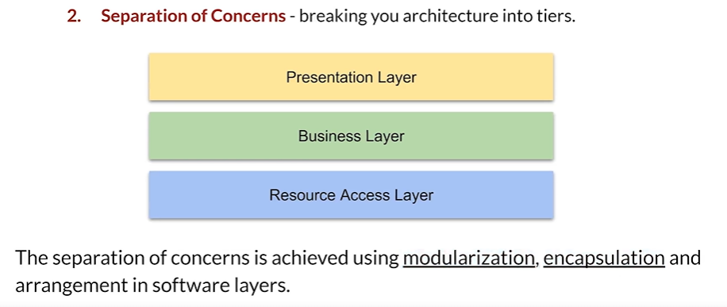

Law of Demeter

First, each unit should have only limited knowledge about other units.

It should only know about units closely related to itself.

Each unit should only talk to its friends.

It should not talk to strangers, and that unit should only talk to their immediate friends.

So let's have a look at three classes.

We have A, B and C, and let's say that A can talk to B and B can talk to C, We can basically say

that B is a friend of A, but C is a stranger to A so A can communicate with B, that makes sense,

but A should not communicate with C, That's basically what law of Demeter states.

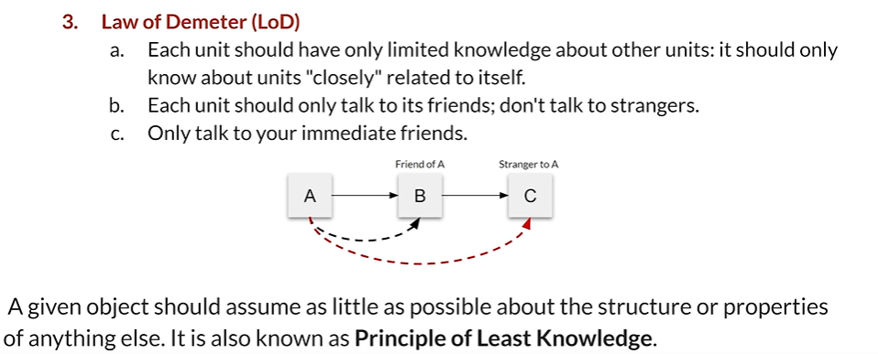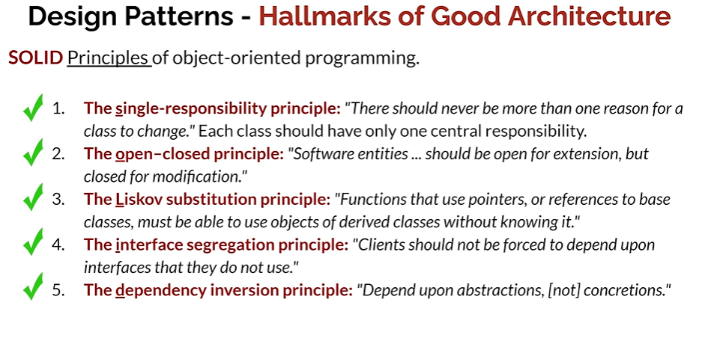

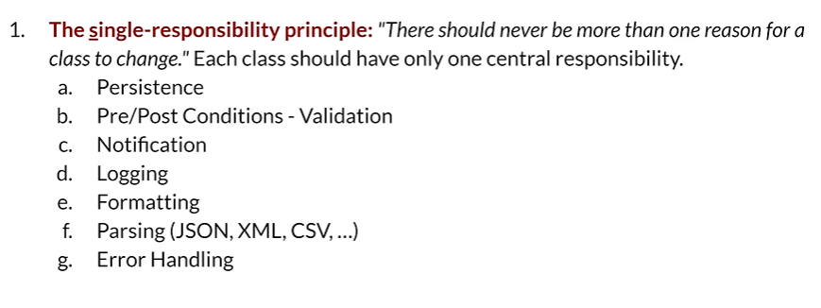

Each class should have only one central responsibility.

For example, it should only deal with persistence or it should only deal with pre and post conditions validation, in other words.

Or it should only deal with notification or only with logging or only with formatting or only with parsing or only with error handling.

The idea being that a class should not deal with any collection of these.

It should specialize in one thing.



Let's say we have a simple calculator class and this calculator class has four methods or four functionalities. It can add, it can subtract, it can multiply and it can divide.

But imagine that somebody comes to you right now and says, Oh, but you know what?

I would like to have a business calculator or a scientific calculator.

What should you do?

According to the open closed principle, you should not change the calculator class.

You possibly already have code depending on it. What you should do is you should extend it.

You should create new classes that extend the calculator class.

So your loan calculator, which could maybe calculate some monthly payments or some future value of your mortgage, you just create a new loan calculator.

Same thing with a scientific calculator. If you want to add sine, cosine and tangent, don't put it into the original calculator class.

Extend it.

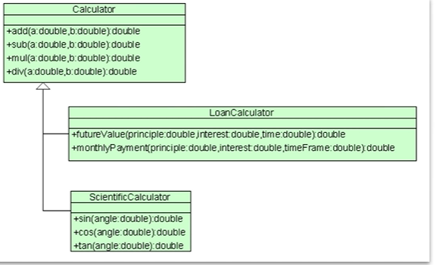

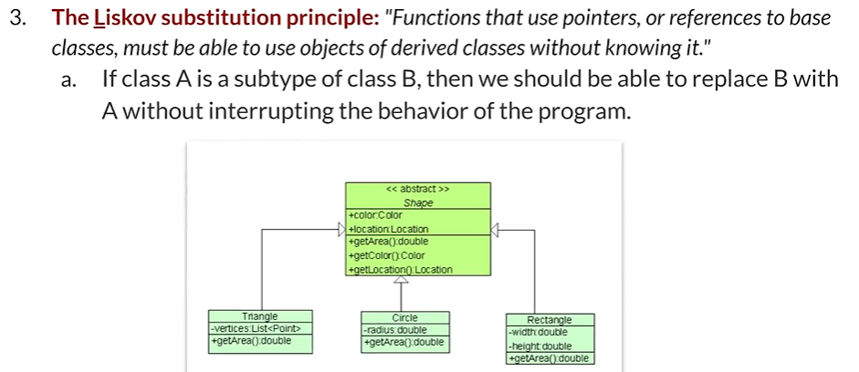

Functions that use pointers or references to base classes must be able to use objects of derived classes without knowing it.

For example, if class A is a subtype of class B, then we should be able to replace B with A without

interrupting the behavior of the program at all.

Here is an example.

If we create an abstract class shape and then we create specific concrete classes like triangle, Circle and rectangle. Any code that uses shape to get area doesn't have to know anything about the actual specific shape that it's using, whether it's a triangle or a circle or rectangle.

If I want to find out the area of something, all I need to do is ask for its area.

I don't need to know specifically that it's any particular shape. That would be the liskov substitution principle.

And you can see that the idea is that if I have code that for example, calculates all of the area of

all the shapes on the screen, and let's say that I add a new shape, some sort of an oval or maybe

a cylinder, my code that calculates the area shouldn't have to change at all. If it changes, that means there's something wrong with your architecture. It shouldn't change because it is still a shape.

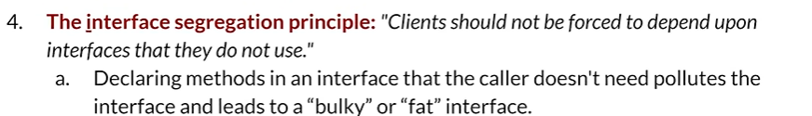

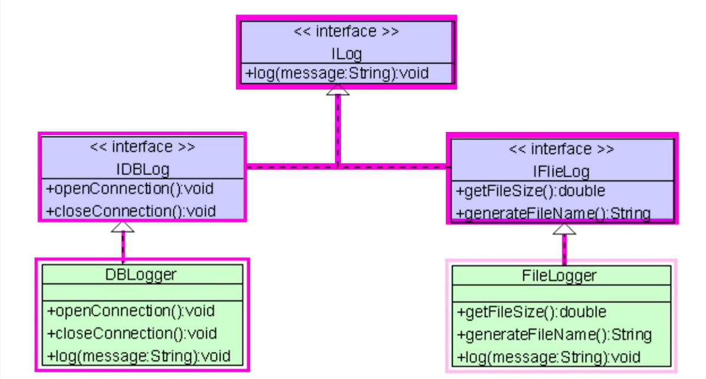

Clients should not be forced to depend upon interfaces that they do not use.

Declaring methods in an interface that the caller doesn't need, pollutes the interface and leads to

a bulky or fat interface.

Let's have a look at an example.

Let's say that I would like to create a logging functionality so I create an interface called I log.

Notice that the interface has only one method, which is log. So now what I could do is I could simply just create a DB logger automatically and I could create a file logger automatically.

But then I need certain functionalities like open connection, close connection, I could add, for

example, open connection to the I log interface, but then the file logger which would extend it,

wouldn't need it.

That's the problem.

If I put the open connection and the close connection inside I log the file logger would be using a

fat interface. It just doesn't need it. What we're doing is we're creating a generic log and then we're creating sub interfaces, ID be log and I file log, which allows us to specifically create two classes DB logger and file logger that use exactly what they need to use.

They don't have to use some extra methods or anything like that.

That is what the interface segregation principle is all about.

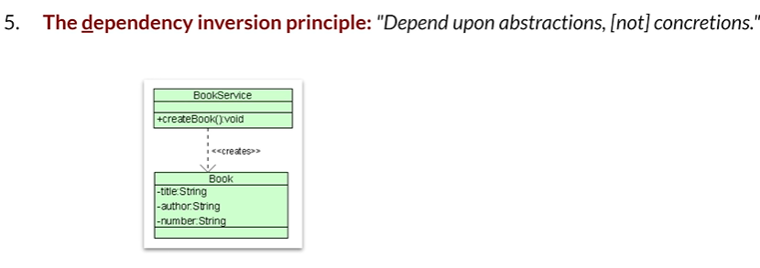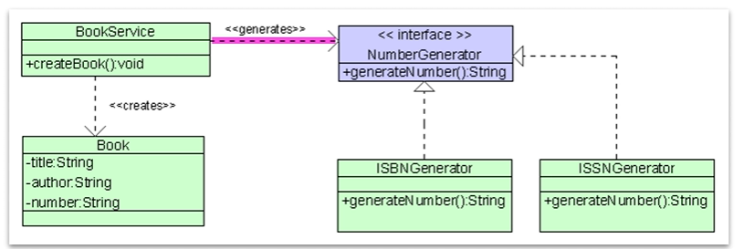

The last one that we have is the D in solid is the dependency inversion principle, which basically

says depend upon obstructions, not concretions.

Imagine that we have a book service that creates a book. So we have two classes, we have a book service class and we have a book class. The book has a number and this number needs to be generated. But because book service is the one that creates it, it would need to generate the number. Now, how would you do that?

The best way to do it is to have the book service use as an interface, which is an abstraction that

has a pretty generic method called generate number. Then whatever number needs to be generated. The book service doesn't need to know what it is. The book service simply wants to generate a number. So whether the actual number generator happens to be ISBN generator or an ISBN generator is irrelevant to the book service. That is the idea.

The book service depends on the number generator. It does not depend on the concrete elements.

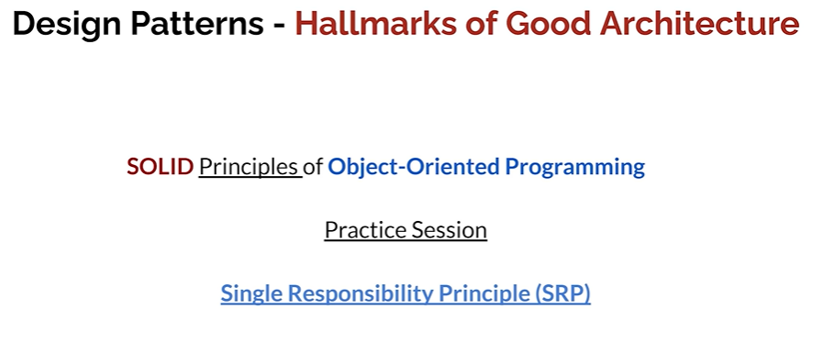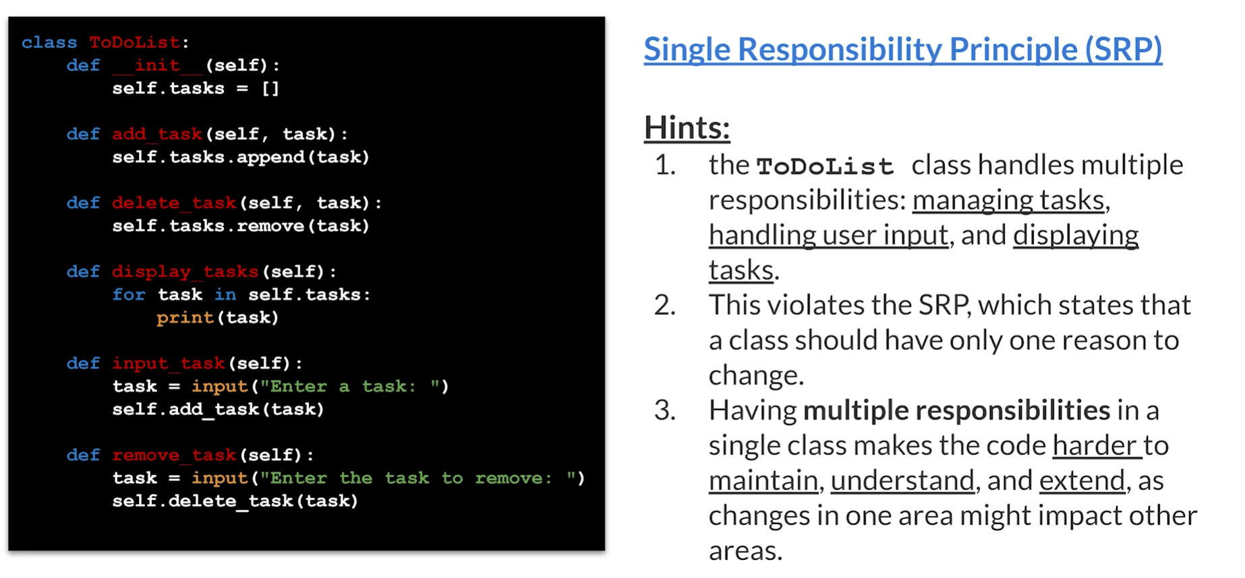

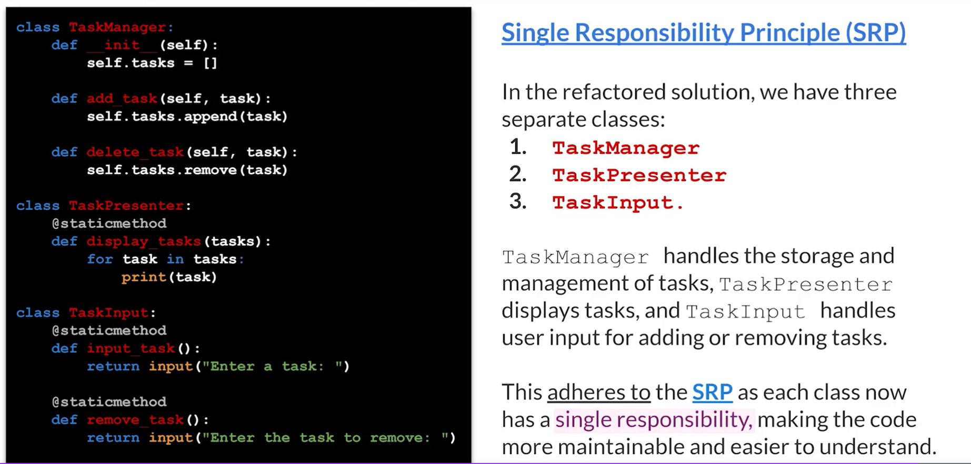

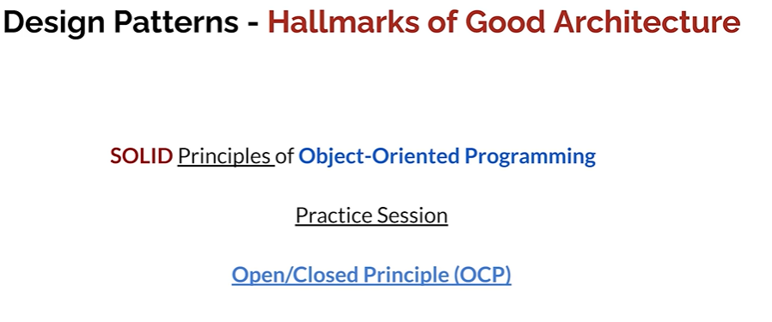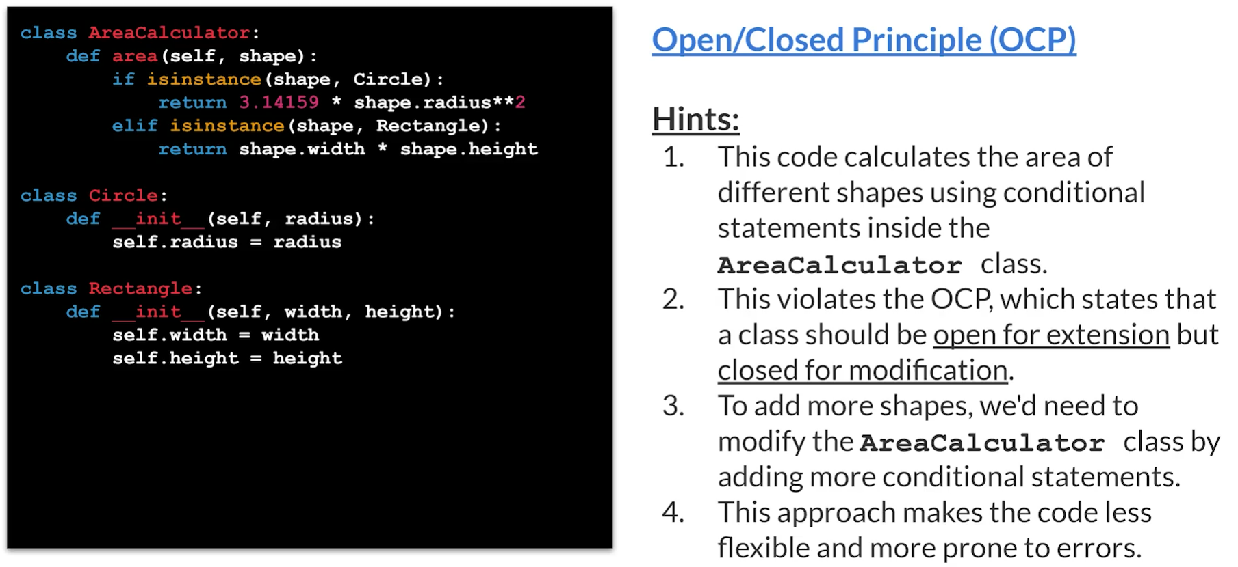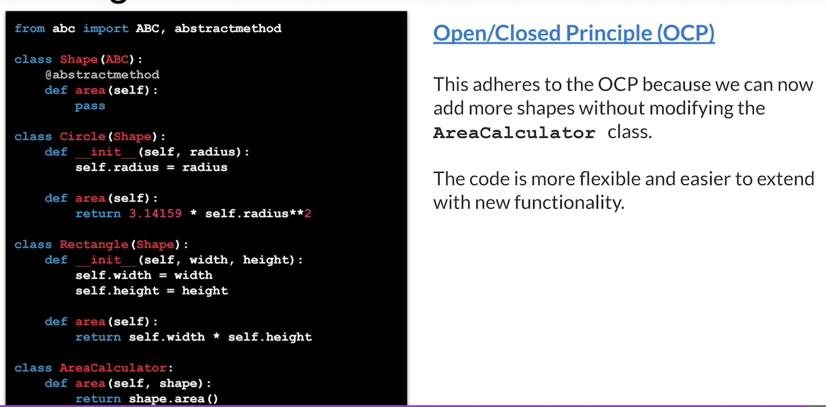

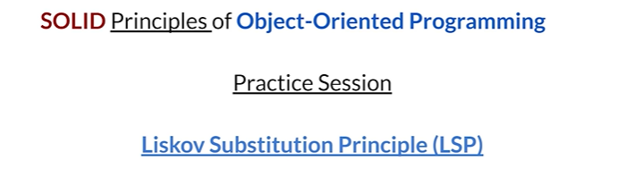

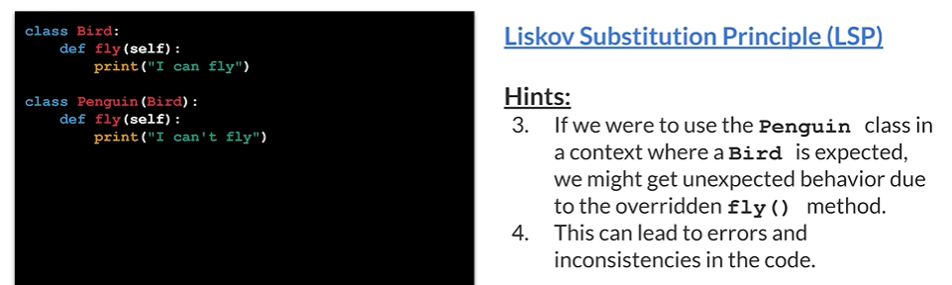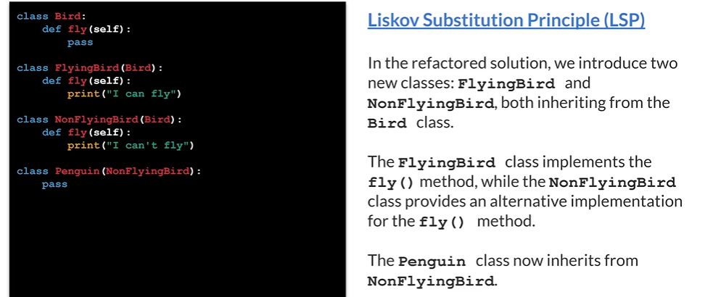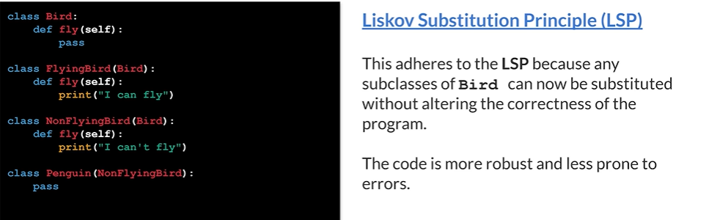

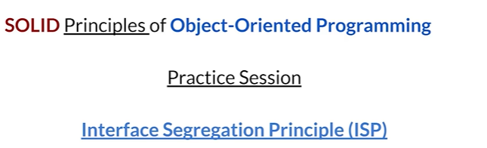

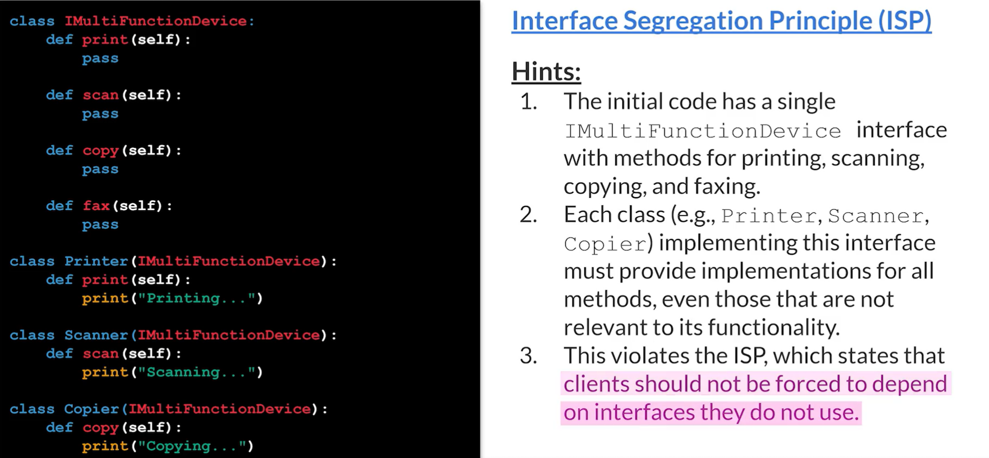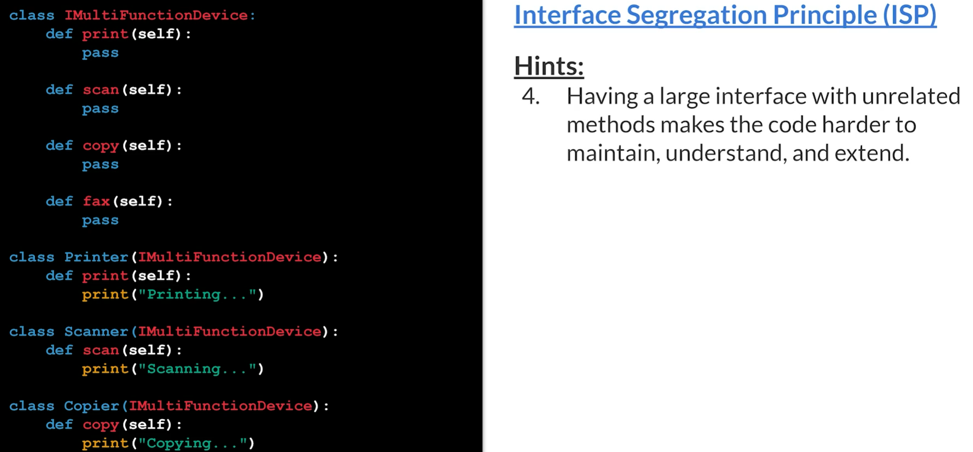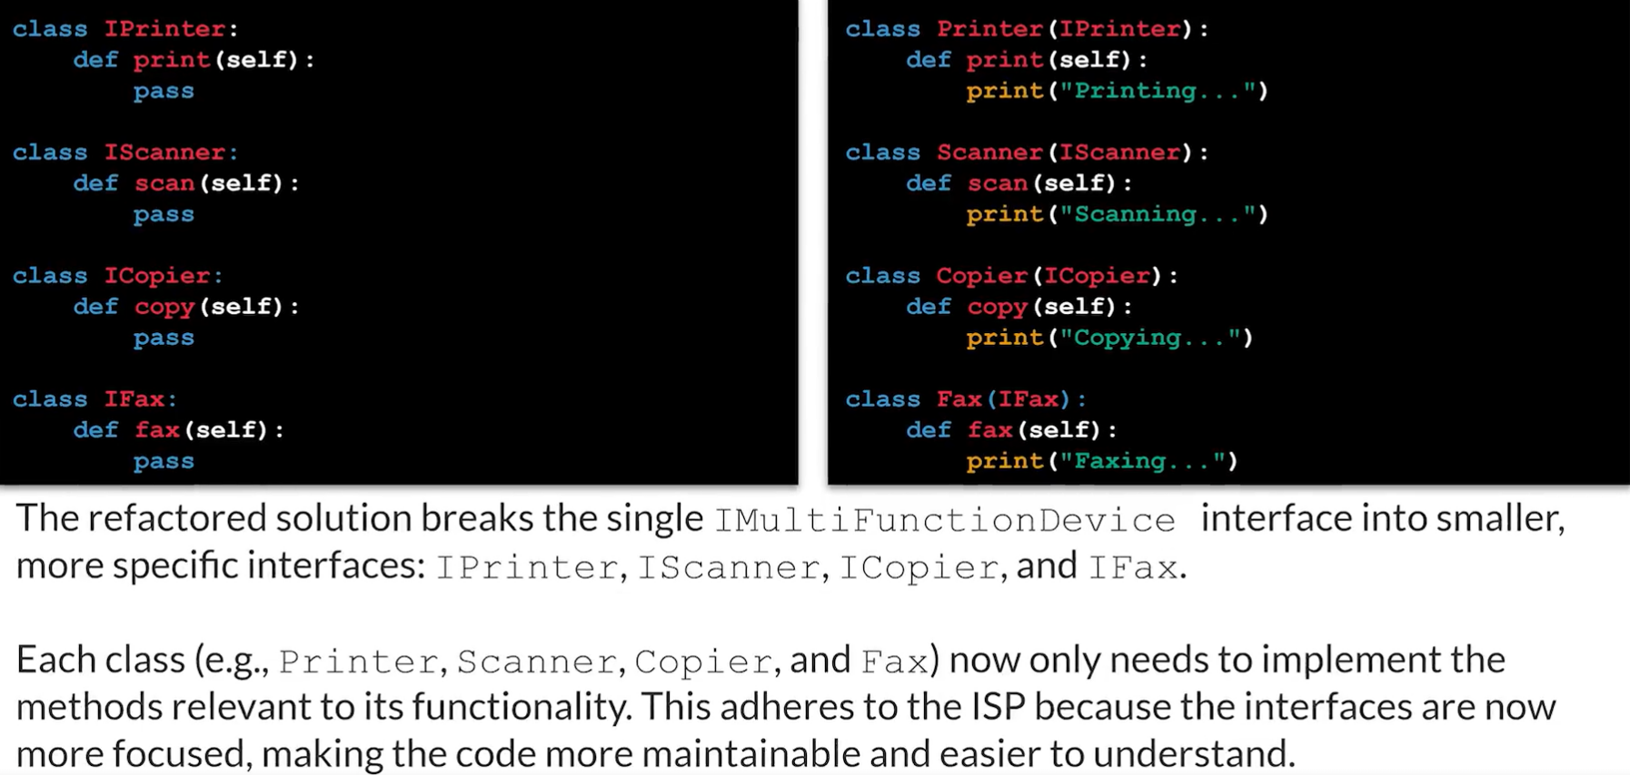

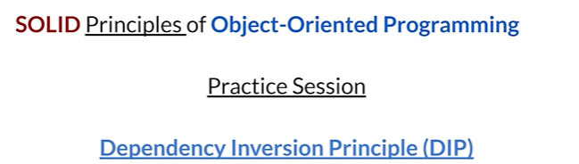

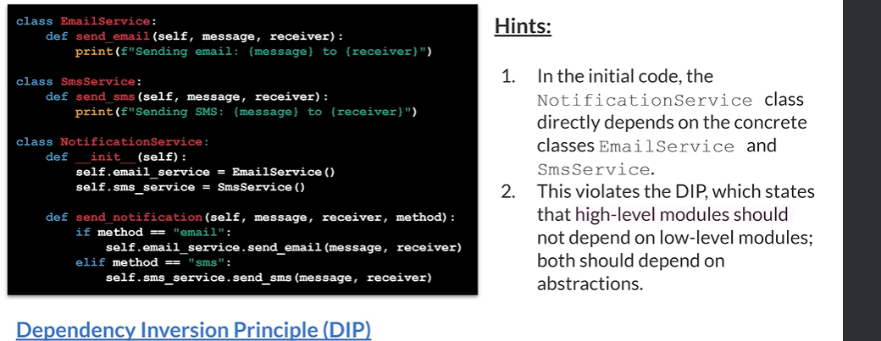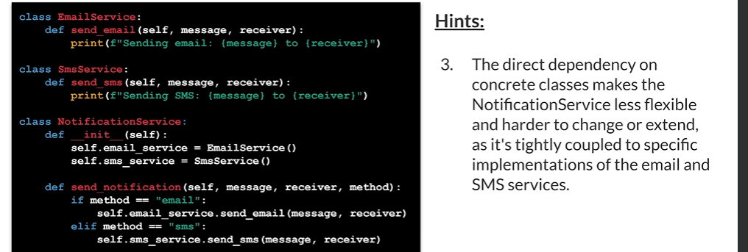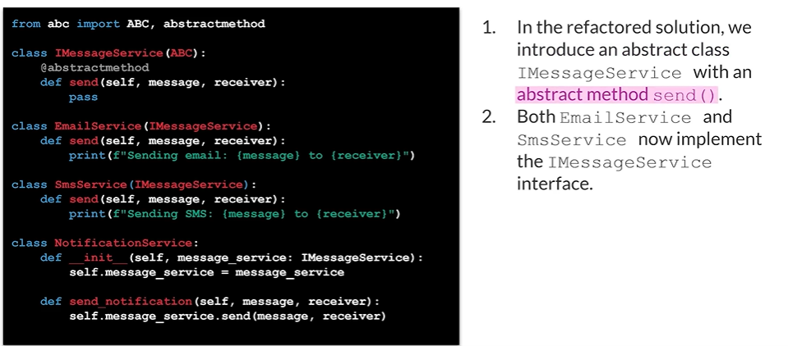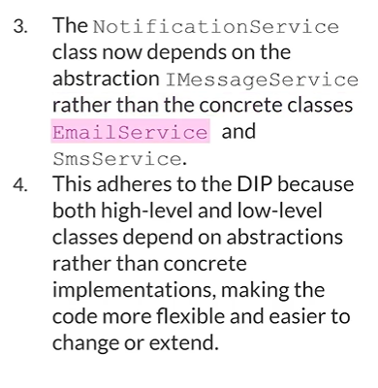

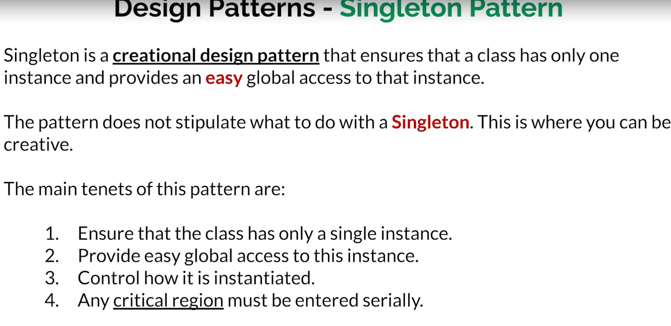

The last 4th point, if there is thread safety issue, ensure that clients are calling the singleton they are calling it one at a time.

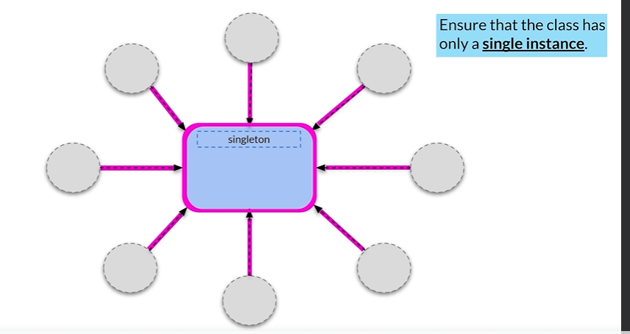

What Singleton Pattern Does? You have instance of singleton and number of clients.

All of these clients are going to access just a single instance. Just make sure that class has single instance only.

If one client goes to create singleton and another client in a different piece of code also tries to create the singleton, both of these instance will have to be the same one.

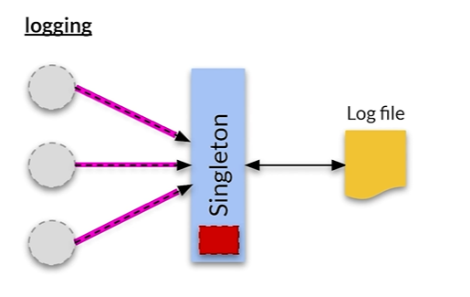

For example you are logging, no matter in your code, you are actually doing the logging, it should all be going to the same destination. So we have three clients and they all go into the singleton. That red box stands for a logger. The singleton logs to a singular log file. They are actually logging to the same log file from various clients.

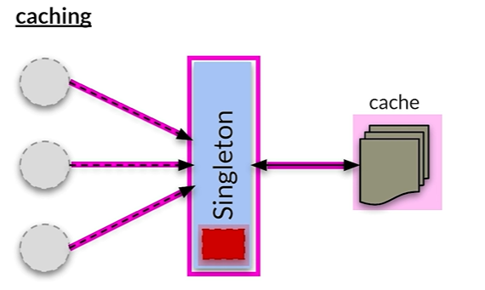

You have a singleton and all the clients are going to hit the singleton, check if there is anything in the cache. That red box stands for caching mechanism, that caching is wrapped inside the singleton. So all that the singleton does here is to ensure that all of these clients just access a single instance.

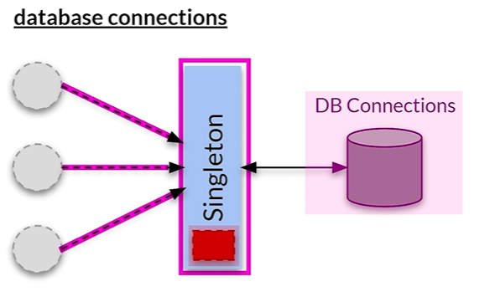

We have our DB connectivity and we have our clients and the clients are hitting the singleton and that red rectangle would be some sort of a database connection. 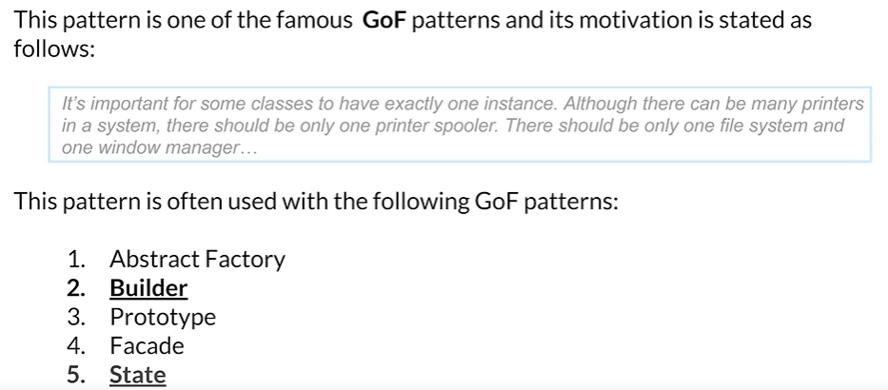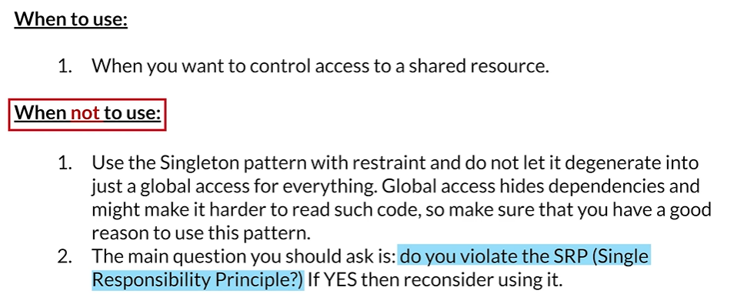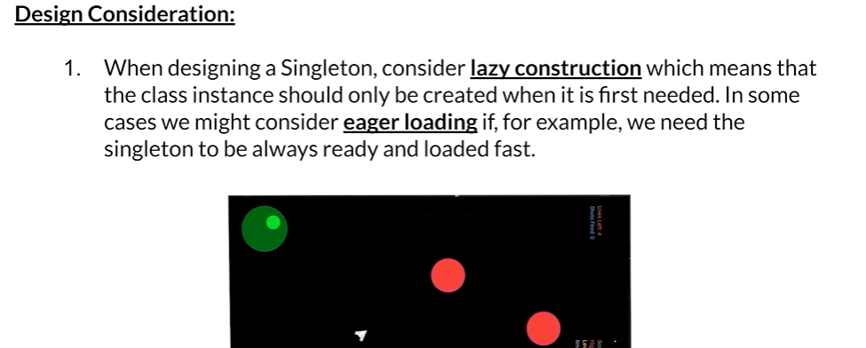

For example, if you're creating a game, if it's some sort of a shooting game, you want the sounds

of the bullets to be happening every time a bullet is fired. At that point, you would eagerly load the sound so that it would be ready the moment the first bullet is fired. Lazy construction or lazy loading would be when you're not 100% sure if a particular instance is going to be used.

So if you're not sure about that and you don't want to waste resources, then you can consider to load it only when it's actually accessed for the first time.

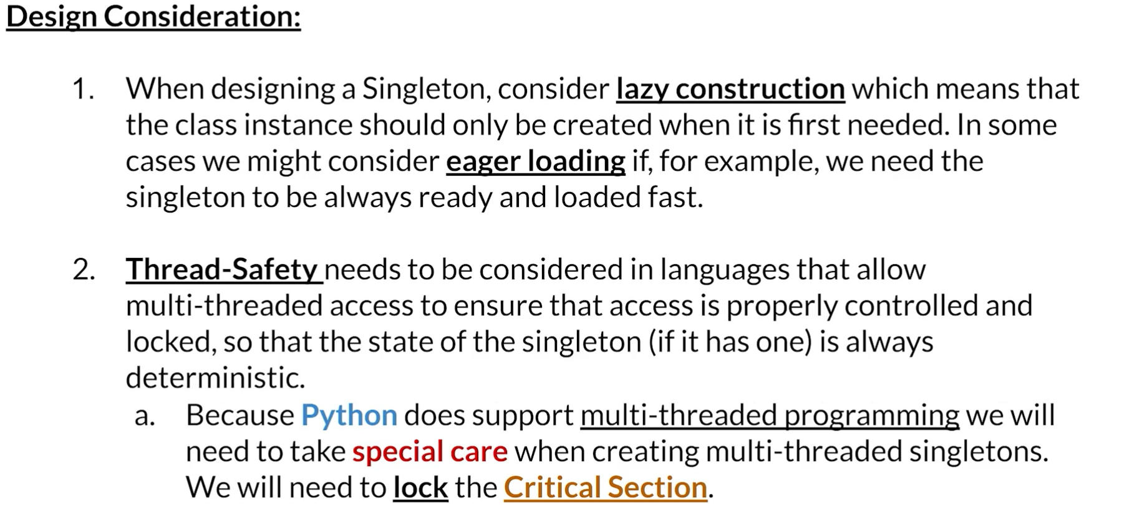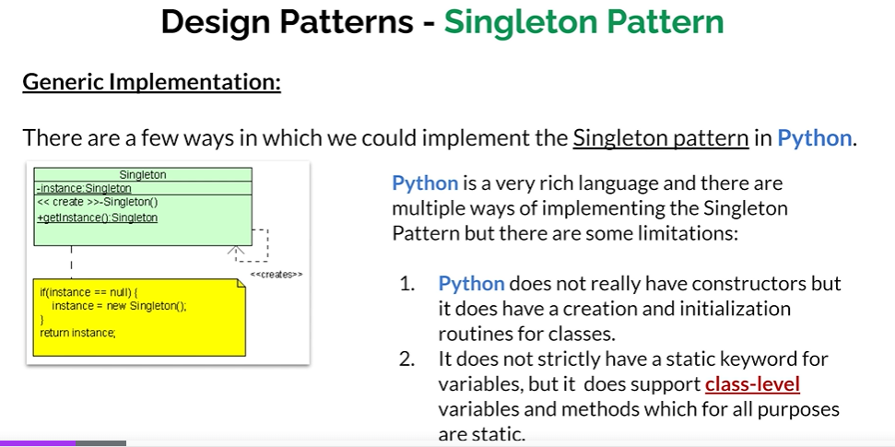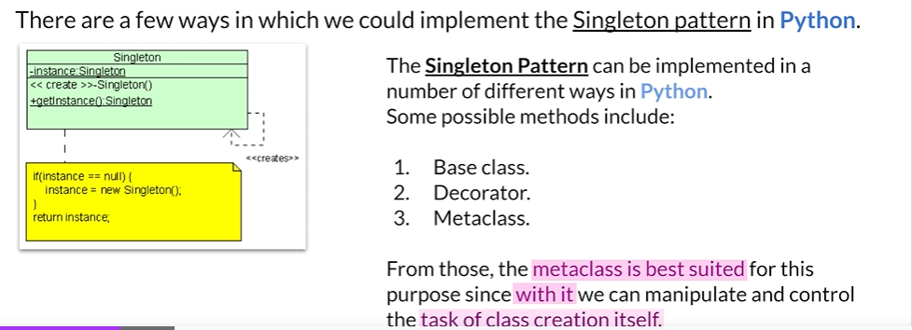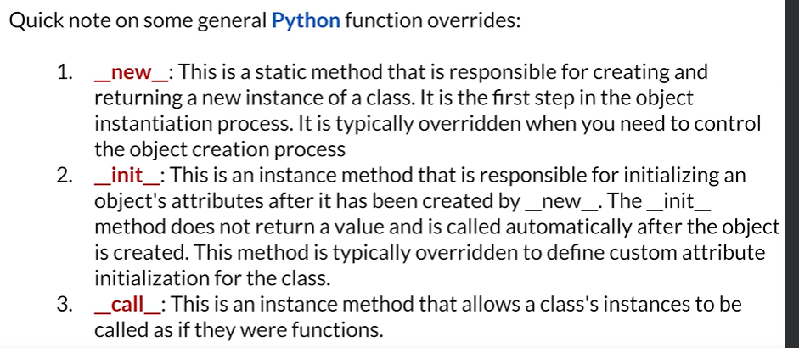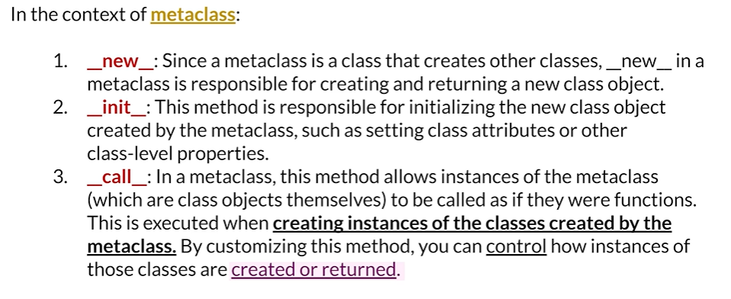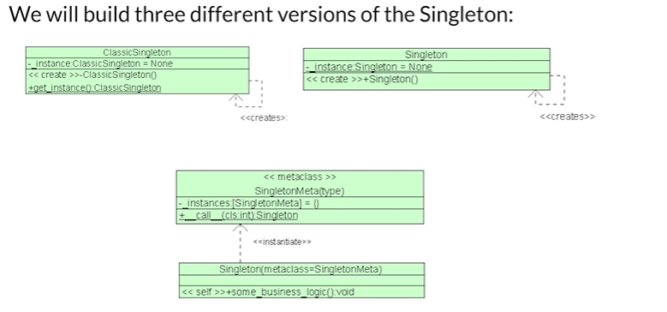

We are going create singleton pattern from good, better , best

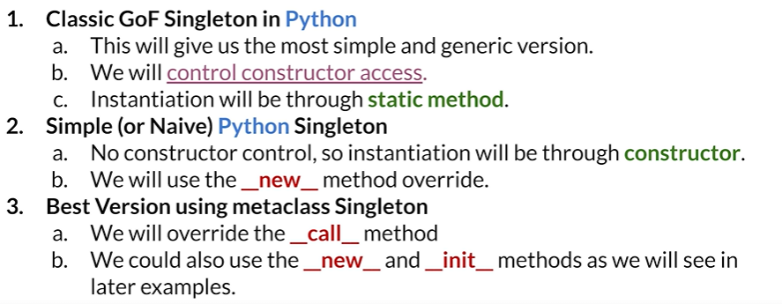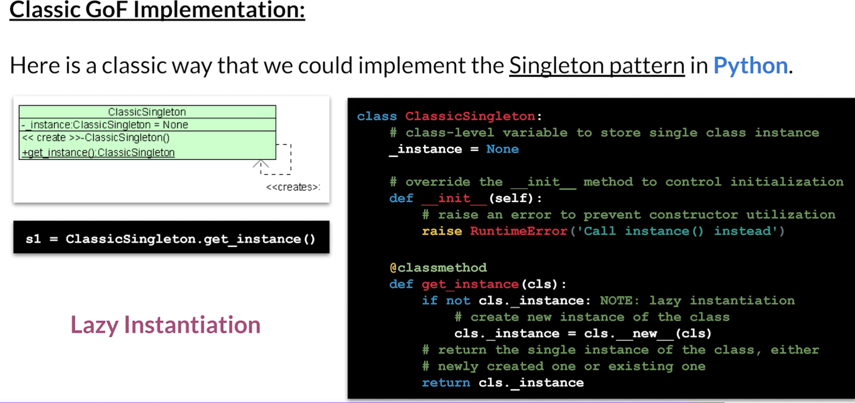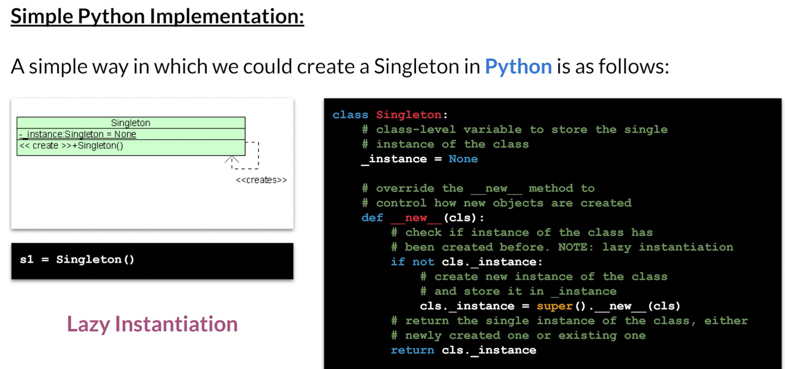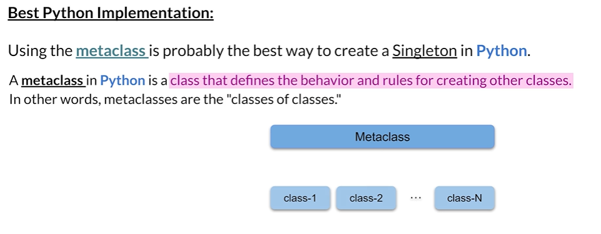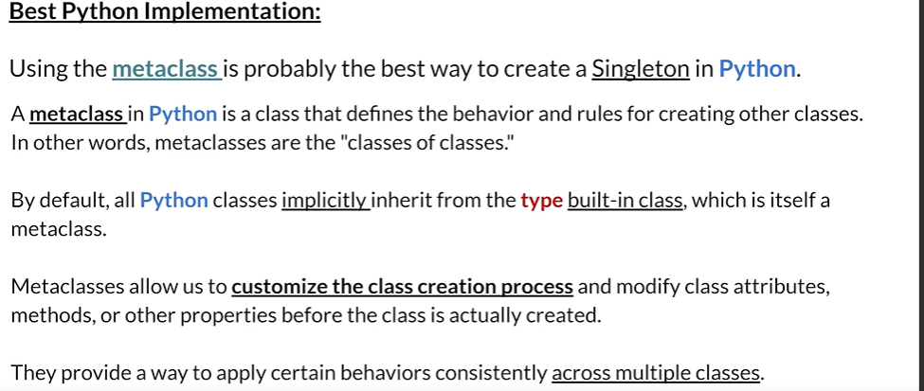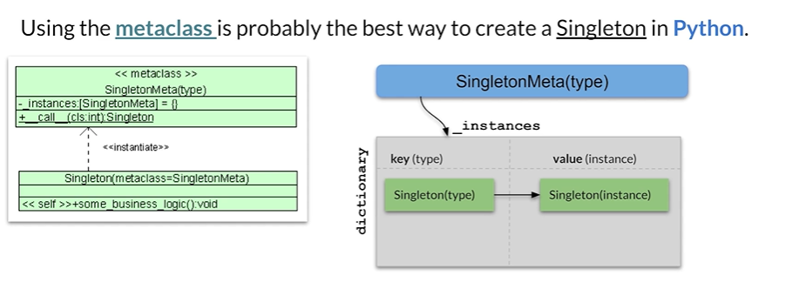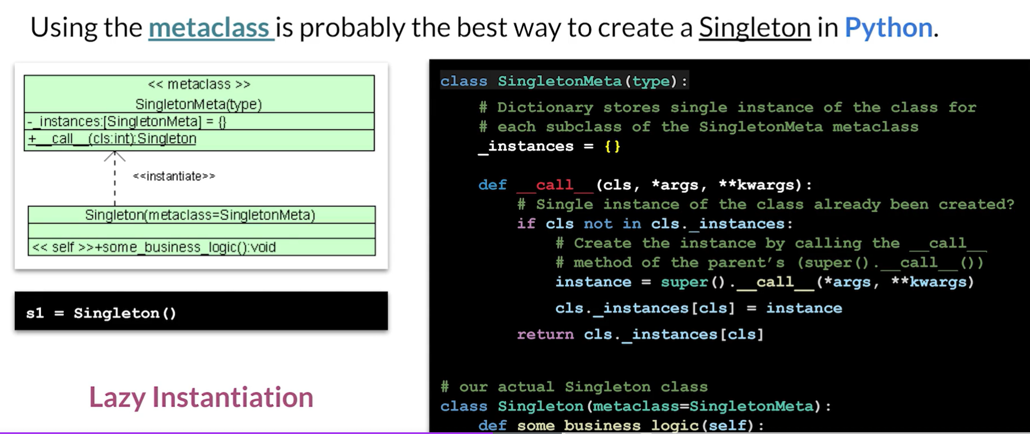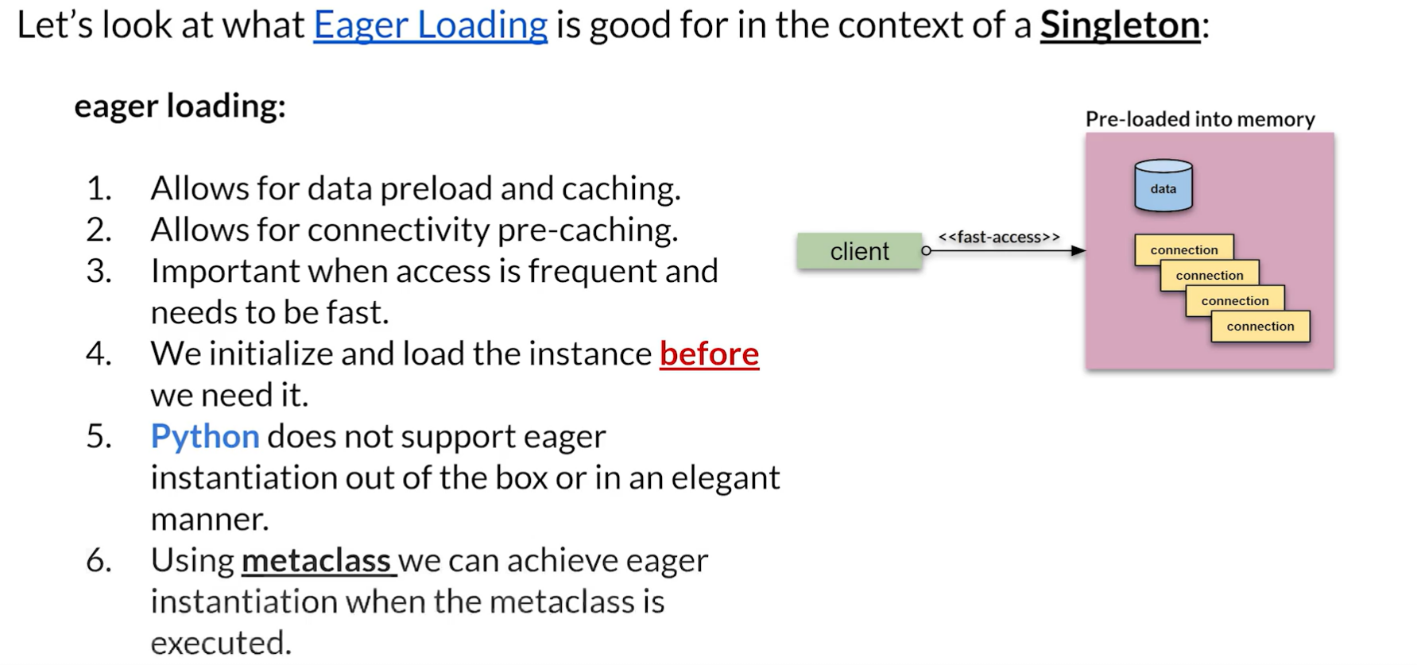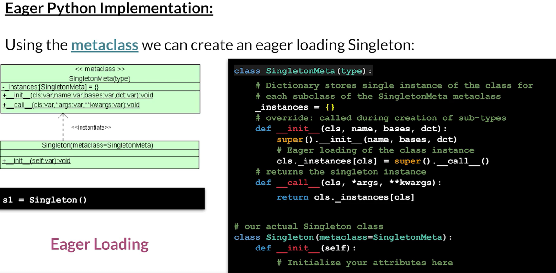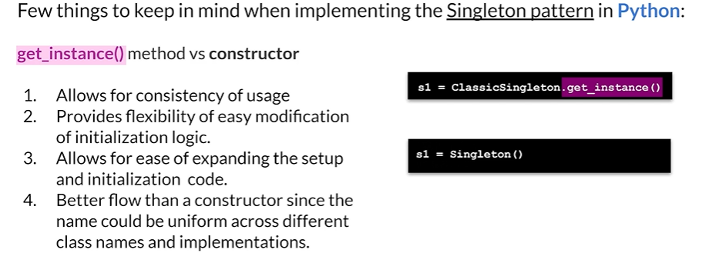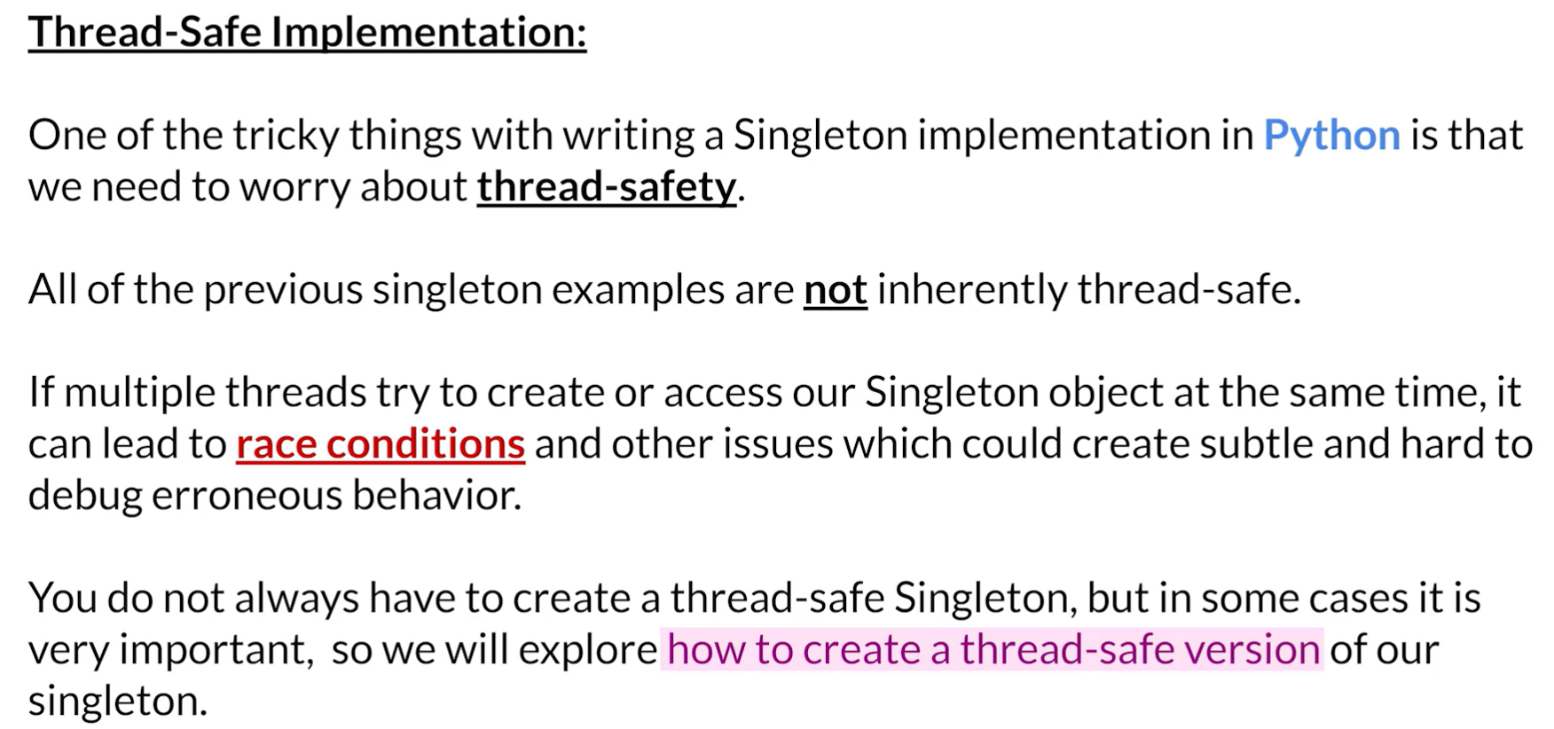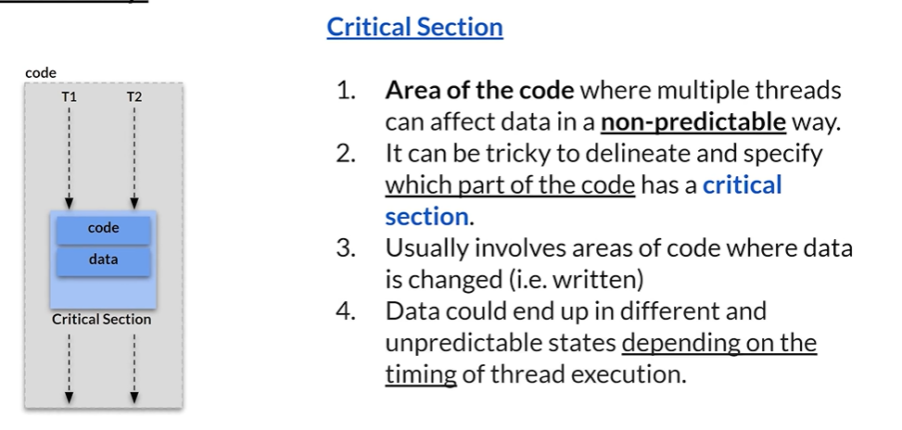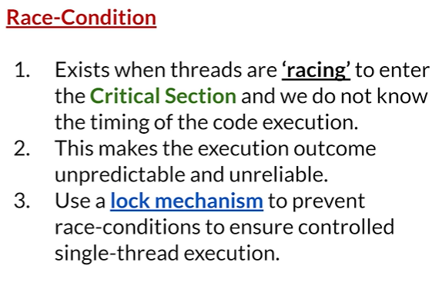

|  |  |  |
| --- | --- | --- |
|  | | We code, we have critical section and we have lock , A lock is basically used to protect our code from Race Condition.  So we have two threads come in before any one of those threads can go into the critical section. They have to go through a lock. |
|  | | One of them is going to acquire the lock. It will hold onto the lock which means that is the only one ALLOWED inside the critical section. |
|  | | Here T2 is put under the waiting queue.  As long as T1 holds the lock, T2 is going to wait to enter the critical section. |
|  | Assume that T3 comes, as it has go through the lock, it will also be put inside the waiting queue.  So now what happens is that eventually T1 is going to be done and it's going to go outside of the  critical section and it's going to relinquish or give back the lock.  So then what happens is the queuing mechanism is going to take T2 out of the queue and it's going  to give it the lock and it's going to put it inside the critical section.  So as long as we know how to create such a lock, we can protect the critical section from any kind  of race condition issues. | |

Let's say we are creating a class called counter and this counter class is going to do a very simple

thing.

It's going to take a piece of its data and it's just going to add one to it.

We initialize the counter itself to zero.

We also initialize lock to lock class variable.

And then what happens is we have a method called increment.

This method will be our critical section.

What we do now is before we change our count data, we acquire a lock.

That's the part that you've seen where the two threads came in and only one of them is guaranteed to acquire the lock. We don't necessarily know whether it's going to be T1 or T2.

The problem is not basically which thread gets access.

The problem is just that only one gets access.

That's the important thing.

So if two threads are going to call this, only one of them is going to acquire the lock and the one

that acquires the lock will be able to then execute self dot count and add one to it.

That part is the critical section. Once it's done with it, it will then release the lock when it does that, another thread that was waiting could go in.

So this is simple. An example of a thread safe code in Python that protects a critical section or a critical section here happens to be just one item of data which is count.

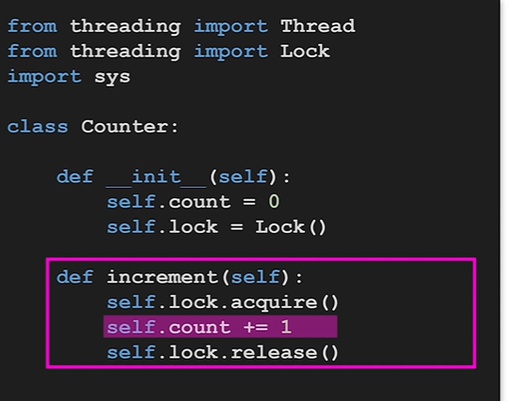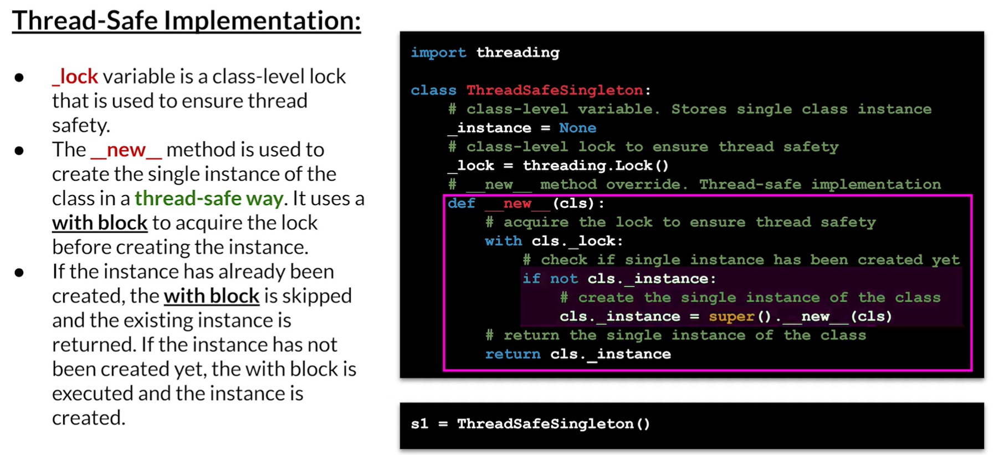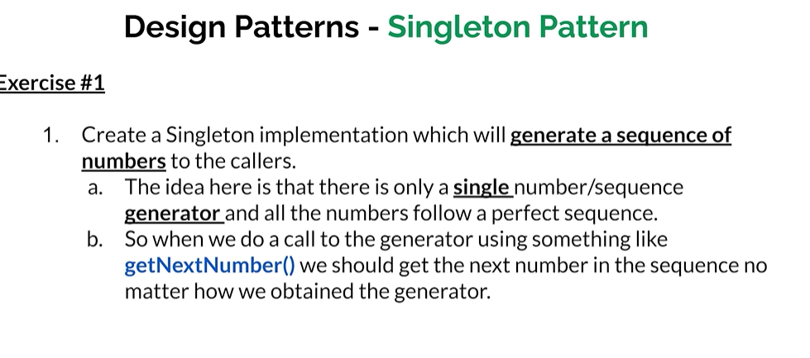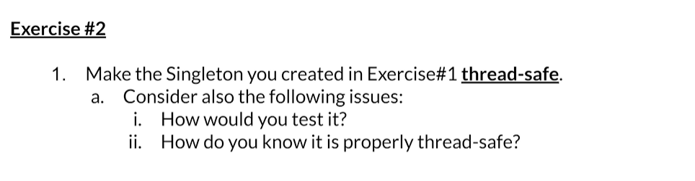

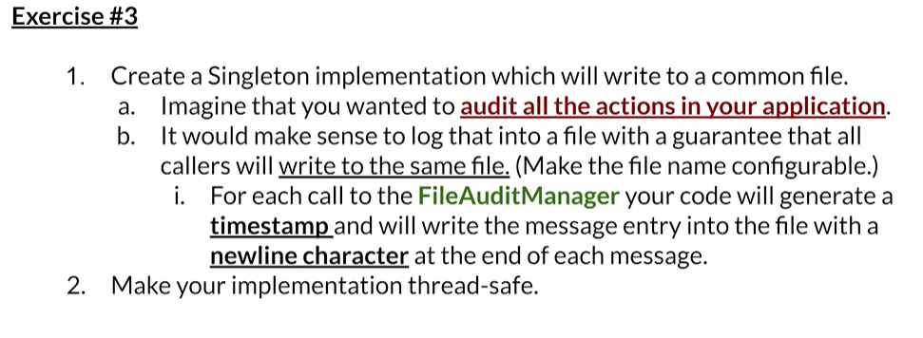

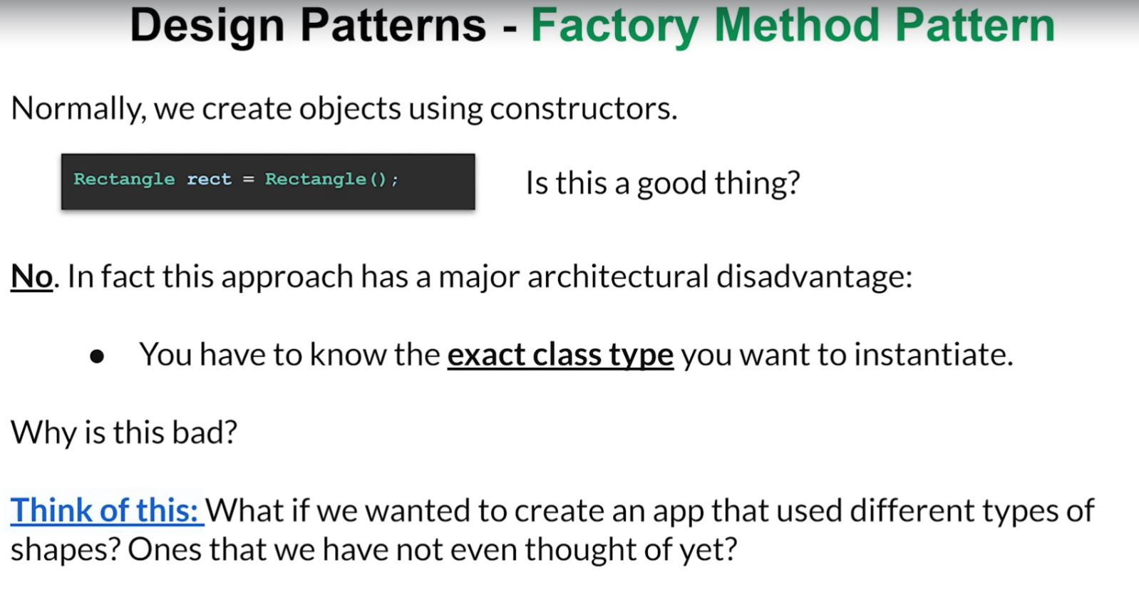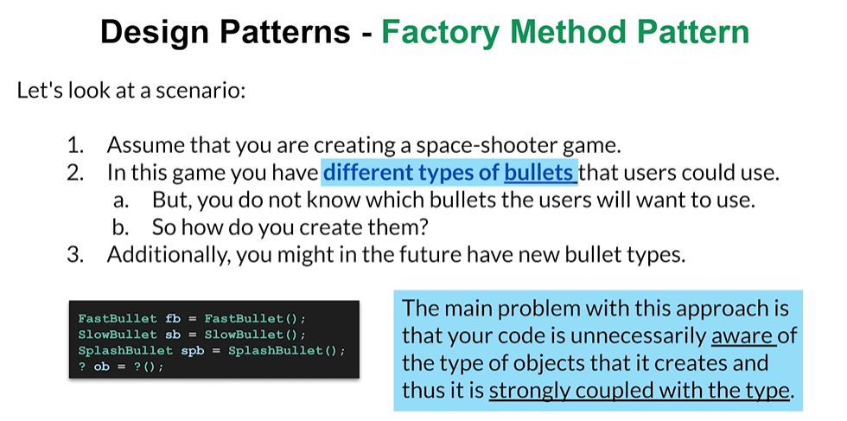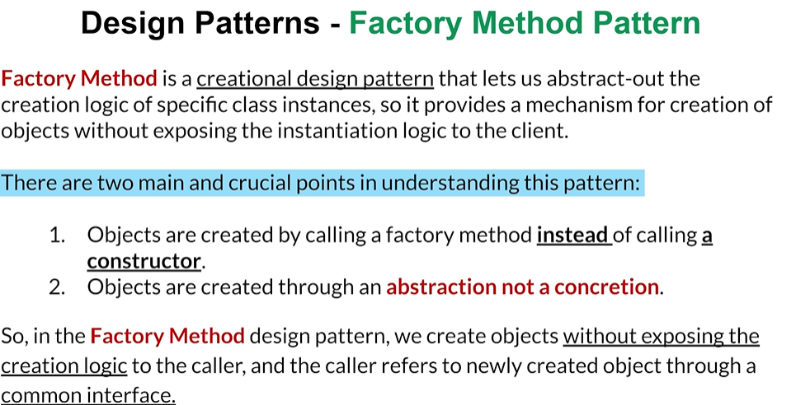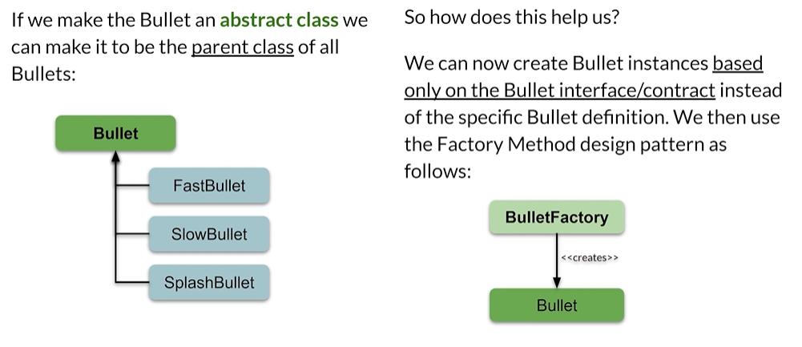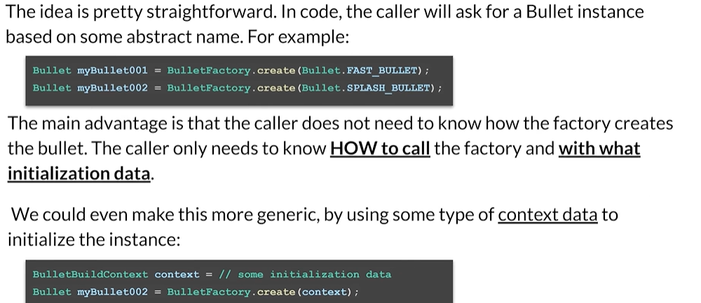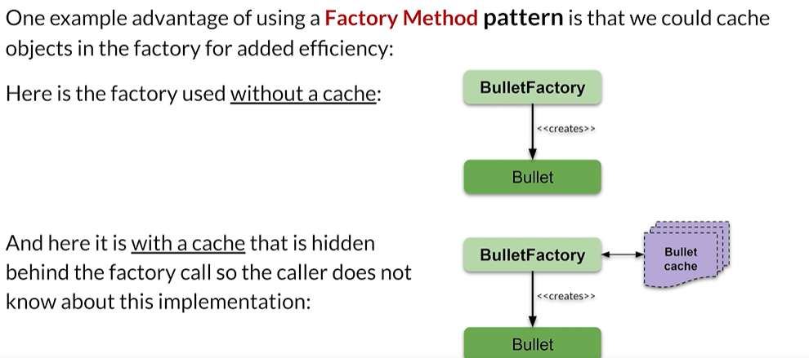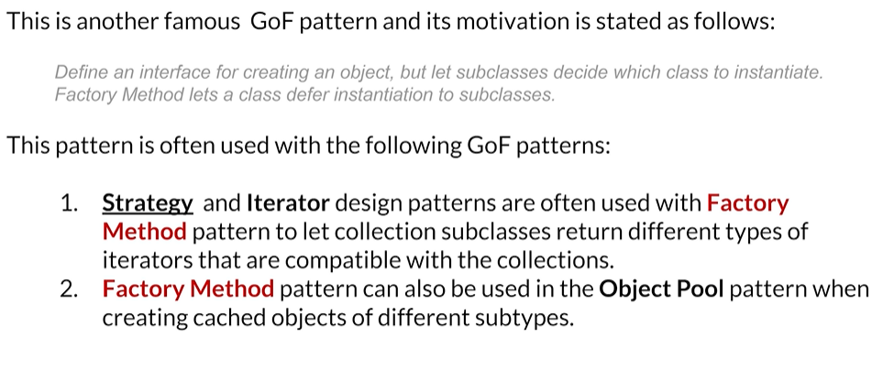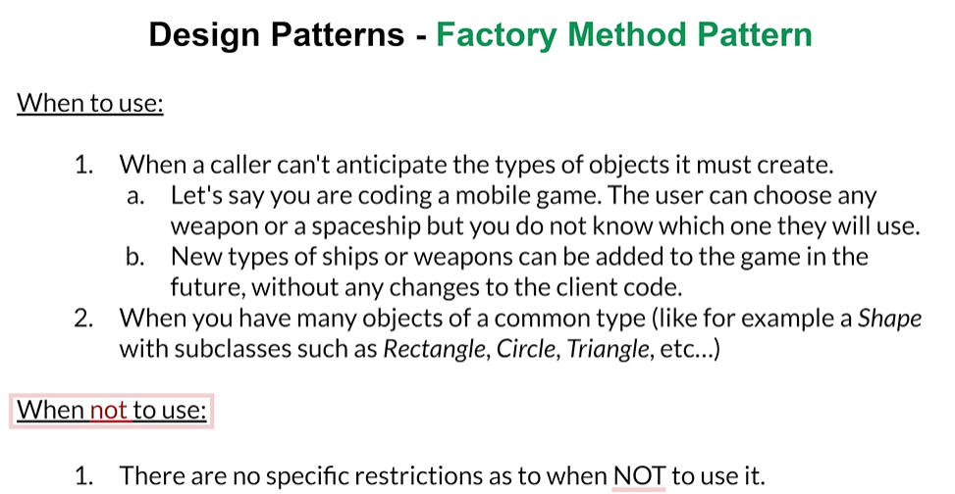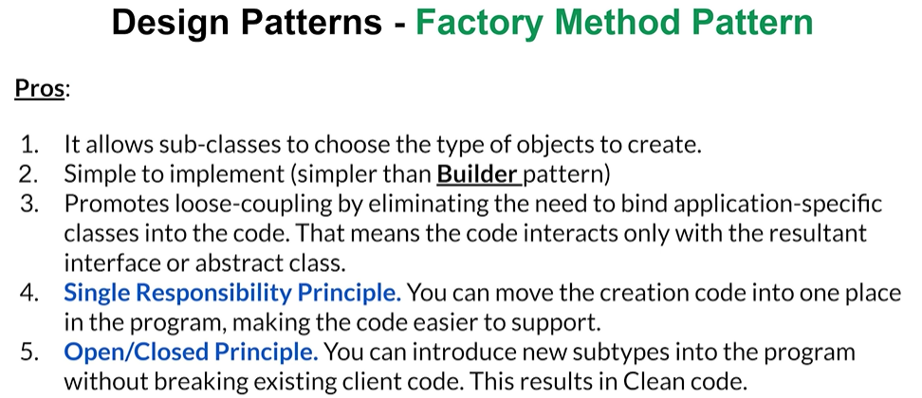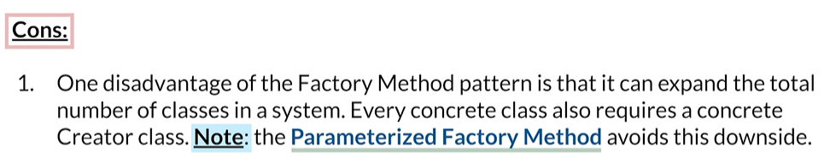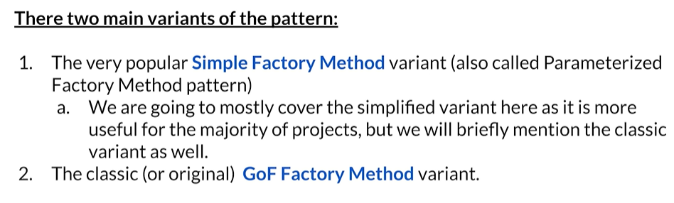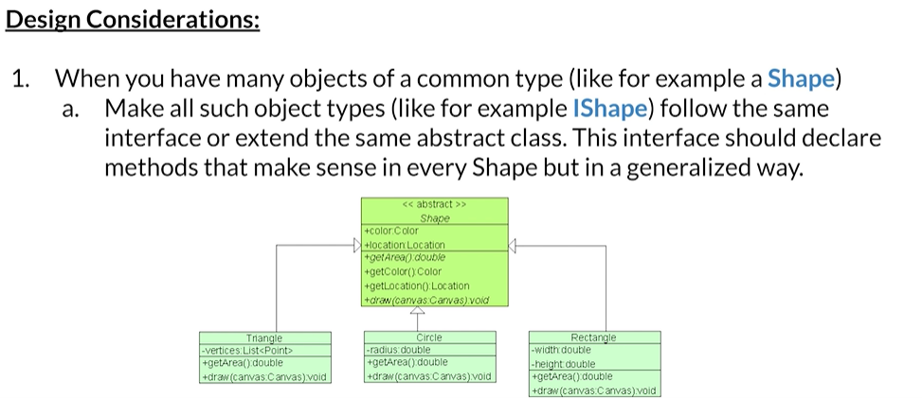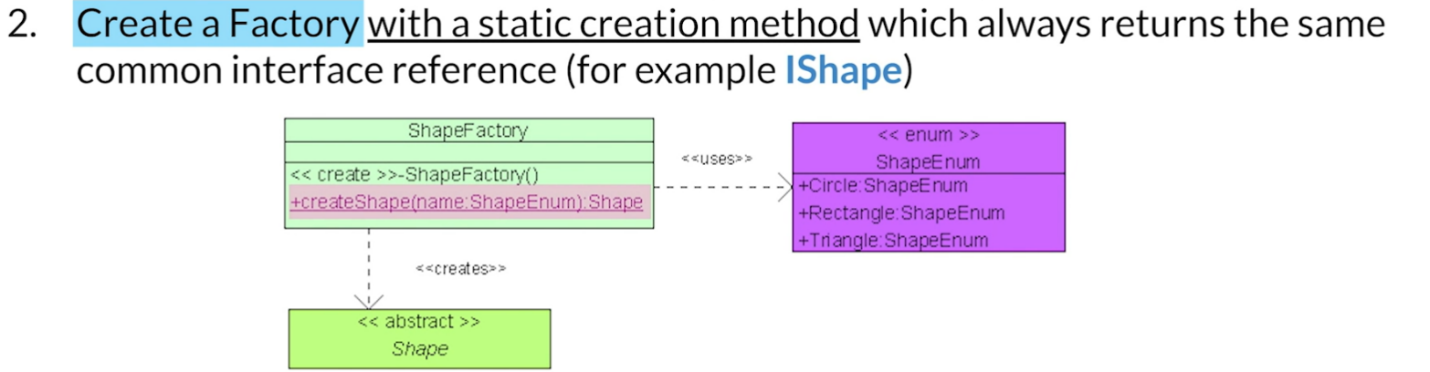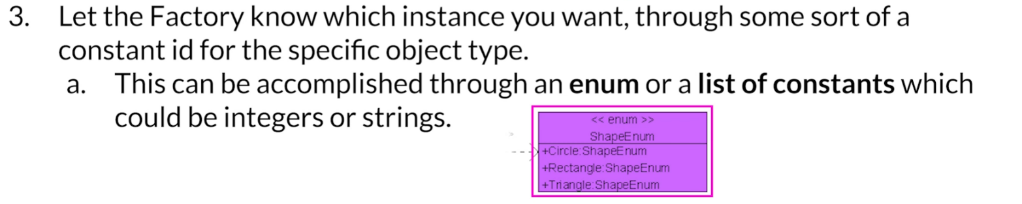

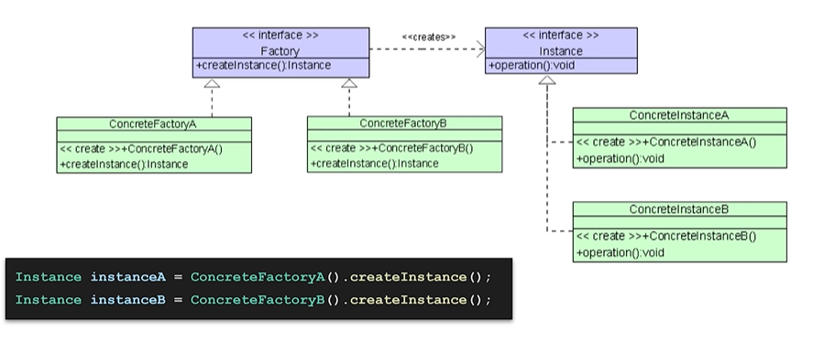

We start with an interface that stands for some sort of an instance of a class that we would like to

abstract. This could, for example, be shape, this could be product, and it has an operation.

Here we have two concrete implementations of the instance interface, which we call concrete instance A and concrete instance B.

Notice that both of them have defined the operation which was defined in the instance interface.

What we then have is we create a contract for a factory which is going to create instances of our instance interface.

For example, we would create a concrete factory, a implementation of the factory, which would specifically create the concrete instance a objects, and we also create a concrete factory B implementation of our factory, which would specifically create objects of the type concrete instance B for every concrete implementation of an interface, we have a concrete implementation of a factory method that will create that.

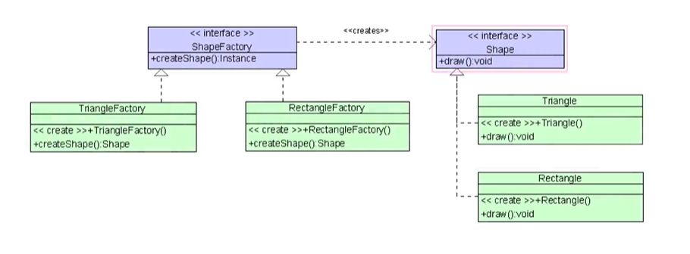So for example, instead of instance, if we had shape and our concrete implementations were trianglecand rectangle, then our shape factory would have two implementations of the factory interface, which would be triangle Factory and Rectangle factory.

That's the idea of the original Gang of four factory method variant.

For every concrete instance of the implementation of our interface(ITriangle,IRectangle) , we would have a concrete factory implementation (Triangle Factory, RectangleFactory).

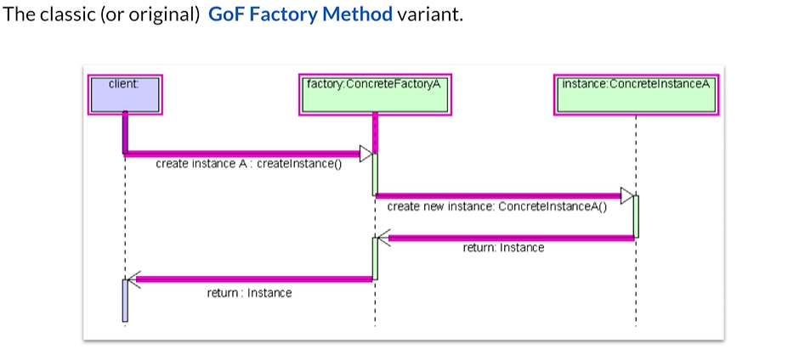

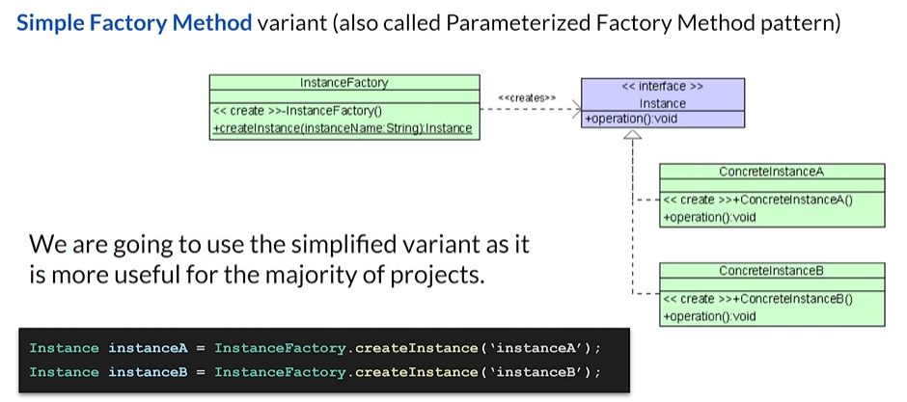The main difference though, is that in this simple factory method variant, we do not have an interface for our factory. We have an instance factory.

We have one factory for all the different instances that we would like to create.

Notice also that we have a private constructor, so you cannot instantiate this factory and we have

a static create instance method which takes a parameter. That parameter could be anything really, but in this example it's going to be the name of the class that we would like to instantiate.

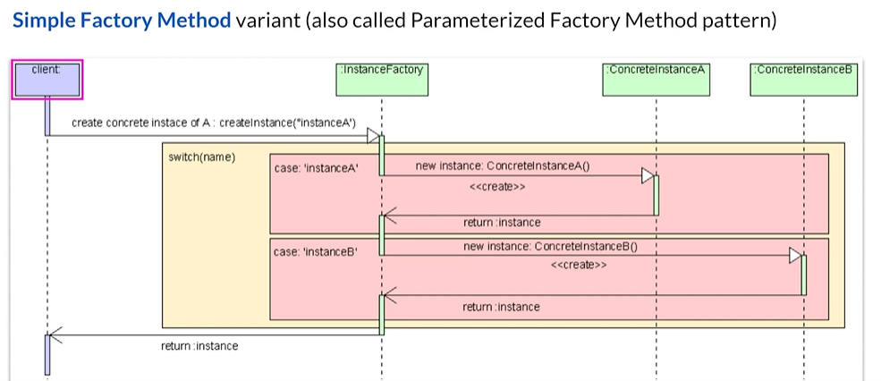

Here's a diagram Our client would like to create a concrete instance, a implementation.

So what it does is it calls the instance factory static method create instance.

It passes a parameter which in this case is a name instance A .The instance factory has a switch statement behind the scenes where it basically matches the name against how it should create the instance for you. In this simple example, we just have a simple switch and if the case happens to be instance A, then it creates specifically a concrete instance, a object.

If you pass instance B, then you would get a concrete instance B object.

The idea is basically that as a client, I don't care how the object is created, I would just like

to get the specific object I'm interested in. And the way you would do it in code is pretty straightforward. If you wanted to get instance a you call instance factory, create instance with the parameter, the instance A if you wanted to create instance B implementation, you would call instance factory with the. Parameter instance B.

So the nice thing about this, as compared to the original one, is that we only need one factory and

we call the factories method with some sort of parameters which allows us to even expand this.

Shape factory Example

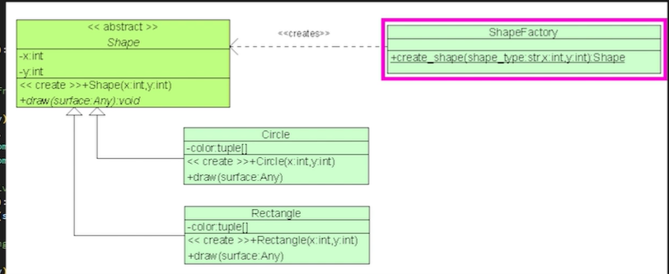

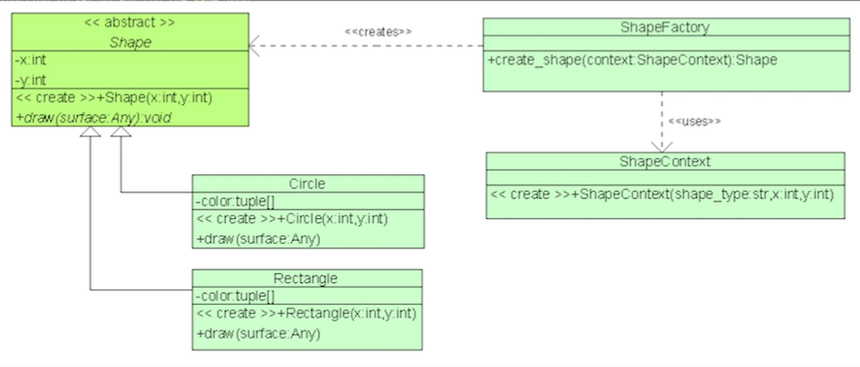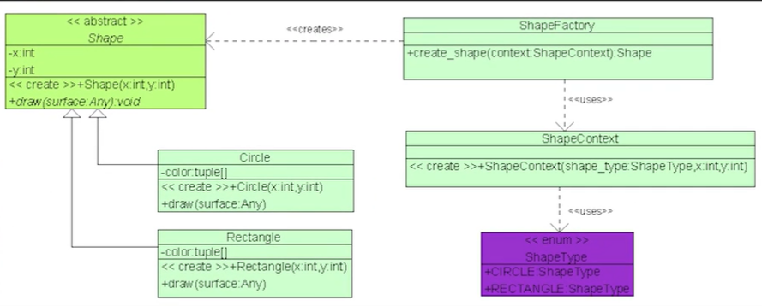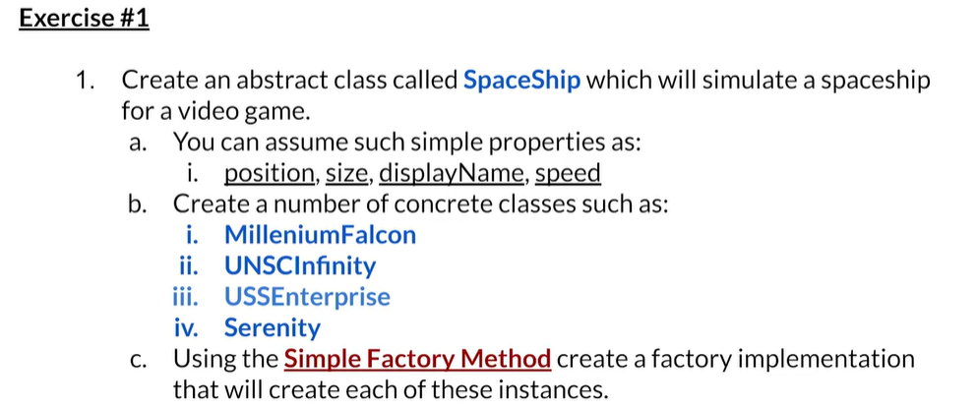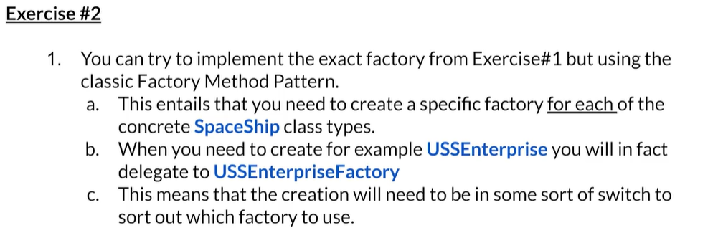

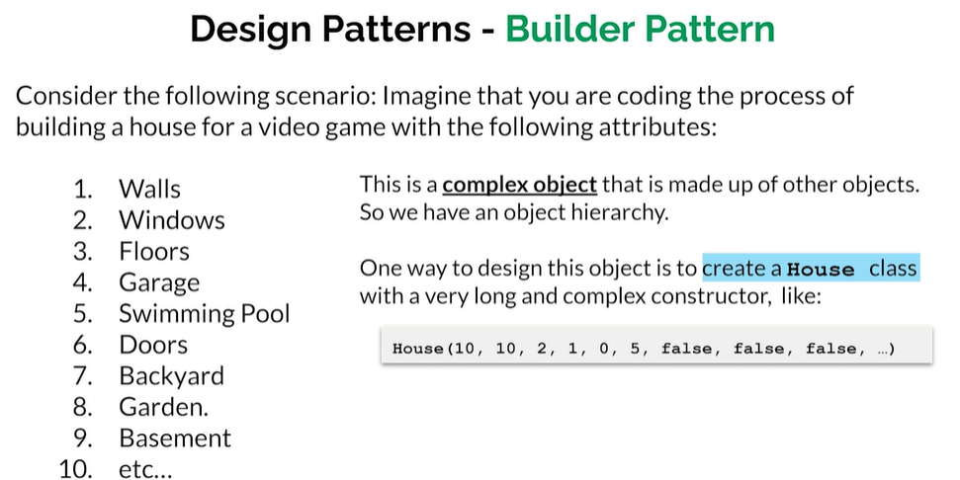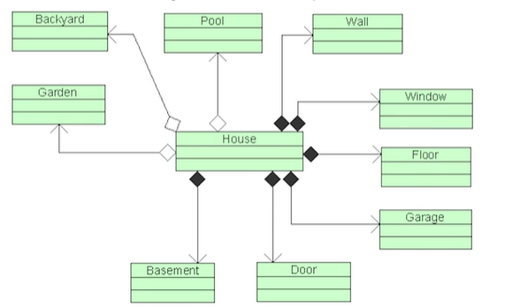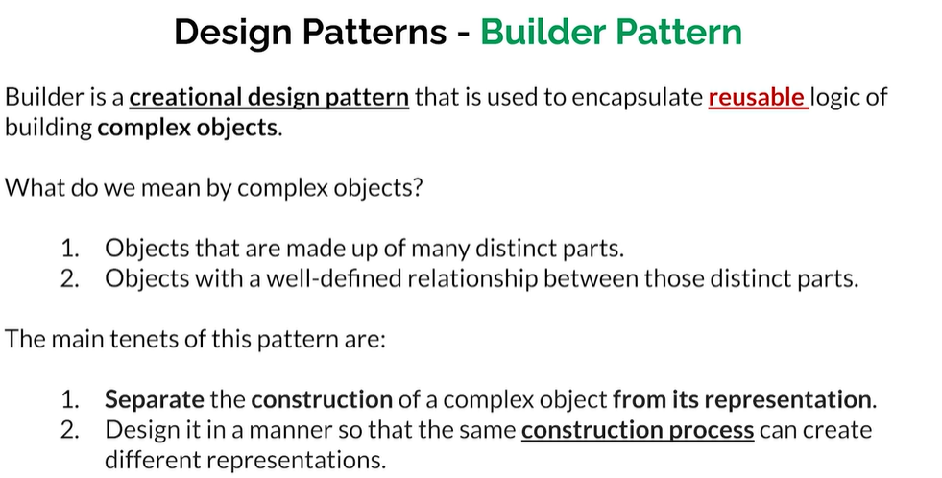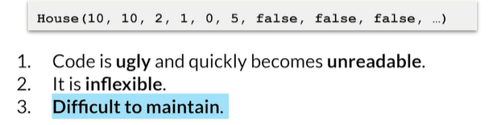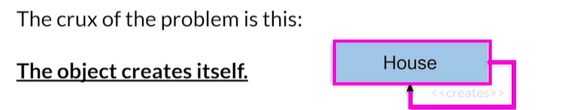

One way to design this object is to create a house class with a very long and complex constructor,

something like House, and you see all those parameters. So for example, we could look at that as we would like to build a house with ten walls, ten windows, two floors, one garage, no swimming pool, five doors, no backyard, no garden and no basement.

The problem with this is that a code like this would be ugly and quickly would become unreadable.

While it is very inflexible and most importantly, it's difficult to maintain. The crux of the problem.

The reason why we have this problem here is that the object the house creates itself.

We have the object representation, which is the house itself, and then we have the object creation.

The problem here is that House also has the responsibility of creating itself through the constructor.

So what should we do?

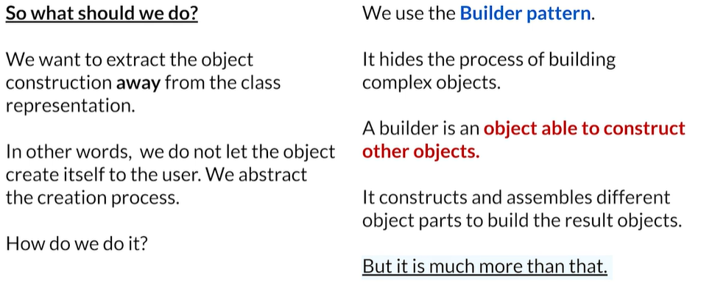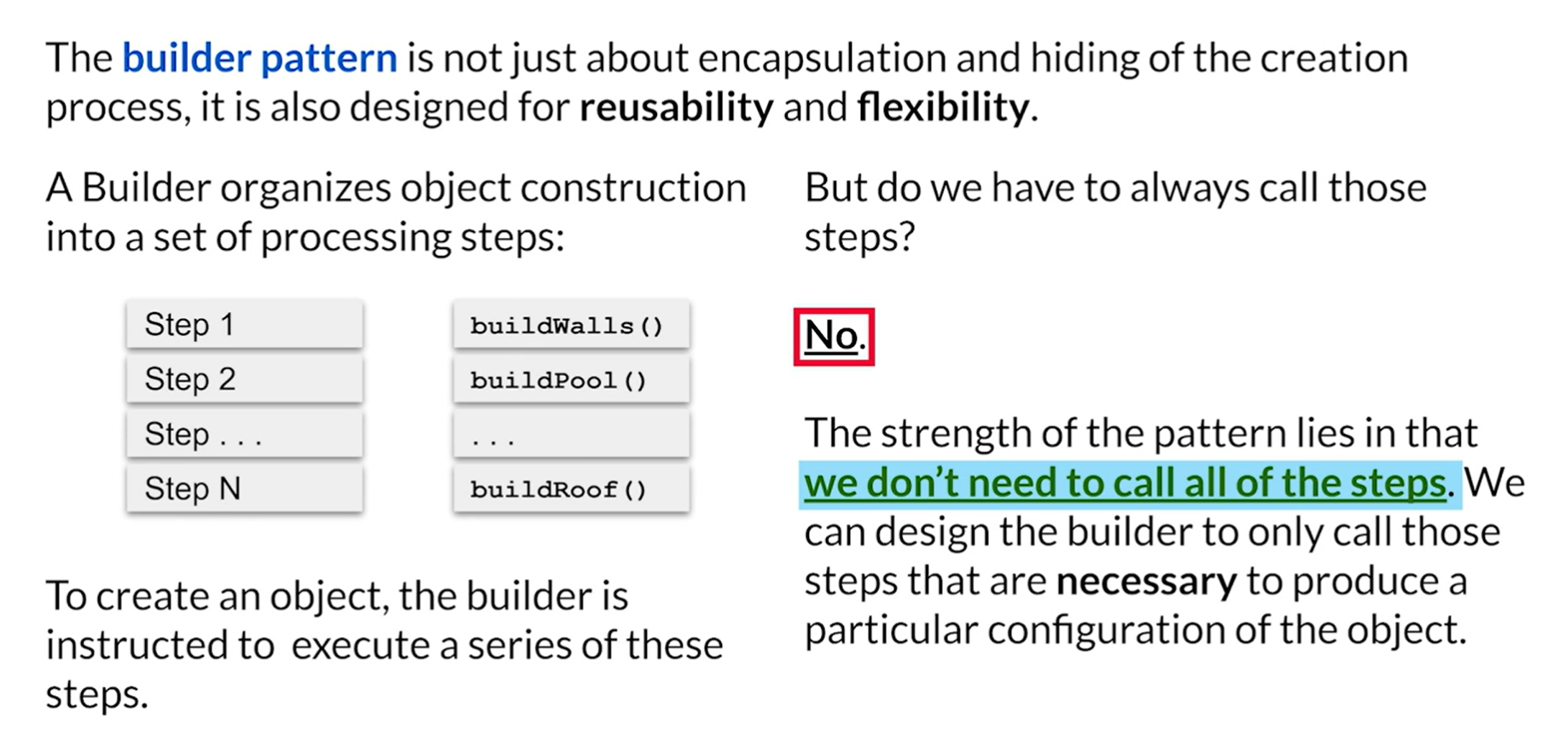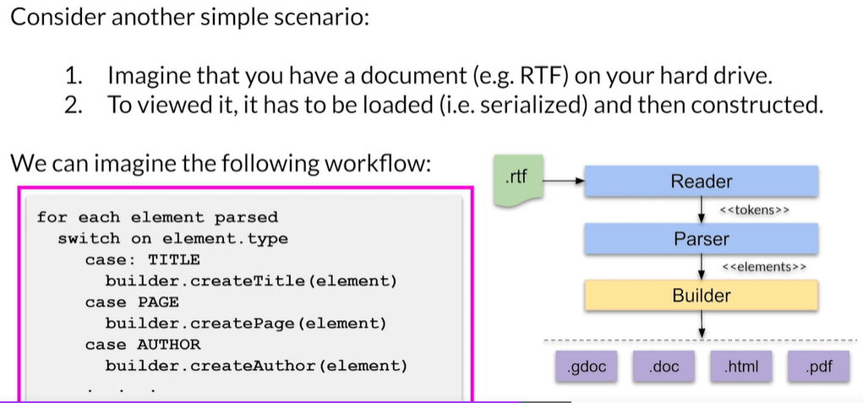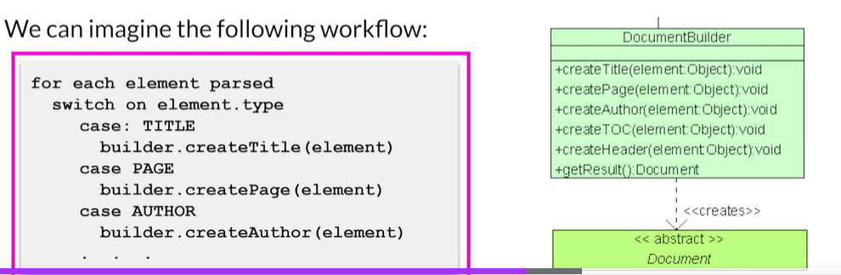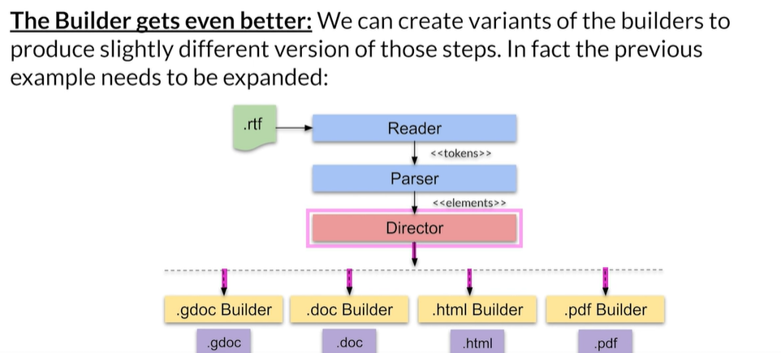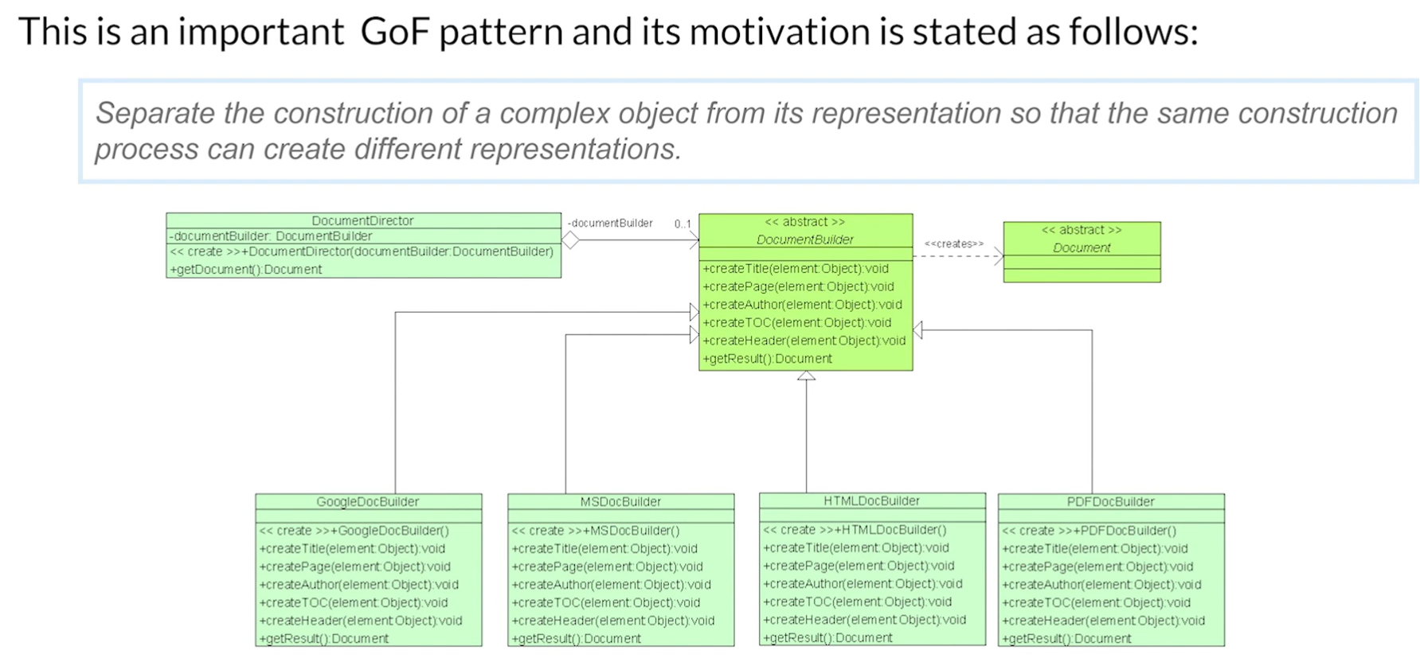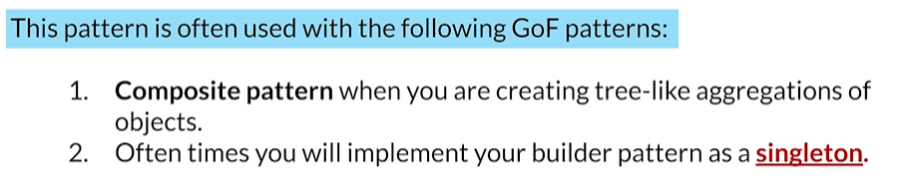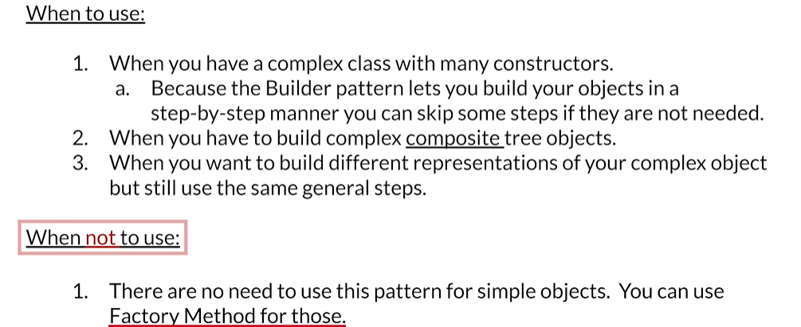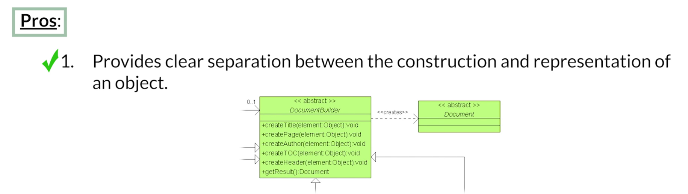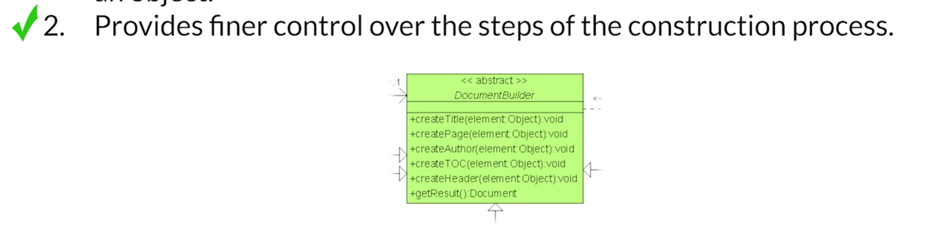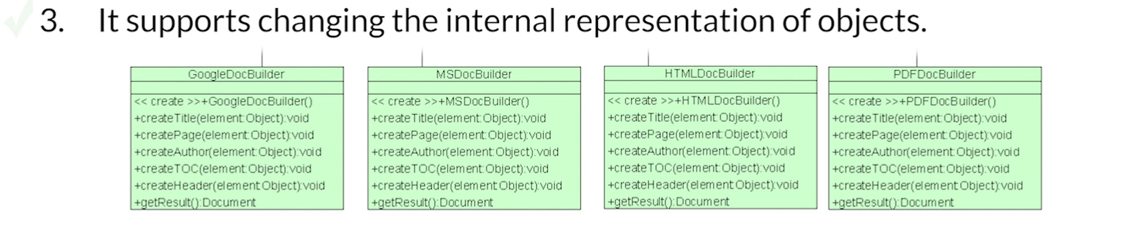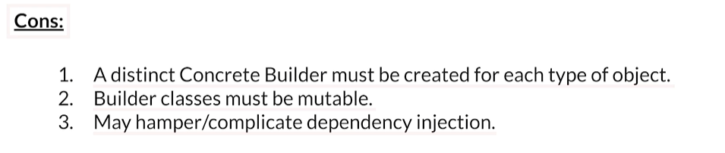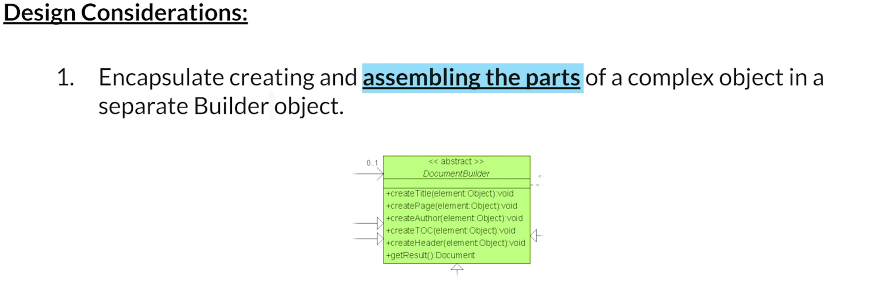

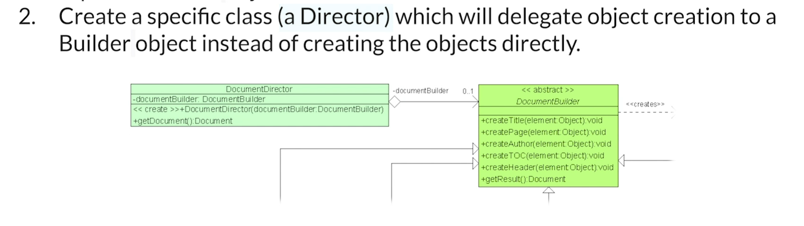

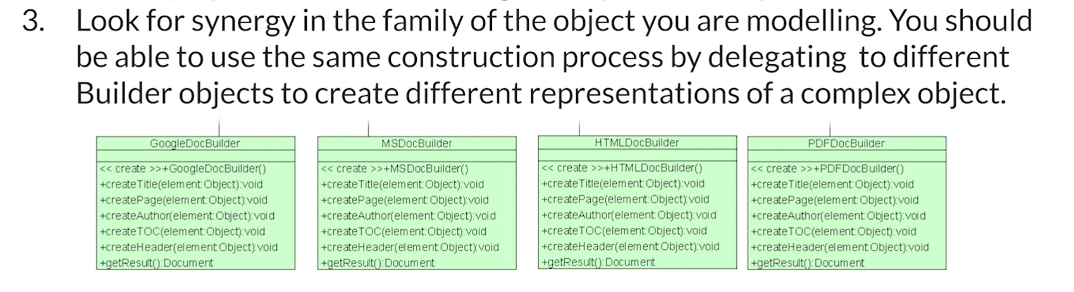

Imagine that you have a product you would like to use the builder pattern to create the product.

So you have an abstract product class.

And let's assume that you have two implementations of the product product 001 and product 002.

The next thing that you're going to do is you're going to create a builder abstraction, which is going

to build a product.

It will have a method called, for example, get result, which is going to be the final build of what

the product is, and you're going to have the necessary steps to build any given product. In this case, we have built part A, part B, part C, it might vary from product to product. So some of the products might actually not include one of the methods. For example, build part A could be empty, but the important thing is that you abstract the builder interface. The next thing that we do is we create concrete builders. So we might have a concrete builder 001 and we will have a concrete builder 002 Notice that each builder creates the specific product, but it returns in the get result an actual product abstraction. This is important.

So now that we have this, what is the next step?

We need a director. Notice that the director aggregates the builder, and there are two ways in which we can initialize the director with the builder. We can either initialize the director specifically when we're creating the director with a given builder, or once we have created the director, we can use the change builder method to move from one builder to another and notice that we have a method for the director called Construct, which, given whatever the current builder is, will construct a product based on that builder. So basically the way internally the director would do it is the director would simply go through all the different parts. So it will call build part A, part B, part C, and then that would return the result. This is a pretty straightforward way of looking at the builder pattern.

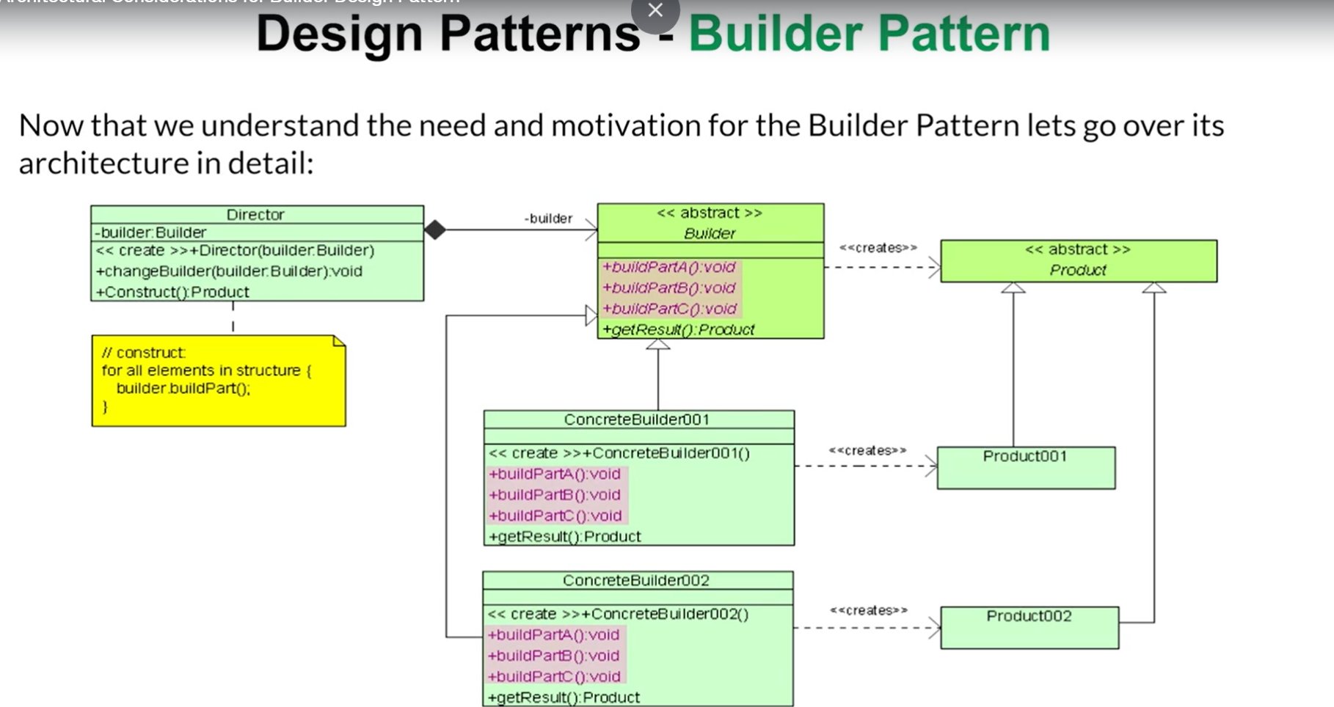

Now let's have a look at the sequence diagram.

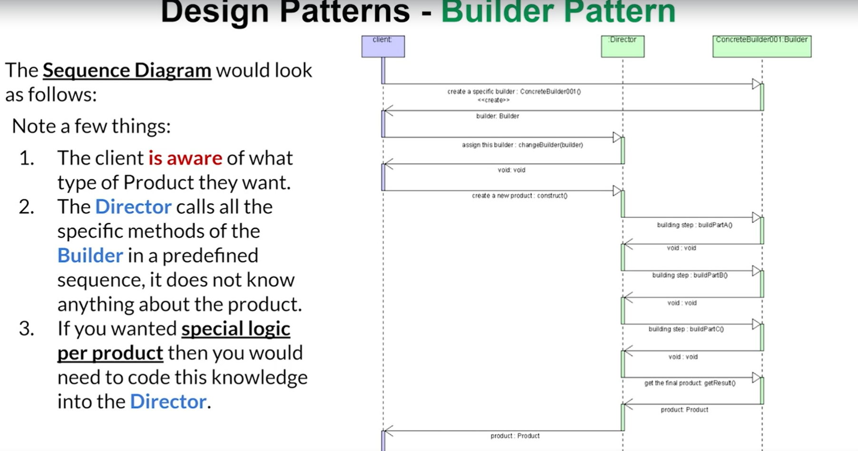 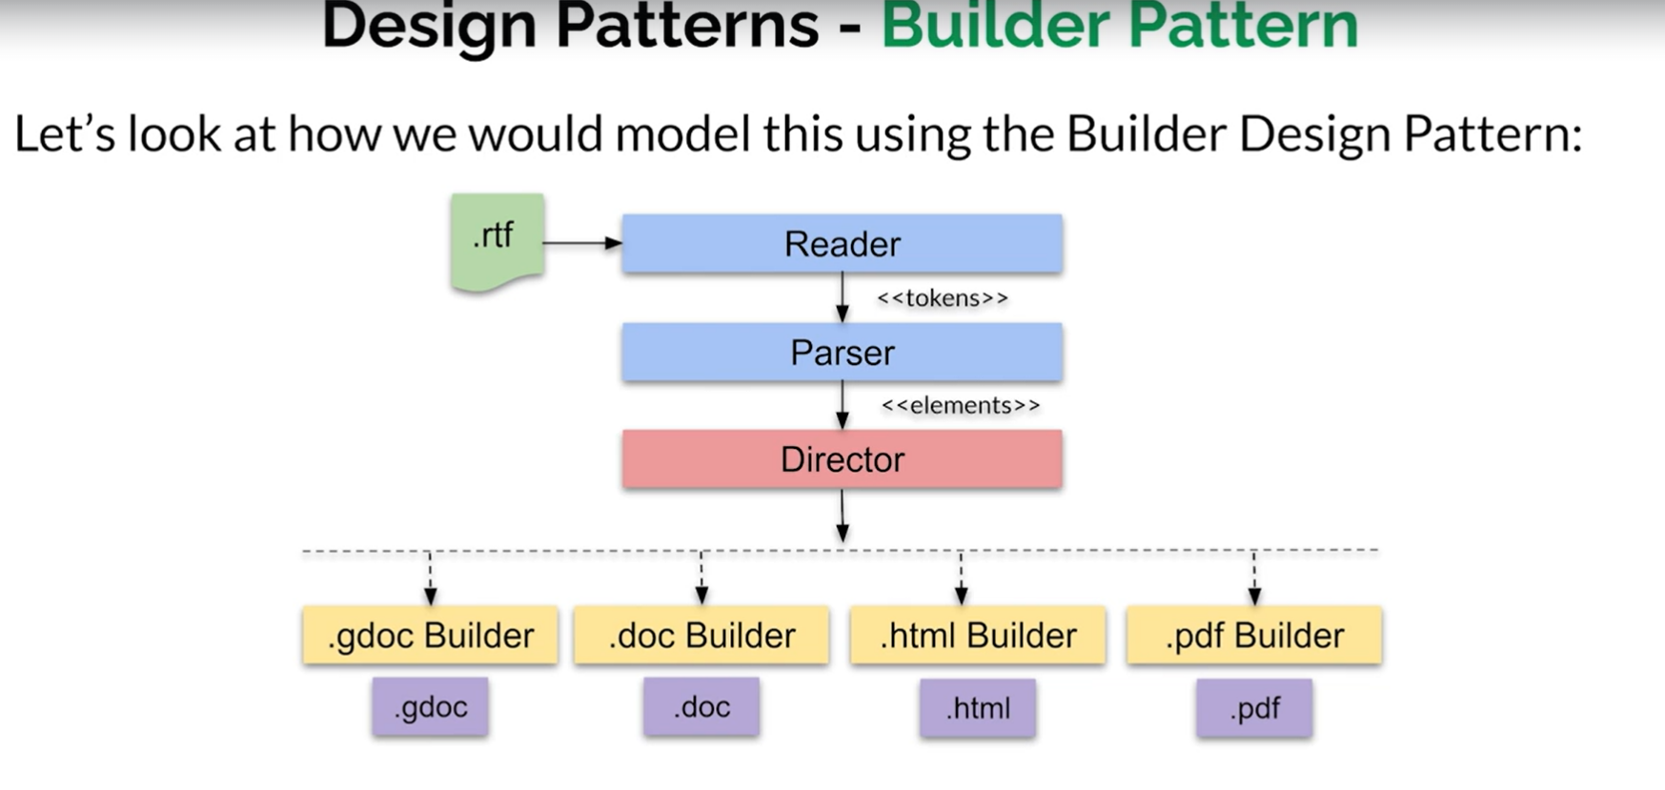 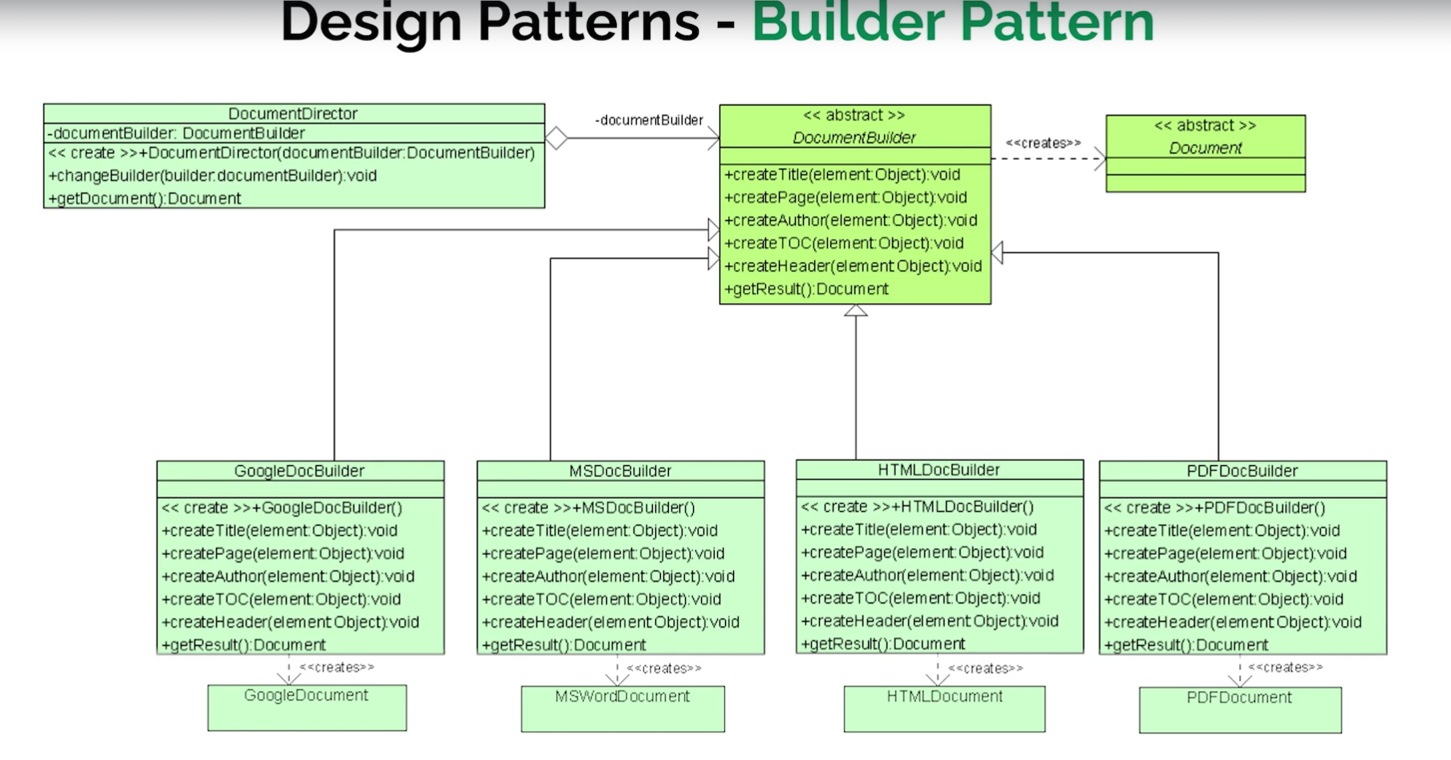 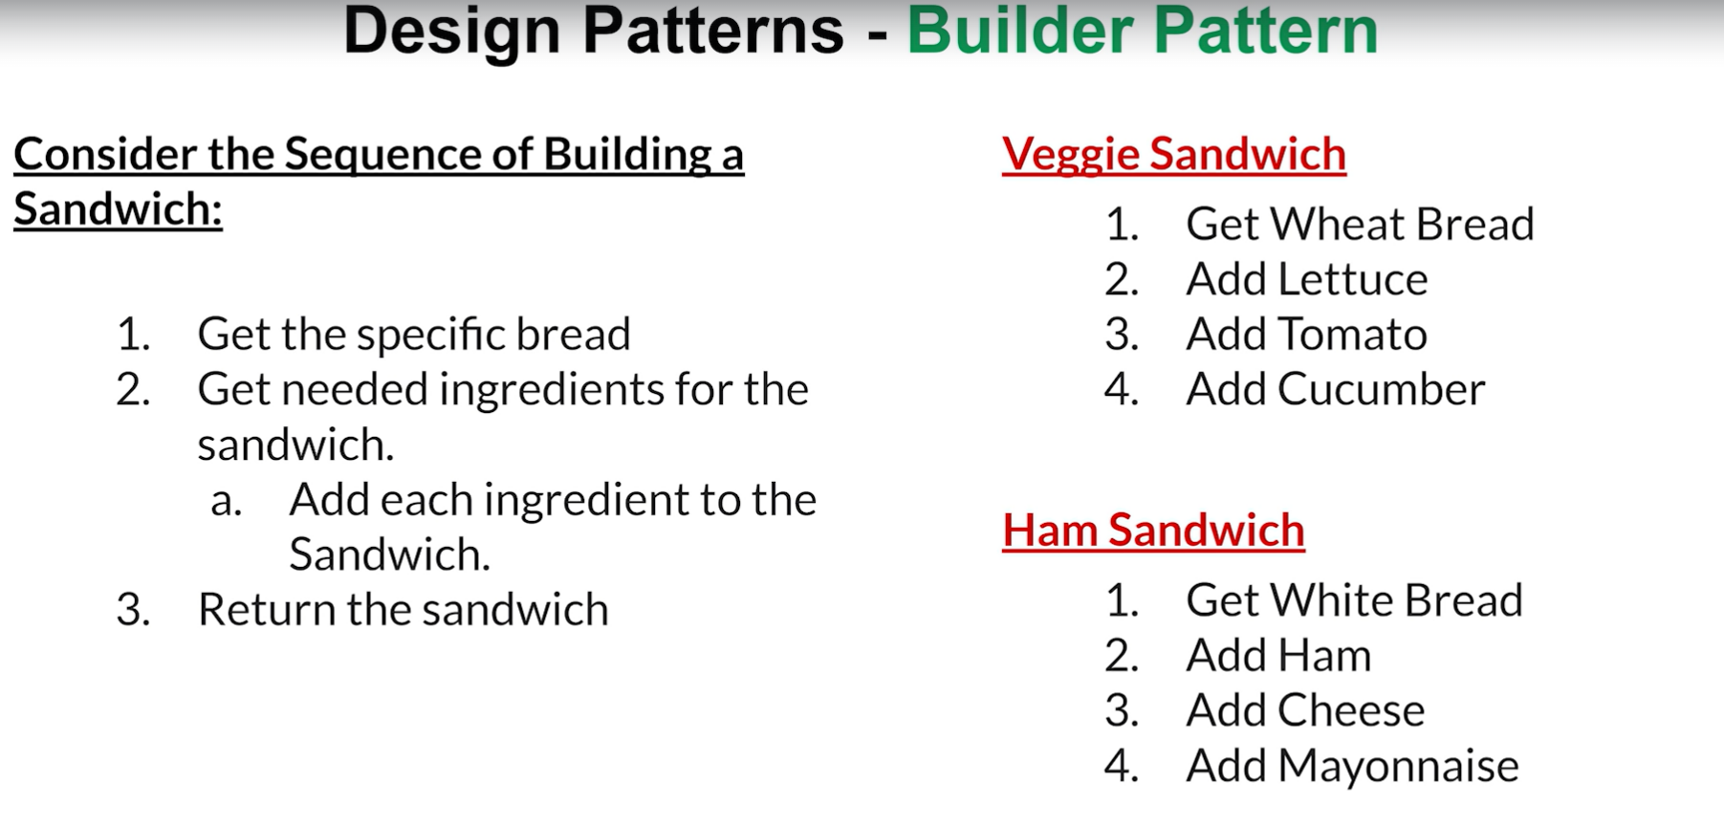 Consider the sequence of building a sandwich.

Usually get the specific bread. You then get the necessary ingredients for the sandwich.

You then add each ingredient to the sandwich and you basically are done.You return the sandwich.

So let's look at a very simple example. Let's say you wanted to create a veggie sandwich.

You get the wheat bread, you get lettuce, you get tomato, you get a cucumber, and you've got yourself a veggie sandwich.

What about a ham sandwich?

Well, you get some white bread, you add ham, you add cheese, and you add mayonnaise.

Relatively simple, but this can very nicely be modeled using the builder pattern.

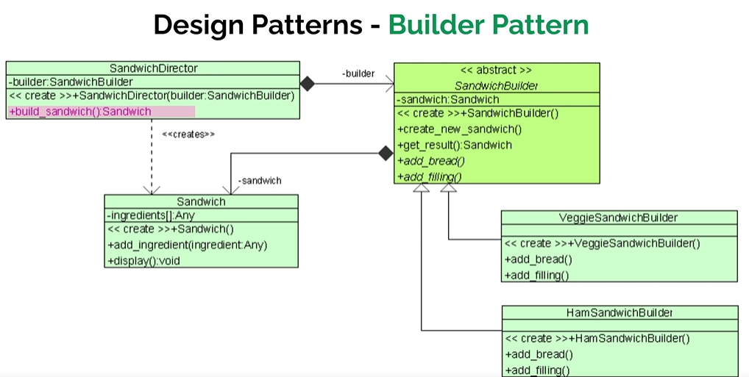 So we start with an object that represents a sandwich. Notice that our sandwich can have any number of ingredients and the sandwich really has only two simple

methods. In reality, it's just one main method, which is add an ingredient to the sandwich.

We also have a display method which kind of displays some information about the sandwich itself.

Consider that to be the embodiment of the sandwich. Okay, great.

So we have the sandwich, but in the builder pattern, what we need is a builder. So here we have an abstract sandwich builder. This sandwich builder aggregates a sandwich. And notice that we have four methods. We have a create new sandwich and get result which returns a sandwich.

Both of these are instance methods that have already been implemented, but we do have two abstract methods, which is add the bread and add filling. Filling would be like an ingredient.

So the idea would be what bread are you going to use for this sandwich?

And then what are you going to put inside the sandwich?

So the sandwich builder is responsible for dealing with those steps. So here we have two concrete examples. We have our veggie sandwich builder and we have ham sandwich builder.

And what happens here is that each of the specific sandwich builders will implement its own specific steps necessary to create that particular sandwich. We finish this with a sandwich.

Director.

What a sandwich director does is it takes specific builder and then it just builds the sandwich.

Pretty straightforward. So from a perspective of a client, the client doesn't really care about veggie or ham or whatever. Basically what it wants is if it wants a veggie sandwich builder, it creates the builder, gives it to the director and gets a sandwich.

So it's almost like you give the order to the director and you get a particular sandwich back.

But just for major clarification, let's have a look at a sequence diagram.

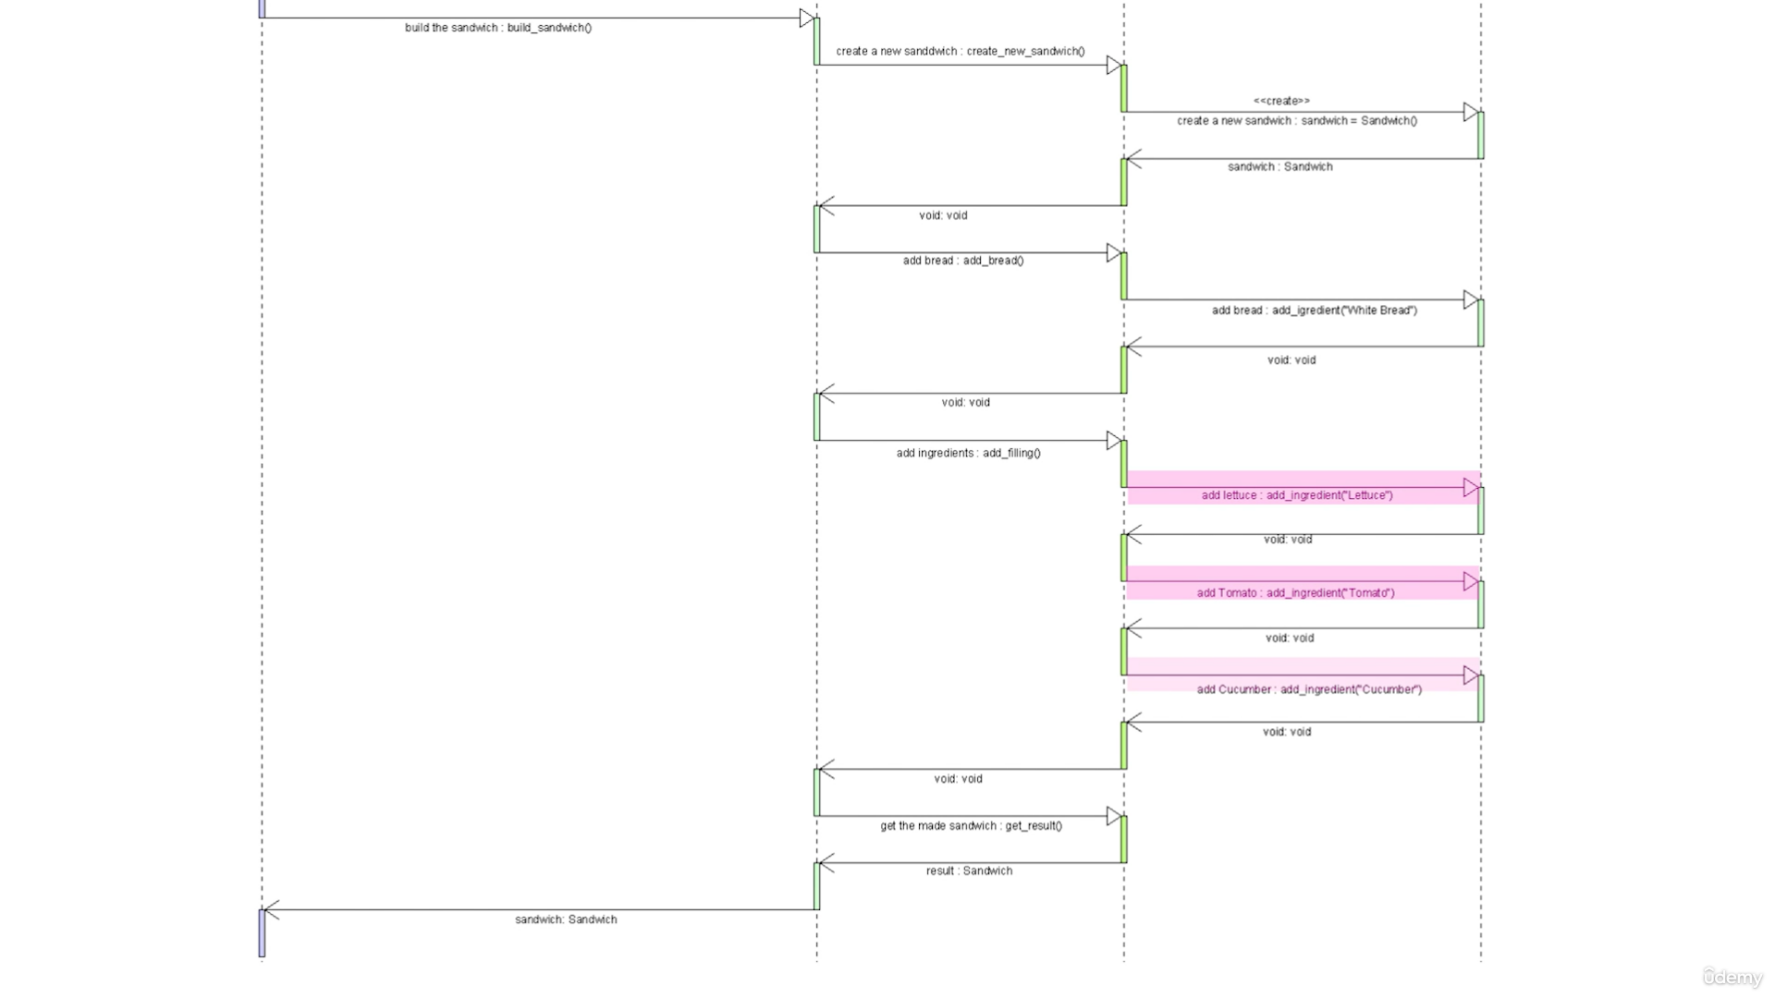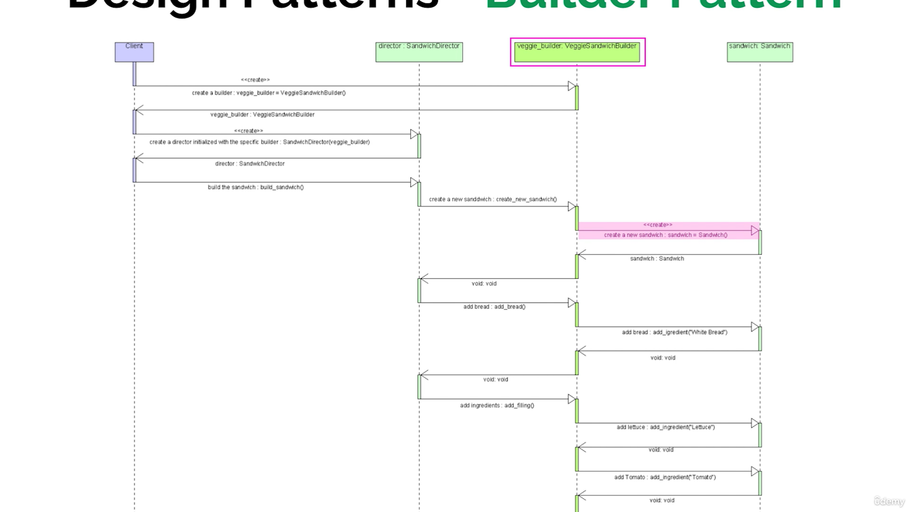

Our client creates a veggie sandwich builder.

It then creates a director which is initialized with that builder, and then the client asks the director

to build the sandwich. The director then delegates that to the specific, in our case veggie builder, which is the veggie sandwich builder.

And what the veggie sandwich builder does is it first creates a new sandwich instance.

It then adds the bread to it, which happens to be done as an ingredient, and then it adds additional

ingredients like lettuce, tomato and cucumber and then gets the sandwich back to the client.

So pretty straightforward.

The main thing that I would like you to kind of notice here, obviously, is that how easy it is for

the client. The client does two very simple things. It decides what kind of sandwich it wants.

It gets the specific sandwich builder for that, in this case the veggie, and it gives it to the director.

That's it. So from a perspective of the client, this is very easy code to use, even though, as you can see, the sandwich building could be complicated in a sense that there could be many steps.

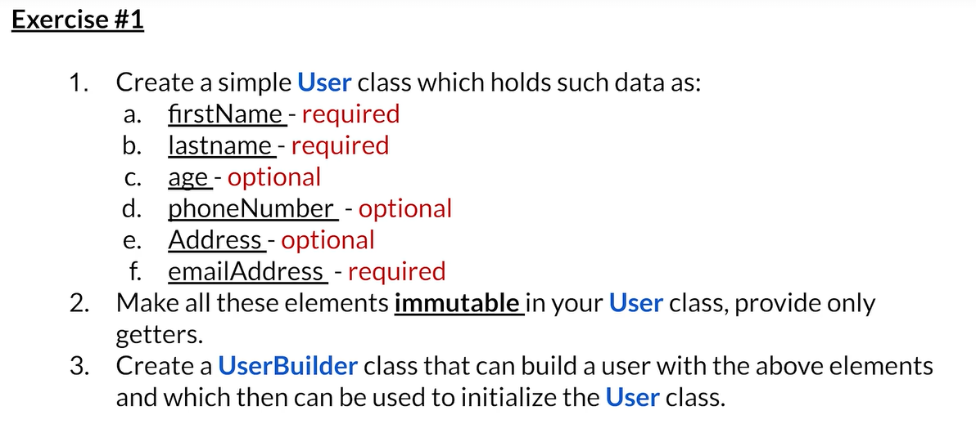

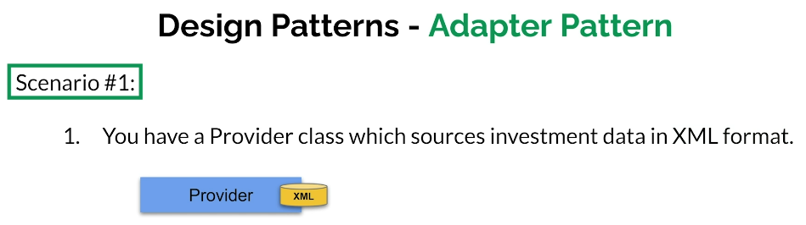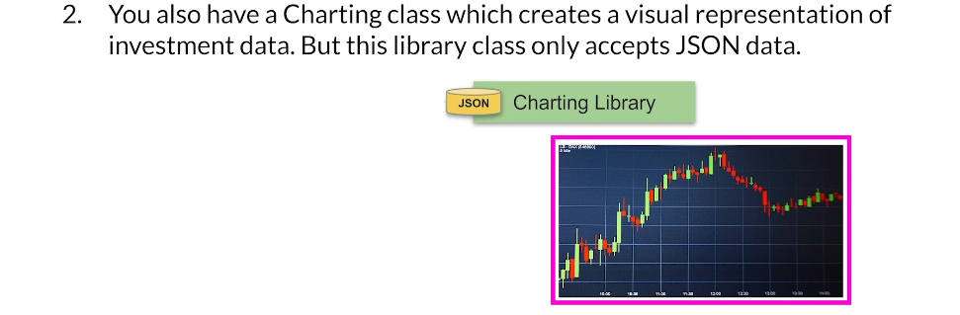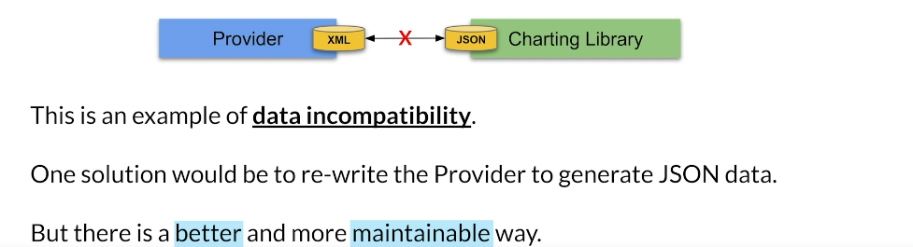

* You have a provider class that sources investment data in XML format.
* You want to visualize your investment data using charts.
* The charting class can only accept data in JSON format.
* The provider outputs XML, but the charting library requires JSON, leading to a format incompatibility.
* Rewriting the provider to generate JSON data is one option, but it may affect existing code dependent on the XML output and violates the SOLID principles.
* Find a more maintainable way to handle the data format incompatibility without rewriting the provider class.

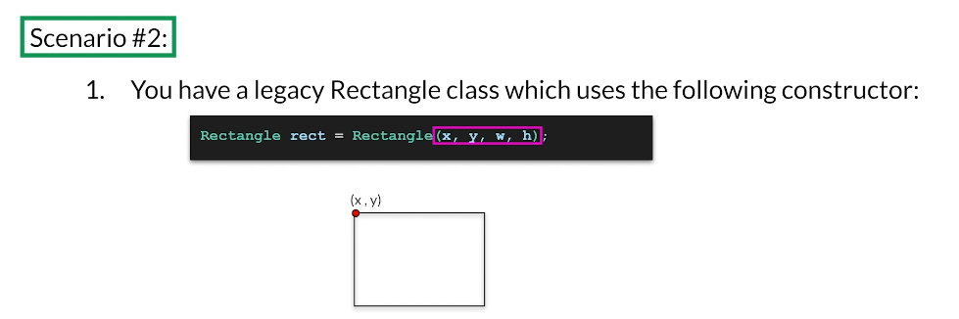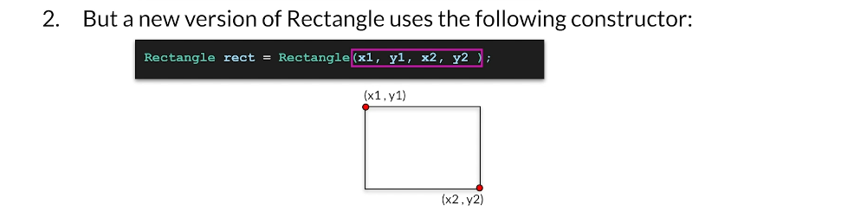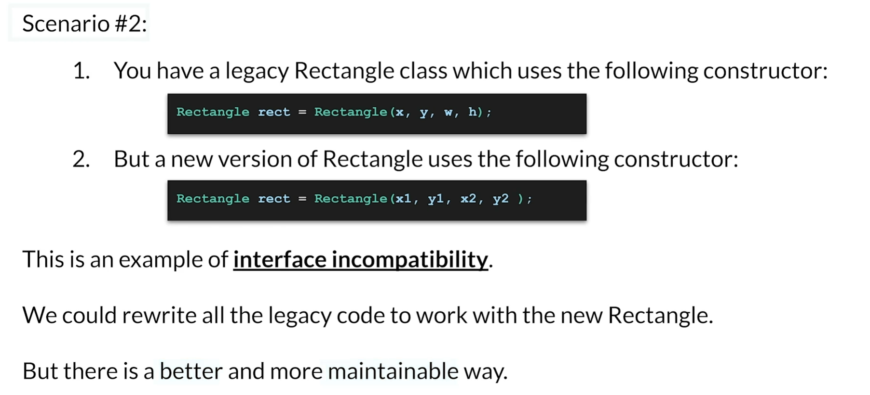

* You have a legacy rectangle code using a constructor: Rectangle(x, y, w, h), which defines a rectangle based on its x, y position and its width and height.
* A new version of Rectangle uses a constructor: Rectangle(X1, Y1, X2, Y2), which defines a rectangle based on its upper left corner (X1, Y1) and lower right corner (X2, Y2).
* Both rectangle definitions are valid, but they are not compatible with each other.
* This situation exemplifies interface incompatibility.
* Rewriting all legacy code to work with the new rectangle could result in numerous code changes.

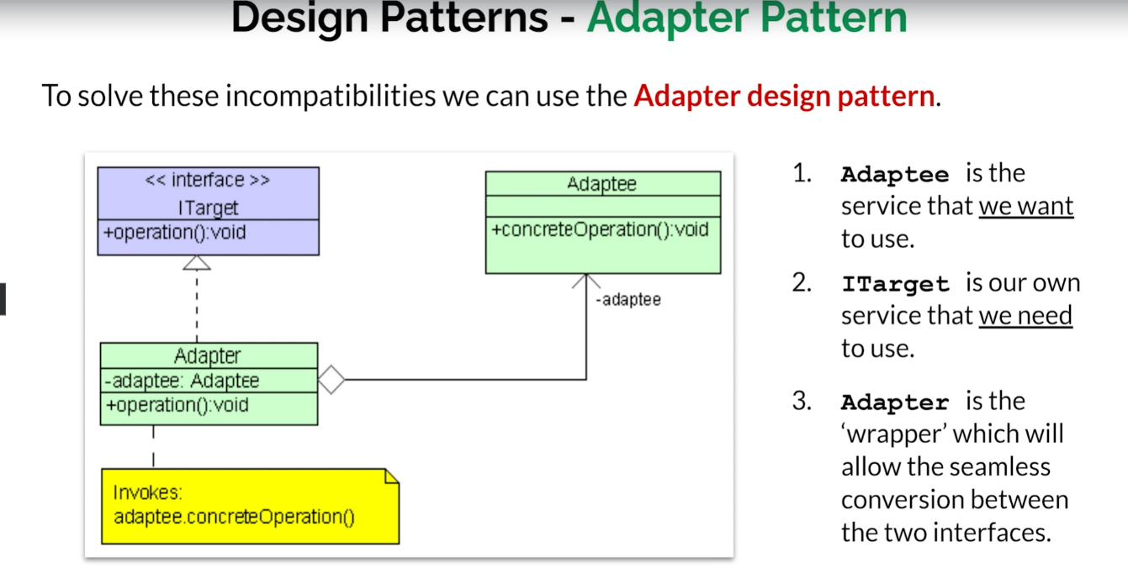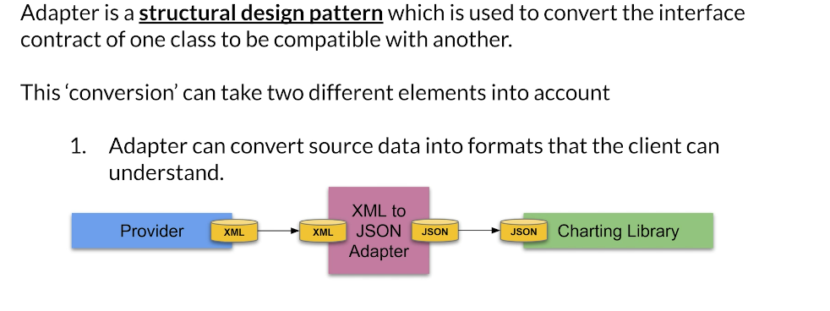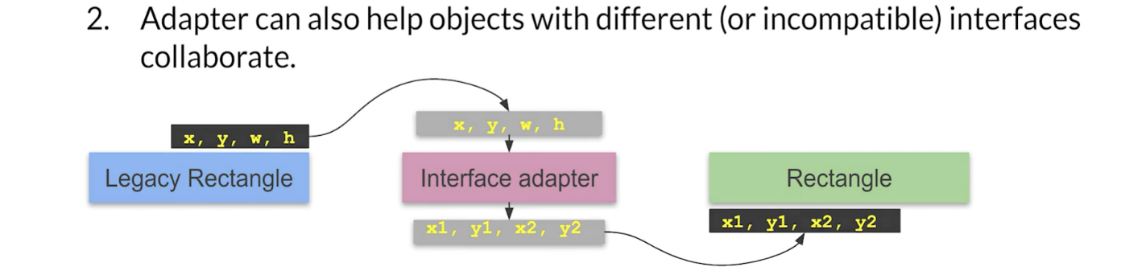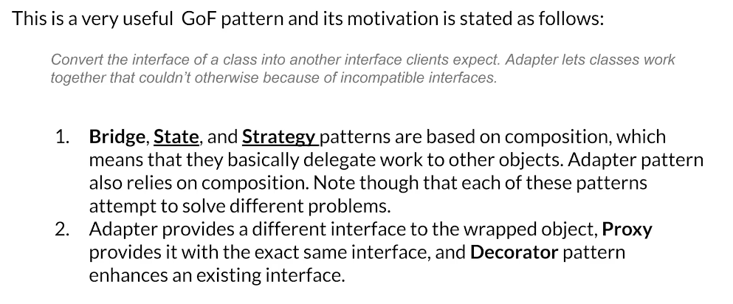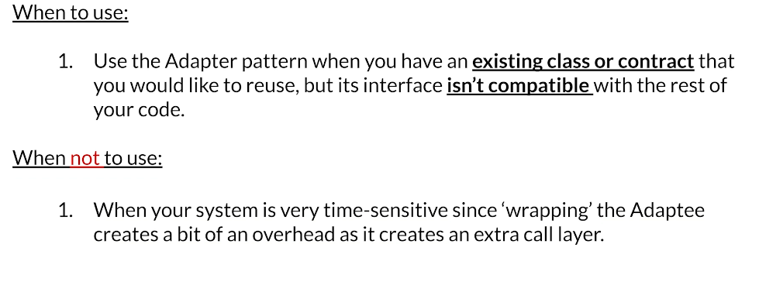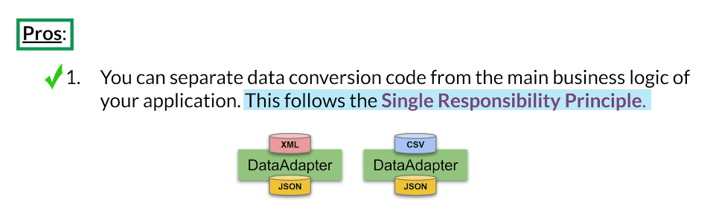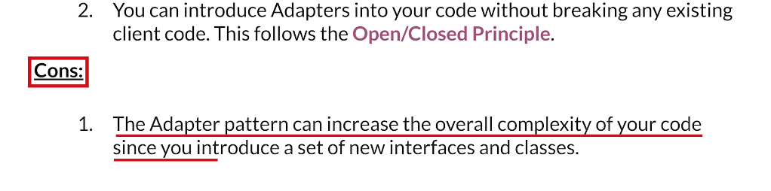

• **Adapter Pattern Overview**:

* Converts the interface of a class into another interface that the client expects.
* Allows classes with incompatible interfaces to work together.

• **Relation to Other Gang of Four Patterns**:

* Adapter, Bridge, State, and Strategy patterns are based on composition, delegating work to other objects.
* These patterns solve different problems with different motivations.
* The adapter provides a different interface to the wrapped object.
* Similar patterns include Proxy (same interface) and Decorator (enhances existing interface).

• **When to Use Adapter Pattern**:

* When you have an existing class or contract you want to reuse but its interface is not compatible with the rest of your code.

• **When Not to Use Adapter Pattern**:

* If your code is very time-sensitive and the overhead of an extra layer would slow down performance, consider rewriting the original code.

• **Benefits of Using Adapter Pattern**:

* Separates data conversion from the main business logic, adhering to the single responsibility principle.
* Facilitates data exchange by adding new adapters as needed without breaking existing client code, following the open/closed principle.

• **Cons of Using Adapter Pattern**:

* Increases the overall complexity of the code by introducing more interfaces and classes.
* This complexity is often outweighed by the benefits of good code abstraction provided by the adapter pattern.

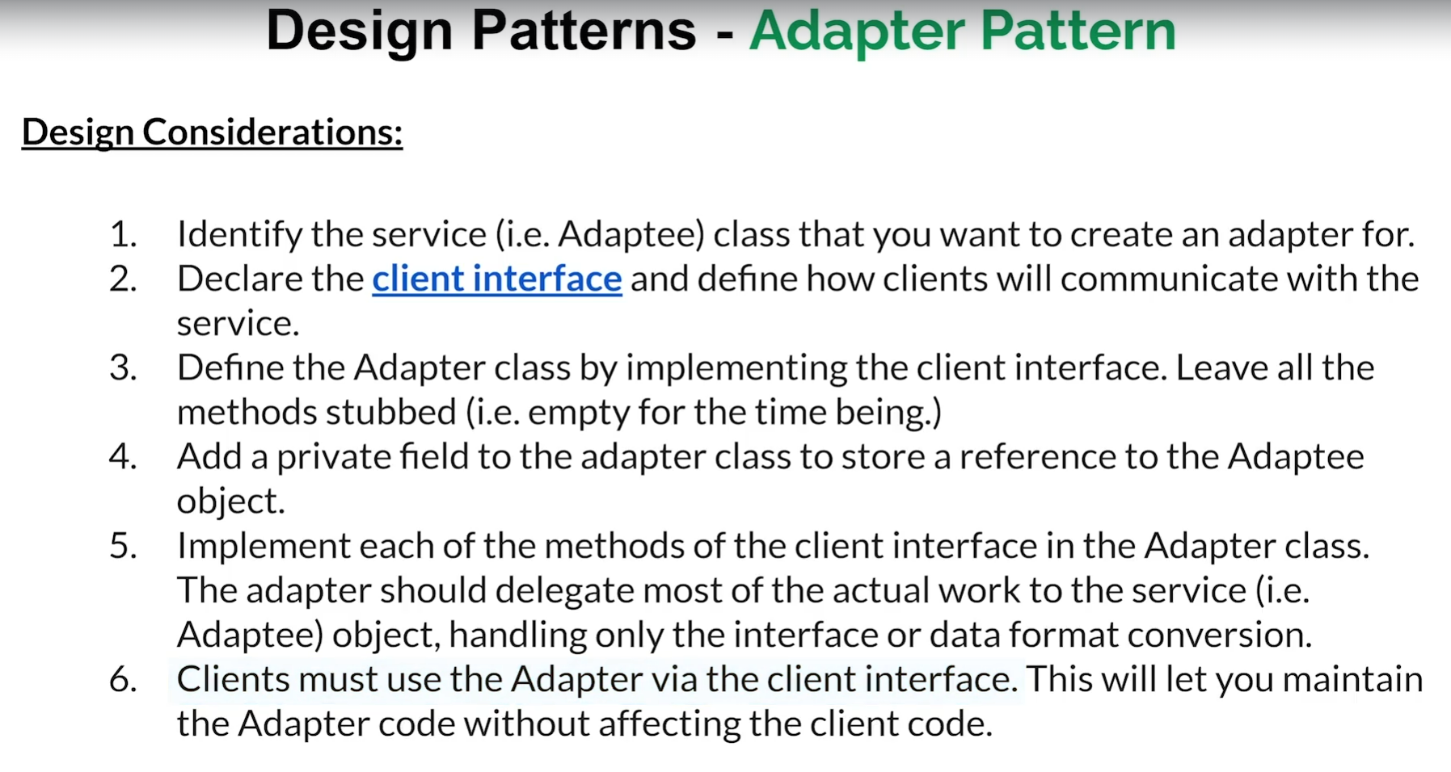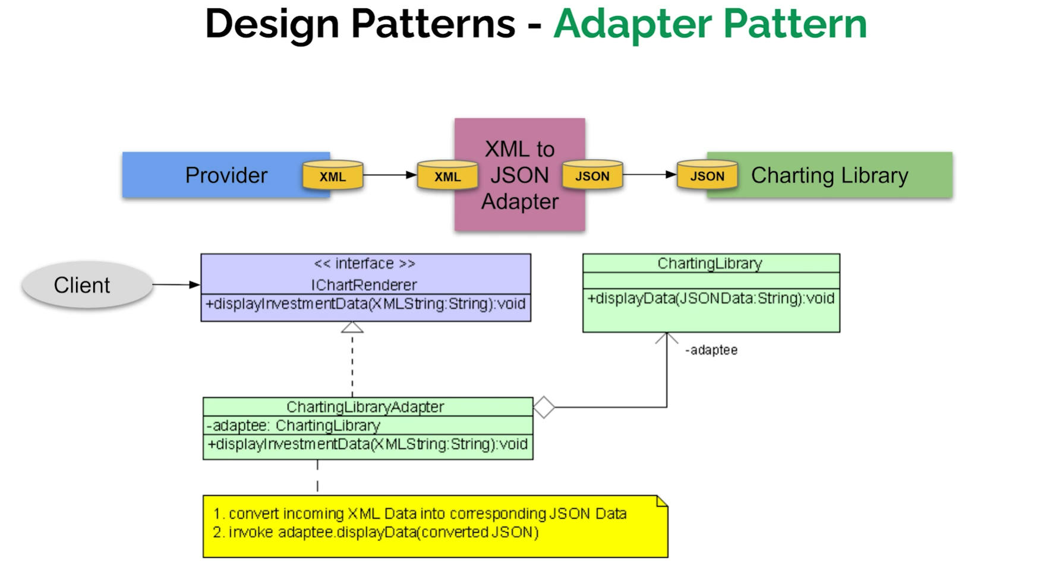• **Designing an Adapter**:

1. **Identify the Service**: Determine the service you want to create an adapter for.
2. **Declare the Client Interface**: Define how the client will communicate with the service.
3. **Define the Adapter Class**: Implement the client interface in the adapter class, initially leaving methods unimplemented (stubbed).
4. **Add a Private Field**: Store a reference to the service object in the adapter class.
5. **Implement Methods**: Implement each method of the client interface in the adapter class, delegating work to the service while handling interface or data format conversion.
6. **Ensure Client Use**: Ensure all clients use the adapter through the client interface, maintaining adapter code without affecting client code.

• **Example**:

* **Identify the Service**: Charting library with a method displayData(JSON).
* **Declare the Client Interface**: Define IChartRenderer interface with a method displayInvestmentData(XML).
* **Define the Adapter Class**: Implement IChartRenderer in ChartingLibraryAdapter class.
* **Add a Private Field**: Store a reference to ChartingLibrary in ChartingLibraryAdapter.
* **Implement Methods**: In displayInvestmentData, convert XML data to JSON and call displayData on the charting library.
* **Ensure Client Use**: Ensure clients use IChartRenderer interface when interacting with the charting library, keeping the conversion process hidden.

• **Conclusion**:

* The adapter pattern allows for seamless integration of incompatible interfaces by converting one interface to another.
* Clients interact with the service through a consistent interface, unaware of the underlying data conversion.

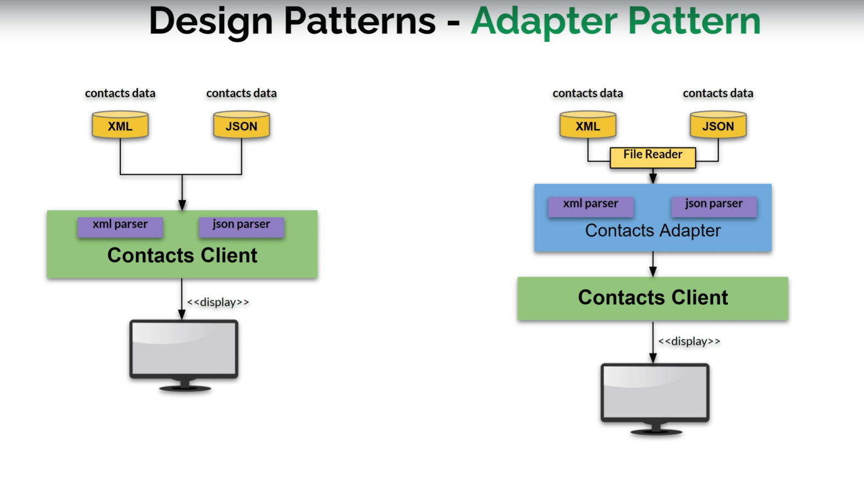• Let's say that you have some contact data coming from different sources in completely different formats. For instance, you have contact data coming in XML and other contact data coming in JSON. You want to display all of this contact information to the user on a display.

• One possible solution is to create a contacts client that takes the data and presents it. The contacts client could be fitted with an XML parser to parse the XML data and a JSON parser to parse JSON data. However, this is a poor architectural solution. The contacts client, which should be responsible solely for displaying the data, should not know anything about XML or JSON. It shouldn't even be aware that there is a JSON parser or an XML parser; it should focus only on displaying the data.

• A better architectural solution would be to have the XML and JSON data behind an adapter. The contacts adapter would handle XML and JSON parsing, and it would provide the parsed contact data to the contacts client for display. This way, the contacts client remains unaware of the data formats and parsers, focusing only on its primary function of displaying data.

• In this improved design, the architecture has changed, not the functionality. We still need to parse and display the data, but we've designed it better by separating concerns. Additionally, we must consider how the data is read. Whether the data comes from a file, the Internet, a socket, or a database, the same principles apply.

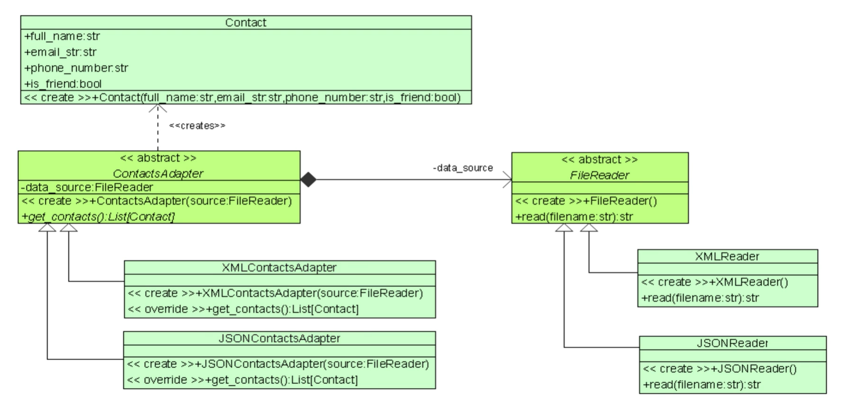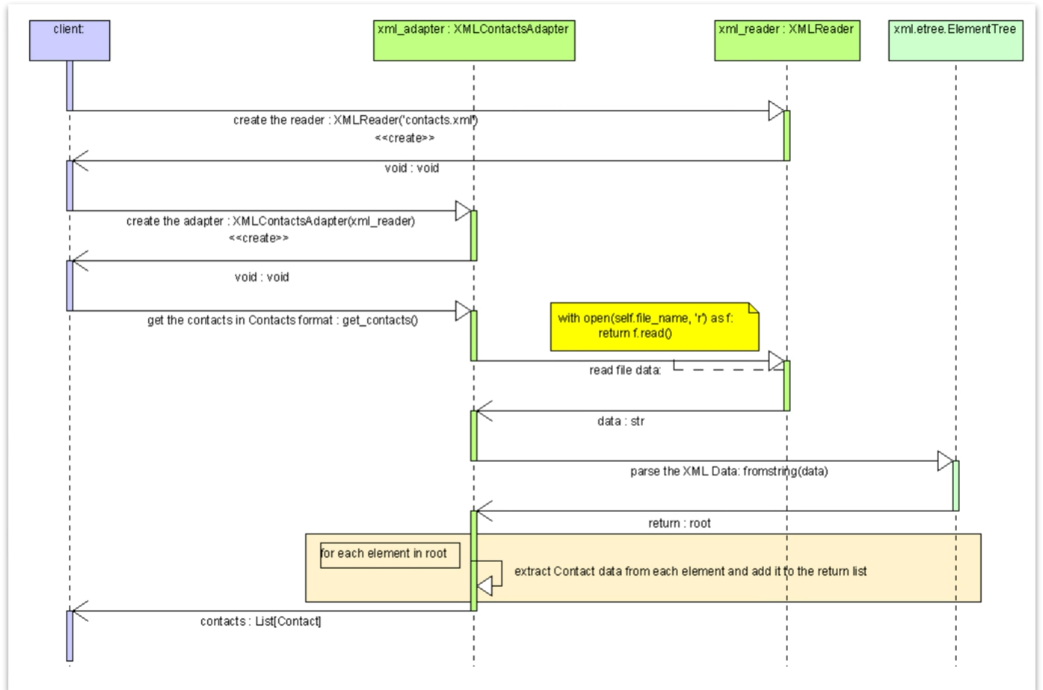To understand how we would code something using an adapter pattern, let's start by looking at a UML diagram that outlines the process. First, we create a class that abstracts and isolates contact information, containing fields like full name, email, phone number, and whether the contact is a friend or not. Next, we need a reader for each data type or source, such as an XML reader and a JSON reader, to read data from respective files and return a string. We abstract this by creating an abstract FileReader class with a read method that accepts a file name.

The next step is to create an adapter. The contacts adapter accepts a FileReader, aggregates the data source, and returns a list of contacts. This means anything needing contact information won't have to worry about file readers like XML or JSON readers. Additionally, we need to parse and format the data, so we create two adapters: an XML contacts adapter and a JSON contacts adapter. Each adapter specializes in converting data from its respective reader to a list of contacts, simplifying their use.

Looking at the sequence diagram, we see the client creates an XML reader, then an XML adapter initialized with the XML reader. From the client's perspective, it simply calls getContacts(). The XML adapter asks the reader to read the file, then uses Python's xml.etree. ElementTree to parse the XML data, extracting contact data for each element and adding it to the return list. This process happens behind the scenes, with the client merely requesting contact data.

Finally, let's look at the actual code and some test data. We have two files, contacts.json and contacts.xml, containing sample contact data in JSON and XML formats, respectively. This illustrates how the adapter pattern abstracts and isolates the complexities of data parsing and format conversion, allowing the client to focus on displaying contact information.

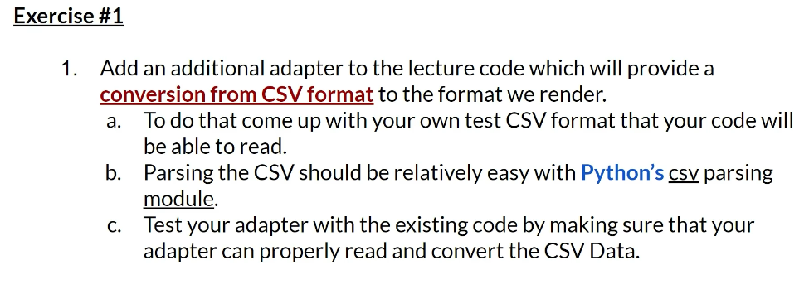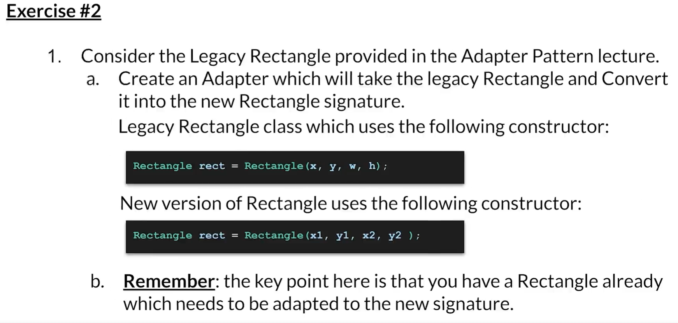

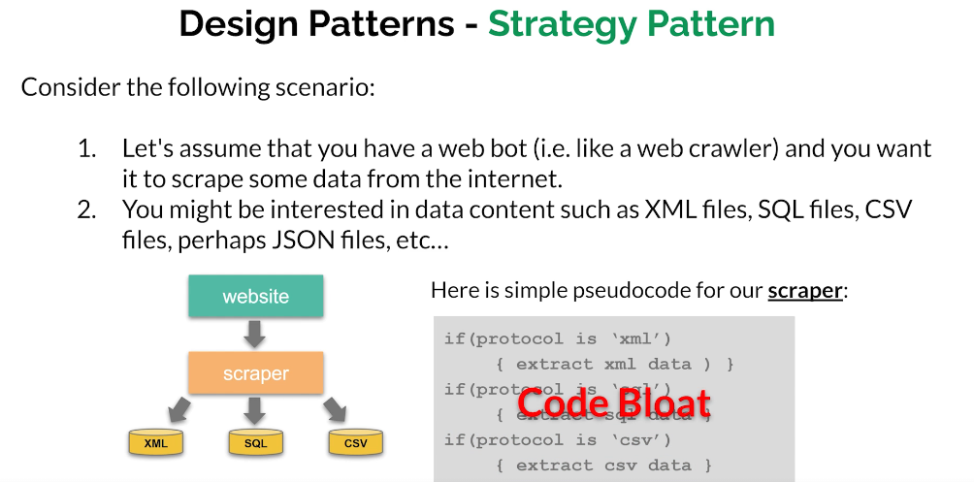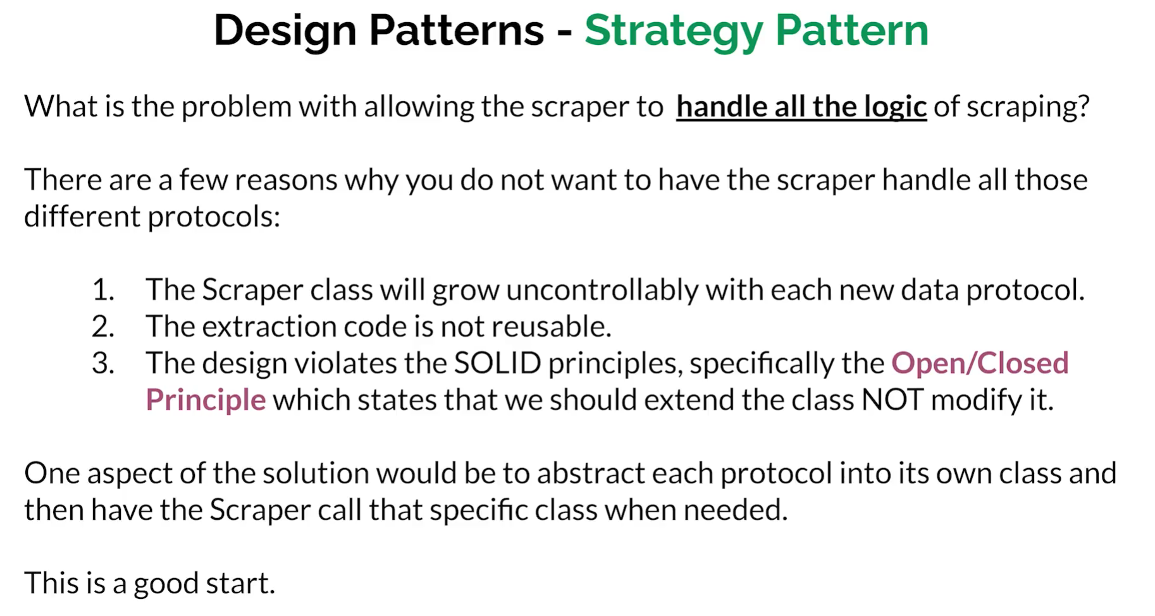Assume a web bot, similar to a web crawler, tasked with scraping various types of data from the internet. The bot might need to extract XML files, SQL files, comma-separated value (CSV) files, JSON files, or other types of data. The scraper would encounter different protocols and need to extract data accordingly: XML data from XML documents, SQL data from SQL documents, and CSV data from CSV documents.



Implementing all these extraction protocols directly within the scraper leads to several issues. The scraper class will grow uncontrollably as new data protocols are added. The extraction logic becomes embedded within the scraper, making it non-reusable. Most importantly, this approach violates the SOLID principles, specifically the open-closed principle, which advocates that classes should be open for extension but closed for modification.

To address these issues, each protocol should be abstracted into its own class. For instance, separate classes should handle XML, SQL, and CSV data. The scraper would then call the specific class required for the protocol it encounters. This approach ensures that the scraper remains manageable, promotes code reusability, and adheres to SOLID design principles by allowing extension through new classes without modifying the existing scraper class.

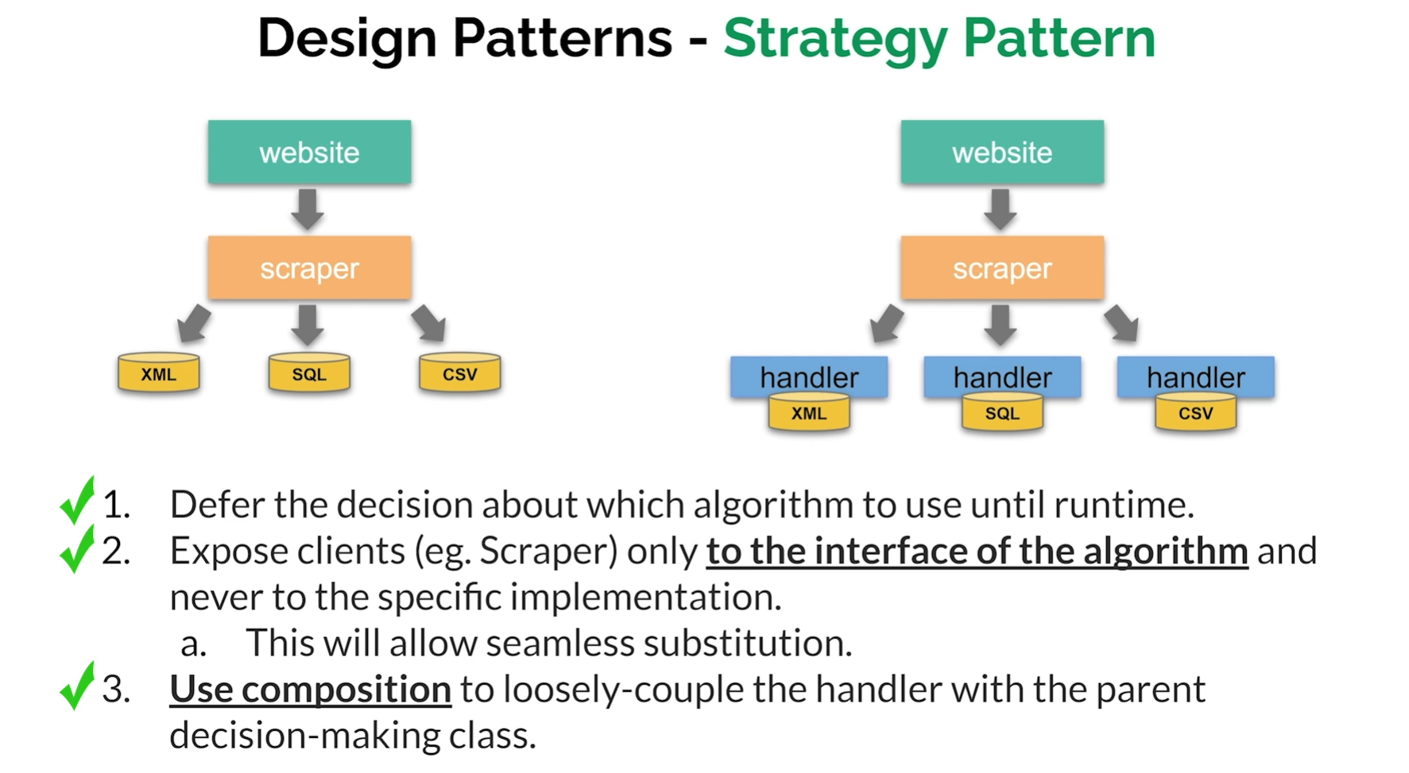

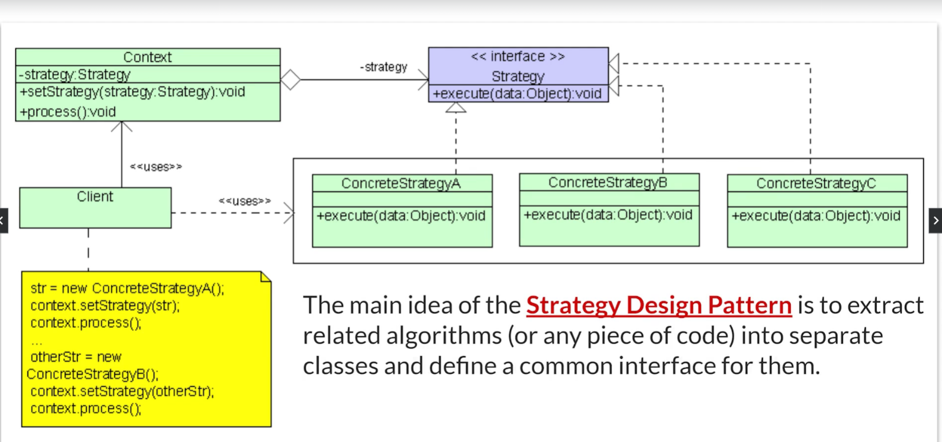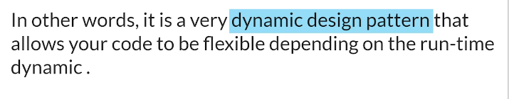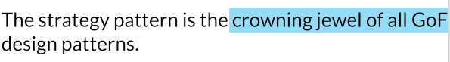

The original scraper architecture was problematic due to its handling of multiple data protocols directly within the scraper, leading to code bloat and violating design principles. The modified architecture improves upon this by introducing handlers for each specific protocol, such as XML, SQL, and CSV.

In this refined approach, the scraper delegates the extraction tasks to the appropriate handler based on the data protocol it encounters at runtime. This decision-making is deferred until the scraper identifies the specific data type during its operation. The scraper is exposed only to the interface of the algorithm and not to the specific implementation details, ensuring all handlers provide the same interface but implement different protocols for data extraction.

This design allows for seamless substitution of handlers. If a new data protocol needs to be supported, a new implementation of the interface can be added without affecting the existing scraper. Composition is used to loosely couple the handler with the scraper, embedding the handler within the scraper to maintain flexibility and modularity.

The strategy pattern is characterized by a strategy interface with a method called execute that accepts some data. Specific implementations of this interface, such as concrete strategy A, B, and C, act as the handlers. The context, analogous to the scraper, holds a reference to the strategy interface and includes a setStrategy method to specify which strategy to use. The client interacts with the context, determining the strategy at runtime.

The main idea of the strategy design pattern is to encapsulate related algorithms or pieces of code into separate classes with a common interface. This dynamic design pattern enhances code flexibility and adaptability, allowing behavior changes based on runtime conditions. The strategy pattern is considered one of the most valuable design patterns from the Gang of Four, providing a robust solution for managing dynamic algorithm selection.

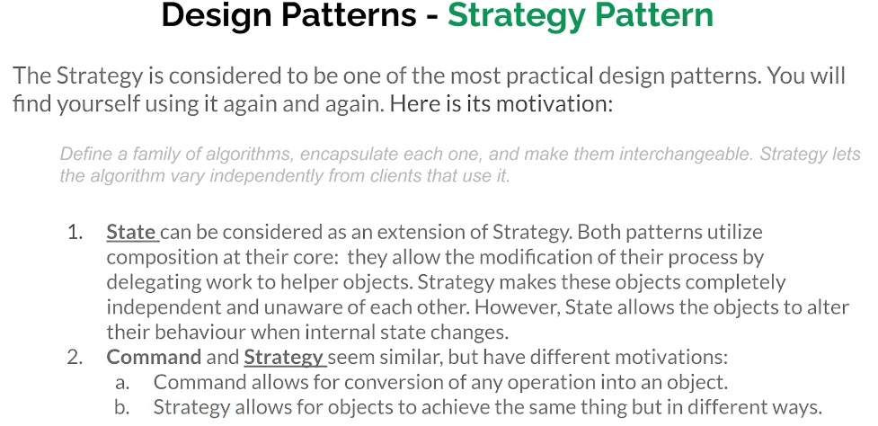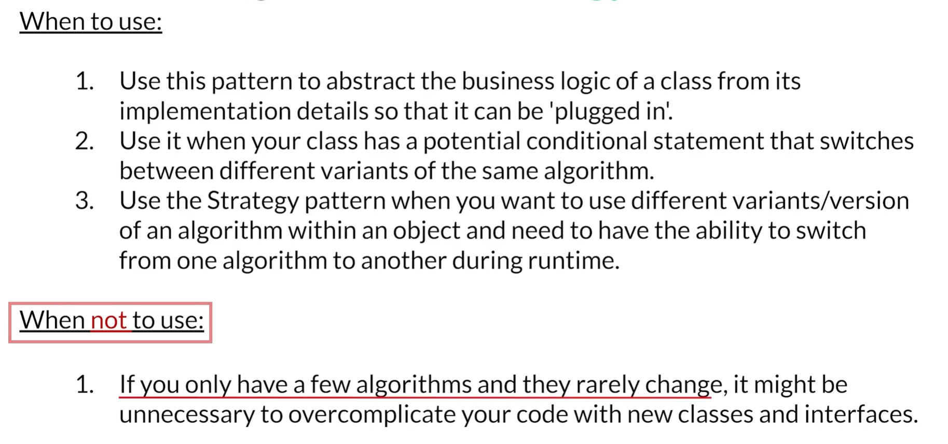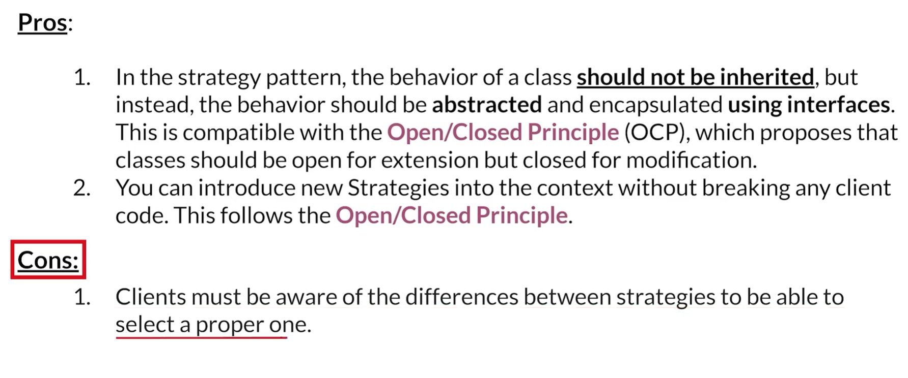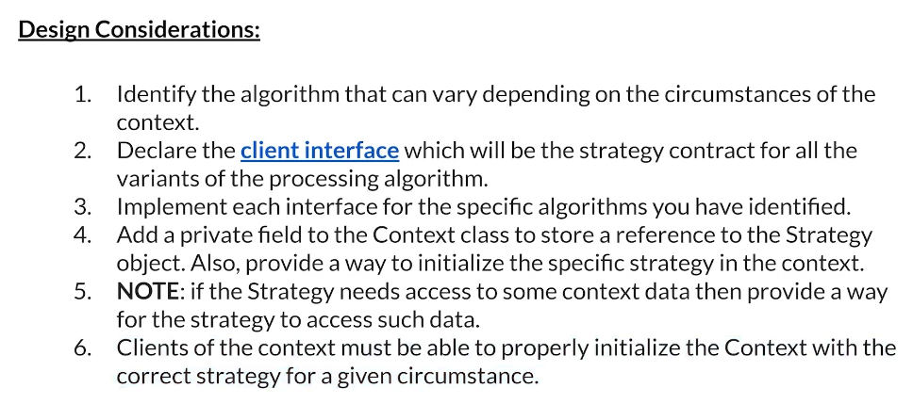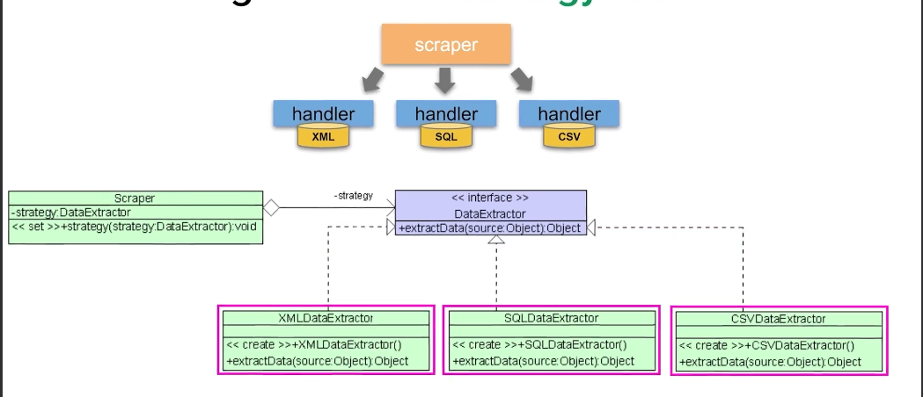

EXCERCISES:

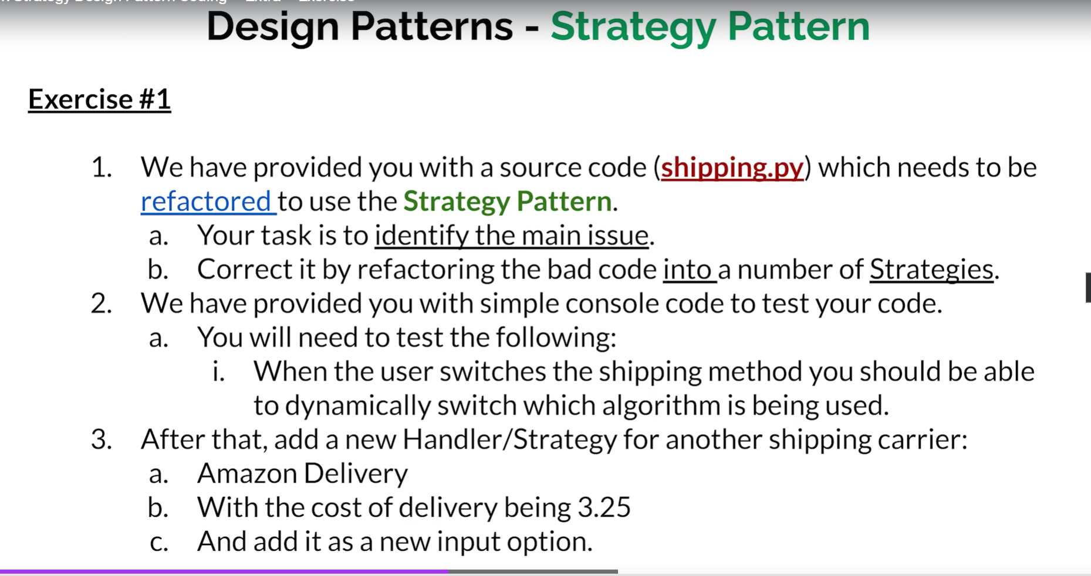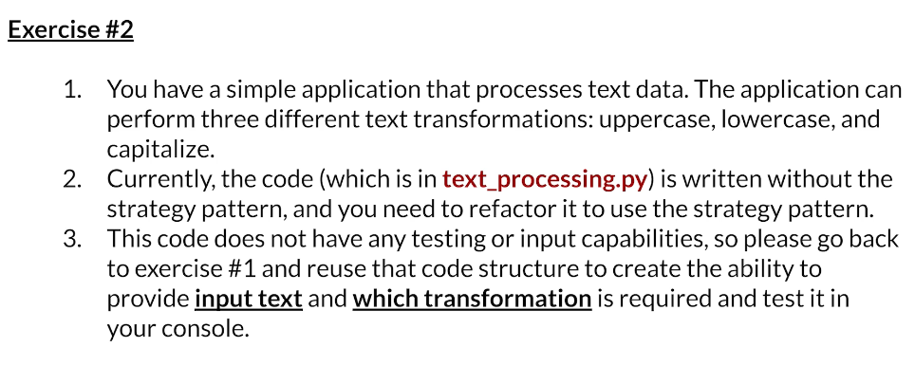  
  
  
  
  
  
  
  
  
  
  
  
  
  
  
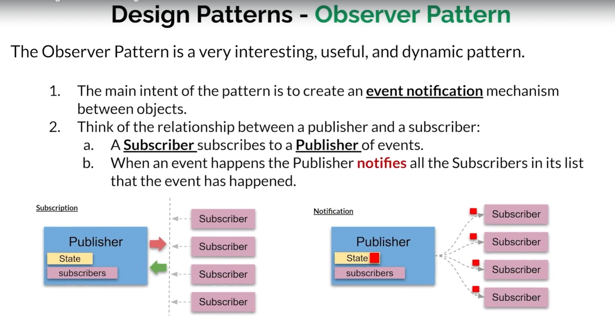

The observer pattern is a dynamic design pattern that establishes an event notification mechanism between objects, akin to a publisher-subscriber relationship. Subscribers can join or leave a publisher’s notification list, and when the publisher’s state changes, notifications are sent to all subscribers. It’s particularly useful for handling random data inputs and is integral to the model-view-controller (MVC) architectural pattern.

Highlights -📢

1. Event Notification: The observer pattern facilitates communication between objects.
2. Publisher-Subscriber Model: Subscribers receive updates from a publisher.
3. Dynamic Subscriptions: Subscribers can join or leave the notification list.
4. State Changes: Notifications occur when the publisher’s state changes.
5. Random Data Handling: Ideal for unpredictable data sources like user input.
6. MVC Integration: A key component of the model-view-controller architecture.
7. Behavioral Design Pattern: Classifies how objects interact based on state changes.

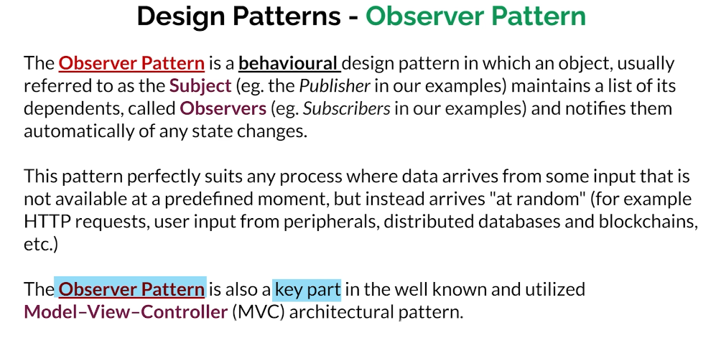

Key Insights -💡

1. Flexible Communication: The observer pattern allows for dynamic communication between objects, promoting loose coupling. This flexibility is essential in modern software development where components may need to evolve independently.
2. Subscriber Control: Subscribers have the autonomy to manage their notification preferences, enhancing user experience and reducing unnecessary overhead. This autonomy helps in building responsive applications.
3. Real-time Updates: By notifying subscribers of state changes, the observer pattern supports real-time applications, crucial for interactive user interfaces and live data feeds.
4. Handling Asynchronous Events: The pattern excels in scenarios with asynchronous data inputs, making it suitable for web applications and event-driven architectures where events occur sporadically.
5. Separation of Concerns: It encourages a clean separation between the data model and the user interface, aligning well with MVC principles, thus maintaining code organization and readability.
6. Scalability: As applications grow, the observer pattern allows for easy addition of new subscribers without impacting existing functionality, promoting scalability within software systems.
7. Common Use Cases: Beyond MVC, the observer pattern is prevalent in various real-world applications, including notification systems, real-time analytics, and collaborative tools, making it a versatile design choice.

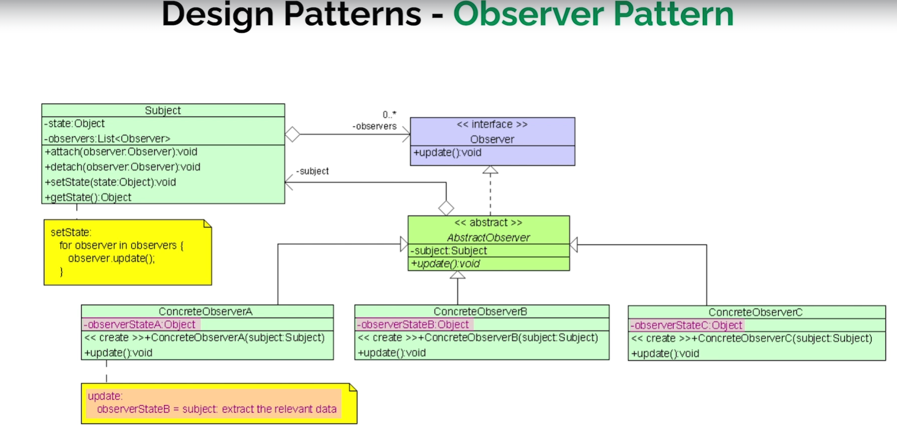Imagine a subject that has a state, which can be changed by a process, and we can also retrieve this state using a method. However, we don't know when the state will change. To handle this, we create an observer interface with at least one method, update, which allows the subject to notify observers whenever its state changes.

The subject is modified to keep track of all observers interested in these notifications by providing attach and detach methods to add or remove observers. The subject has an aggregation of zero or more observers who are interested in knowing when there is a change in its state. When the state is changed, the subject goes through the list of observers and calls their update method.

The observer is just a pure interface, so we create an abstract observer that keeps track of the subject it is interested in. While the subject has the observers, each observer also has access to the subject. When the subject's data changes, it notifies all observers, which then check the new data using their access to the subject.

In the abstract observer, the update method is still abstract and not implemented. Concrete observers are then created, each implementing the update method according to their needs. When the subject calls each observer's update method, the observer retrieves the new data from the subject's state object and performs its specific actions.

